Empowerment
and participation

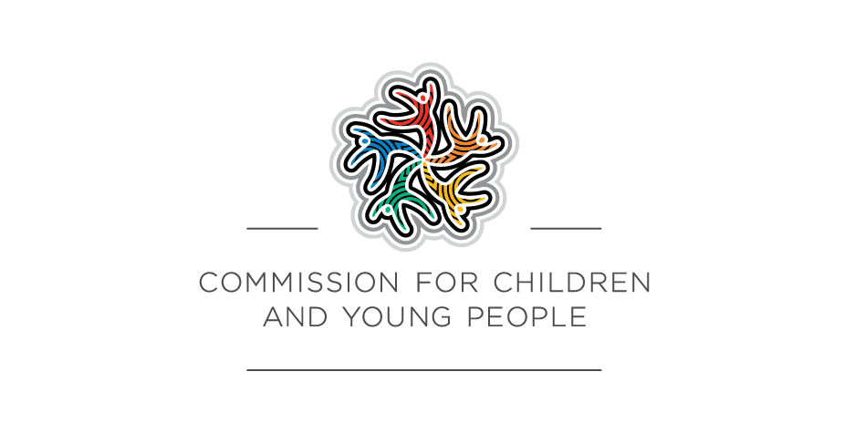
A guide for organisations working with
children and young people

It’s important that young people have an opportunity to talk about this stuff but it has to be done safely so, you know, so it doesn’t make life worse for them… but I think that even though adults are scared to talk about this stuff because it is uncomfortable, it has to be done if things are going to change - Young person

© Commission for Children and Young People 2021
This work is copyright. Apart from any use as permitted under the Copyright Act 1968, no part may be reproduced by any process without prior written permission from the Commission for Children and Young People, Level 18, 570 Bourke Street, Melbourne Victoria 3000.
Also available at www.ccyp.vic.gov.au.
ISBN 978-1-76096-331-6 (pdf/online/MS word)
Commission for Children and Young People
Level 18, 570 Bourke Street
Melbourne Victoria 3000
Phone (Free call) : 1300 78 29 78
Phone: (03) 8601 5281
Email: contact@ccyp.vic.gov.au
www.ccyp.vic.gov.au
The Commission for Children and Young People respectfully acknowledges the Traditional Owners
of the country throughout Victoria and pays respect to the ongoing living cultures of First Peoples.

 | 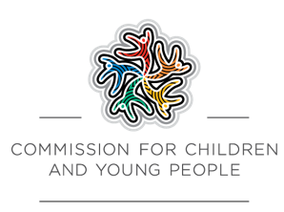

Foreword from the Commissioners
Children and young people have unique insights into their lives, needs and the world around them. It is their human right to be heard on matters affecting their lives.
Young people have much to offer organisations who engage them, listen and take their concerns seriously.
In Victoria, Child Safe Standard 7 requires organisations working with children to have strategies in place that empower young people to meaningfully participate in decisions that impact them. This requirement is intended to enrich organisations’ policies and processes; ensuring they best meet the needs of children they interact with. It is also intended to create a culture in which young people feel respected and valued, and feel confident to report problems – particularly if they are harmed or feel unsafe.
The Child Safe Standards also recognise that children and young people bring unique capabilities, experiences and views that can assist organisations to be child safe. Organisations can disempower children and young people when they don’t recognise these strengths and don’t seek, or shut down, their voices.
Empowerment and participation is particularly important for children and young people who are more likely to be misunderstood, marginalised or discriminated against. This includes children who are Aboriginal and/or Torres Strait Islander, from newly-arrived communities, who identify as LGBTQIA+ or who have a disability. Creating organisations that are culturally safe, inclusive, welcoming and accessible benefits all children.
Many organisations are motivated to improve their practices, but have told us they struggled to know how best to embed child empowerment and participation in a way that is effective and meaningful. For this reason, we partnered with the NSW Office of the Children’s Guardian and the Australian Centre for Child Protection at the University of South Australia to develop a guide that is comprehensive, practical and draws heavily on the views and experiences of children and young people themselves. Covering both the concepts of empowerment and participation, it is filled with sensible and achievable strategies that can be used and adapted for organisations of all types.
Empowering children and young people does not just improve their safety and wellbeing, it also promotes a healthy organisational culture that is consultative, collaborative and open to feedback and improvement. This guide will support organisations to be truly responsive and adaptive to the needs of the children and young people they care for and work with.
Liana Buchanan
Principal Commissioner
Justin Mohamed
Commissioner for Aboriginal Children and Young People

Contents
Introduction 6
Part one: Empowerment 8
What is empowerment and why is it important? 8
Empowering children in child safe organisations 8
How children and young people can be vulnerable in organisations 9
Children and young people with trauma 10
Celebrating and responding to diversity 11
Aboriginal and Torres Strait Islander children and young people 12
Children and young people from culturally and/or linguistically diverse backgrounds 12
Cultural safety 13
Lesbian, gay, bisexual, trans and gender diverse, intersex, queer and questioning children and young people 13
Children and young people with disability 14
Supporting empowerment in organisations 15
Empowering cultures 15
Empowering relationships 16
Empowering relationships: peers 18
Building awareness, skills and knowledge 19
Participation 20
Empowering children: a shared responsibility 20
The process of empowerment 21
Part two: Participation 24
How participation empowers young people 24
What makes positive participation? 24
How can my organisation support positive participation? 25
Before you start 25
Building trust and rapport 26
Elements of participation 28
1. Space 29
2. Voice 30
3. Audience 31
4. Influence 32
Benefits of participation 33

Part three: Tools 35
Empowerment tools for organisations 35
Empowerment tool 1: How empowering is my organisation? 36
Empowerment tool 2: Planning for empowerment 40
Empowerment tool 3: Assessing outcomes 48
Participation tools 51
Setting up a safe space to get children and young people’s views 51
Participation tool 1: Identifying safe spaces 53
Participation tool 2: Safety shields 56
Participation tool 3: Developing a child safe policy or statement of commitment to child safety 59
Participation tool 4: V is for Victory 61
Warm-up games 63
Group agreements 64
Tailoring guide for participation of children and young people of different ages 65
Further resources 80

Introduction
Child safe organisations value and celebrate children and young people for who they are and the contributions they make. They also recognise that because of their age, children and young people can be disempowered and are at greater risk of experiencing harm.
Organisations have an obligation to empower children and young people, and to uphold their human right to participate in decision-making that affects them. Some organisations are already skilled in doing this, while others remain unclear about what empowerment and participation look like and are yet to take first steps.
This guide is designed to assist adults to empower and involve children and young people in their organisation, in line with the Child Safe Standards. It contains guidance, tools and tips.
Empowerment and participation are two different things.
Empowerment is about building up children and young people and changing the way organisations operate. It helps children and young people to have greater confidence and to seek out support when they need it.
In child safe organisations, children and young people can be empowered through their relationships with staff and peers, and through positive and affirming experiences. They also need to be given information and skills to overcome problems and challenges, and to enable them to have a say about things that affect them. Empowerment builds children and young people’s confidence in themselves and in the organisation.
In organisations that are already empowering, children and young people are given opportunities to grow and build their confidence and self-esteem. They feel as though they belong and know that they can raise concerns if they feel unhappy or unsafe. These foundations can be built on further to help ensure children and young people have even more positive experiences.
The first part of this guide explains why empowerment is important in child safe organisations and how it helps keep children and young people safe. It provides information on what organisations can do to empower the children and young people they engage with and tools to put their plans into action.
Participation is about giving children and young people opportunities to have their say and to inform decision-making. This requires organisations to listen, to hear, and to make appropriate changes based on what children and young people share. Participation contributes to empowerment when it builds children and young people’s confidence, not just in themselves but in the organisations they are connected with. It strengthens relationships and helps children and young people feel valued.
As they grow and develop, children and young people have an increasing ability to express themselves and to be involved in decision-making. It is the responsibility of the adults in their lives to help foster this. Participation in child safe organisations is not only about giving children and young people opportunities to have their say. It’s also about organisations considering the needs and views of children and young people when making decisions that affect them. It’s a conversation where ideas are shared back and forth. In child safe organisations, these discussions are built into decision-making processes, demonstrating a commitment to listening and responding.
In organisations where children and young people are given opportunities to have their say, adults find out what children and young people are thinking and feeling. This means they are informed when it comes to making decisions that affect children and young people.
The second part of this guide focuses on participation. Participation helps children and young people to feel empowered. This guide describes how to encourage children and young people to participate in your organisation in ways that strengthen their confidence and safety.
This resource was developed by Associate Professor Tim Moore, Dr Lesley-Anne Ey, Greg Antcliff, Professor Leah Bromfield and Ashleigh Bagshaw from the Australian Centre for Child Protection at the University of South Australia, in partnership with the Victorian Commission for Children and Young People and the NSW Office of the Children’s Guardian. It draws on research and the findings of focus groups conducted with children and young people and those working with them.

Part one: Empowerment

What is empowerment and why is it important?
Children and young people have much to offer organisations, including their unique insights, talents and experiences. Their ability to participate develops as they build skills, knowledge and confidence in themselves and others.
Some organisations don’t appreciate these strengths and operate in ways that make children and young people feel less valued and respected. In these situations, children and young people can be disempowered and become more vulnerable to being hurt or harmed.
Empowerment recognises and builds on the strengths of children and young people. It is a process of allowing them to become stronger and more confident. It gives them greater say in and control of their lives, and helps them understand their rights, so they can act on them if they need to.
By empowering children and young people, child safe organisations aim to help them:
- become more resilient
- identify risks and know what to do if they are unsafe
- develop confidence to seek support if they need it.
For children and young people to be empowered, they need organisations to foster certain values and commitments, including:
- showing that they value children and young people and their contributions
- demonstrating a commitment to their rights
- taking their experiences seriously and responding to their views and insights
- demonstrating a commitment to keeping them safe.

Empowering children in child safe organisations
Empowerment is a critical element of creating an organisation that is safe for children and young people. Children and young people’s empowerment and participation can protect against abuse and harm within organisations by:
- raising their awareness of inappropriate or unsafe situations
- fostering appropriate, trustworthy relationships with adults and peers who can help them
- building their confidence to report concerns by reinforcing that their views and wishes will be taken seriously
- increasing staff and volunteer knowledge of their safety needs and concerns.
The four key principles organisations need to demonstrate are:
- developing an empowering culture
- fostering empowering relationships among children and young people, their peers and the adults in the organisation
- building awareness, skills and knowledge to recognise unsafe situations and raise concerns
- supporting meaningful, positive participation in the organisation.
Not all efforts to empower children and young people or to encourage their participation necessarily make them safer. Isolated or token efforts often fail to lead to substantial or lasting change. They can be seen as insincere and disempowering. It is therefore important that organisations support these principles effectively on an ongoing basis.

Empowerment model
In a child safe organisation, children and young people:
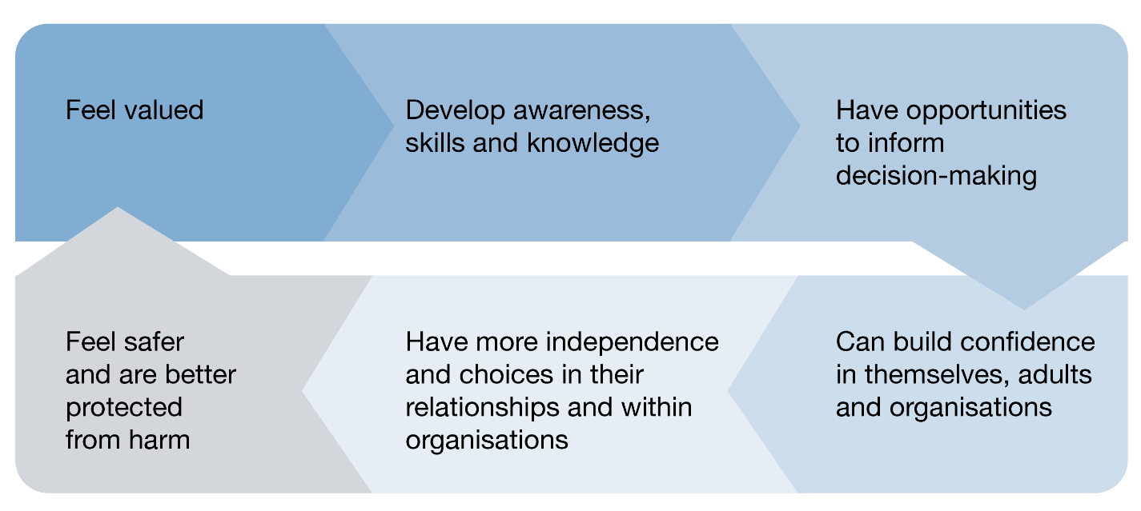

How children and young people can be vulnerable in organisations
At birth, children rely on adults to protect them, to identify and respond to their needs, and to make decisions that are in their best interests. As they grow, children develop skills, knowledge and abilities and build their independence. In the process of growing and developing, children and young people can be at risk of being hurt or harmed, and they do not always feel empowered to seek help and support.
Within organisations, there is very often a power imbalance between children and young people and adults. This is in part due to their different ages and stages of development, and the authority and power adults are generally given in organisations.
Although all children and young people can be vulnerable to abuse, research tells us that some are more vulnerable than others. They are at increased risk of abuse if they:
- have previously been the victim of bullying, harassment, abuse or maltreatment
- have encountered racism, sexism, homophobia or discrimination
- have disability or mental health issues
- are socially isolated
- come from families facing poverty and lacking support, or that have experienced trauma
- have experienced stress, worry and challenges that have negatively impacted their physical and emotional health, hopefulness and wellbeing.
These children and young people may also find it more challenging to speak up and to believe that adults will take them seriously.

Child safe organisations understand the connection between disadvantage and disempowerment, and take steps to ensure all children and young people are empowered and can speak up and be listened to. Although this guide provides general guidance, organisations should approach empowerment with sensitivity to the specific needs and backgrounds of the children and young people they are involved with. Organisations should tailor their actions and approaches to establish a safe environment where everyone feels able to contribute.
At the end of this guide there are links to further resources to support your understanding of the following groups of vulnerable children and young people.
Why might children and young people be vulnerable in organisations?
Adults sometimes take advantage of the power imbalance between them and young people.
Young people may feel that adults take advantage of them.
Young people sometimes feel that organisations prioritise the needs of adults.
Young people are often physically smaller than adults and can’t always protect themselves.
Young people aren’t always able to draw on past experiences to know what to do.

In their own words
They stand over you and make you feel really small. They want to remind you that you are weak and you have to do exactly what they say. There’s nothing you can do because you’re just a kid and you can’t fight back…
That’s why kids are unsafe because they can’t stand up and protect themselves. If no one is around, anything could happen.
We haven’t been through this stuff like adults might’ve so that makes us unsafe. And it freaks you out cos you don’t know what to do.
You always have to do what adults tell you. You’re taught from when you’re little that adults are always right and that you’ll get in trouble if you don’t listen to them.
There’s too many pressures on them to do other things than just listen to us or to care about things that happen outside of their job… They’re not accountable to us so it doesn’t matter if they don’t do what we ask them to do, what we need.
We’re not always a priority. Adults worry about themselves.

Children and young people with trauma
Childhood trauma – such as abuse or neglect, the loss of a parent or exposure to violence – can take a great toll on a child’s outlook and affect their sense of safety and security.
Children and young people who have experienced trauma may believe that they and their needs don’t matter or that trauma is part of life. They may have a history of feeling powerless, particularly when decisions are made without their input. Empowerment is valuable for these children and young people because it can help to restore their confidence in themselves and others. It can assist them to take more control over their lives.
Organisations may not know whether the children and young people they engage with have experienced trauma. It is therefore important that efforts to empower all children and young people use a trauma-informed approach. Understanding the impacts of trauma on children and young people will assist organisations to minimise the likelihood of exacerbating these problems.
Trauma-informed organisations:
- recognise that emotional, physical or sexual abuse – and other adverse life experiences such as racism or violence – can constitute a trauma
- understand that the impacts of trauma can be profound, especially when the trauma occurs at developmentally vulnerable times, and this can greatly affect children and young people’s sense of safety and trust
- create culturally, psychologically and physically safe spaces
- work with children and young people in trauma-informed ways that give them opportunities to safely participate and have their say without causing them distress or harm.

Celebrating and responding to diversity
No child or young person is the same as another. Each has unique abilities, skills and talents and different experiences to draw on. They each also relate to other people, see the world and share their thoughts and feelings in different ways. The way adults involve children and young people and relate to them can be empowering or disempowering. Child safe organisations think about ways to ensure that every child is able to have a positive experience. They respond to the specific and additional needs children and young people might have.
Children and young people feel disempowered and unsafe in organisations where they experience discrimination, harassment or abuse on the basis of their culture, identity or background. They may also feel disempowered when organisations don’t tailor supports to meet their unique abilities or needs.
Some groups of children and young people are more likely to experience disempowerment, discrimination, harm or abuse. These include:
- Aboriginal and Torres Strait Islander children and young people
- those from culturally or linguistically diverse backgrounds, including refugees
- those who identify as lesbian, gay, bisexual, transgender, intersex or queer (LGBTIQ+)
- those with disability.
The Royal Commission found that children and young people in these groups were more likely to encounter circumstances that increased their risk of abuse in organisations. This often came about because their perceived or actual ability to disclose or report abuse and receive an adequate response was reduced.

Aboriginal and Torres Strait Islander children and young people
Culture and community are often protective factors for Aboriginal and Torres Strait Islander children and young people, strengthening their sense of safety, identity, confidence and connection. Where organisations fail to celebrate their culture, don’t act in culturally appropriate ways or fail to see their background as a strength, it can increase the risk of Aboriginal and Torres Strait Islander children and young people experiencing racism and discrimination and not feeling safe. In these circumstances, they are often less willing and able to share their views and participate to their full potential.
Empowering organisations celebrate Aboriginal and Torres Strait Islander cultures. They actively prevent racism and discrimination, and take action when it occurs. They recognise that there are culturally appropriate ways of involving Aboriginal and Torres Strait Islander children and young people that help them feel safer and more empowered, and they work with local communities and Elders to understand what this looks like.
Find out about the Traditional Owners of the land/s on which your organisation operates at the Map of Indigenous Australia and learn about the importance of acknowledging Traditional Owners.
Learning from experience
Worker: Aboriginal youth need to have pride in the culture, because it’s such a big part of them. If you want to empower Aboriginal young people you have to link them to culture, make them feel good about being Aboriginal, let them know that it’s something that’s special that’s going to get them through [their difficulties]… Having Aboriginal staff, celebrating culture, having things like NAIDOC Week can give them that confidence in themselves – and if they see that white organisations are making an effort they’ll probably feel that they can trust you because you’ve tried.
Community leader: Our kids will never feel empowered, no matter how much you do to build them up, if you haven’t dealt with racism because that’ll just knock them down harder.

Connection to culture for Aboriginal people comes in many forms and often isn’t limited to just one or two ways. Culture is our healing, strength, belonging and purpose. It is the heartbeat of our existence.
Justin Mohamed, Commissioner for Aboriginal Children and Young People, Victoria

Children and young people from culturally and/or linguistically diverse backgrounds
Many children and young people live in families where they or their family members were born overseas or have culturally diverse identities. They often speak languages other than English at home. Drawing on their cultural heritage, these children and young people enjoy different cultural practices, beliefs, values and celebrations. Cultural background plays an important part in the way they form their identities. It offers them a sense of belonging and connection.
Child safe organisations celebrate this diversity. They recognise and prevent racism and discrimination and create environments where children and young people can be involved and share their views in culturally safe ways. Child safe organisations also appreciate that cultural expectations and values differ from one community to another. They encourage children and young people to contribute and share their views in a variety of ways. In some communities, children and young people may not be encouraged to share their ideas as freely as in others.
Some children and young people may find it difficult to talk in English about topics that they are not accustomed to sharing. Child safe organisations spend time getting to know individual children and young people, to find out how they would most like to participate. It may help to communicate in their mother tongue, or provide them support with reading, writing or speaking. This will encourage children and young people to participate more, which will result in them feeling more empowered.
Because they are experts in their own lives and have a good appreciation of what is culturally appropriate and safe, children and young people from diverse backgrounds can offer child-related organisations ideas on how to best empower them and support their participation in decision-making.

Cultural safety
Cultural safety is an essential precursor to the empowerment of children and young people from culturally diverse backgrounds. Children and young people won’t feel empowered or able to speak up and participate if they don’t feel that their identity, culture and background are respected. Children and young people feel more able to fully participate when they feel they belong and are safe from discrimination and harassment.
Cultural safety in organisations requires an environment that is free from discrimination or denial of culture. It is also about valuing and celebrating cultural difference and affirming the right of children and young people to enjoy and practice their culture. It requires awareness of cultural difference and a willingness to learn and a commitment to challenge both unconscious and overt discrimination and bias. For organisations, this can include:
- being respectful, inclusive and welcoming of families from a range of backgrounds
- taking a zero-tolerance approach to racism and discrimination in all forms
- reflecting on and working to address unconscious biases in staff, systems and processes
- representing and celebrating a broad range of cultures within imagery and activities
- communicating in ways that are accessible to children, young people and families from non-English speaking backgrounds
- celebrating diversity by recognising important cultural events
- fostering links with culturally diverse communities to strengthen awareness and understanding of different perspectives and facilitate cultural learning and connection.

Lesbian, gay, bisexual, trans and gender diverse, intersex, queer and questioning children and young people
Some children and young people do not identify as being heterosexual or may question their gender. They feel safest when:
- those around them understand what this means to them
- they are referred to in a way that makes them feel comfortable
- organisations create safe spaces for them where they aren’t discriminated against, judged or bullied.
These children and young people may have shared experiences of discrimination, harassment and abuse. Organisations can empower all children and young people by creating an inclusive environment that actively demonstrates that the organisation welcomes and values diversity and takes a zero-tolerance approach to discrimination. This may include:
- educating staff and volunteers about diversity in sexual orientation, intersex status and gender identity
- acknowledging people are not exclusively heterosexual or have a gender identity that aligns with the sex assigned at birth
- including a range of representations of lesbian, gay, bisexual, trans and gender diverse, intersex, queer and questioning people in imagery and activities, including depictions of diverse families, including rainbow families
- supporting and respecting decisions that children and young people make about their own gender identity, including respecting their preferred names and pronouns.

Children and young people with disability
Children and young people with disability often experience the world in different ways to their peers. This means that they have unique perspectives and can make important contributions within child safe organisations. When organisations fail to understand or accommodate their needs, their involvement in programs and support and contributions to decision-making becomes restricted. This can be incredibly disempowering and frustrating and can also amount to unlawful discrimination.
Children and young people with disability often experience discrimination and harassment. Research shows us they are at greater risk of being abused or harmed than those without disability. Children and young people who rely on others for personal care and movement often have little say over who touches their body. Some have cognitive difficulties and aren’t aware of how they should be treated. Others have particular communication needs and are not given an opportunity to raise concerns about others’ behaviours.
Child safe organisations recognise that children and young people with disability have a right to feel valued, to feel they belong and to have their say about things that are important to them. This often means ensuring that spaces are accessible, activities are inclusive, and their communication needs and preferences are met.
Supporting the empowerment and participation of children and young people with disability involves:
- communicating in a way that works best for them
- attending to any assistance that may be required for them to express themselves or raise concerns
- structuring spaces, processes, communications and activities to support them
- treating their views and insights with the same weight and respect as anyone else’s.
Organisations that are unsure about how to empower or support the participation of a child or young person with disability should seek further information and advice from families, carers, or disability services and advocates.

Supporting empowerment in organisations
Four key things organisations can do to support the empowerment of children and young people are:
- developing an empowering culture
- fostering empowering relationships between children and young people and adults, and between children and young people and their peers
- building awareness, skills and knowledge
- supporting participation.

Empowering cultures
Culture is the system of shared assumptions, values and beliefs that influence the way people behave in an organisation. Leaders have an important role in creating organisational cultures that are safe for children, but ultimately the decisions and behaviours of all adults in an organisation contribute to its culture.
Child safe organisations have strategies that empower all children and encourage them to speak up if they feel unsafe. In these organisations, children are aware that staff have a responsibility to protect them. In empowering cultures, organisations demonstrate the following:
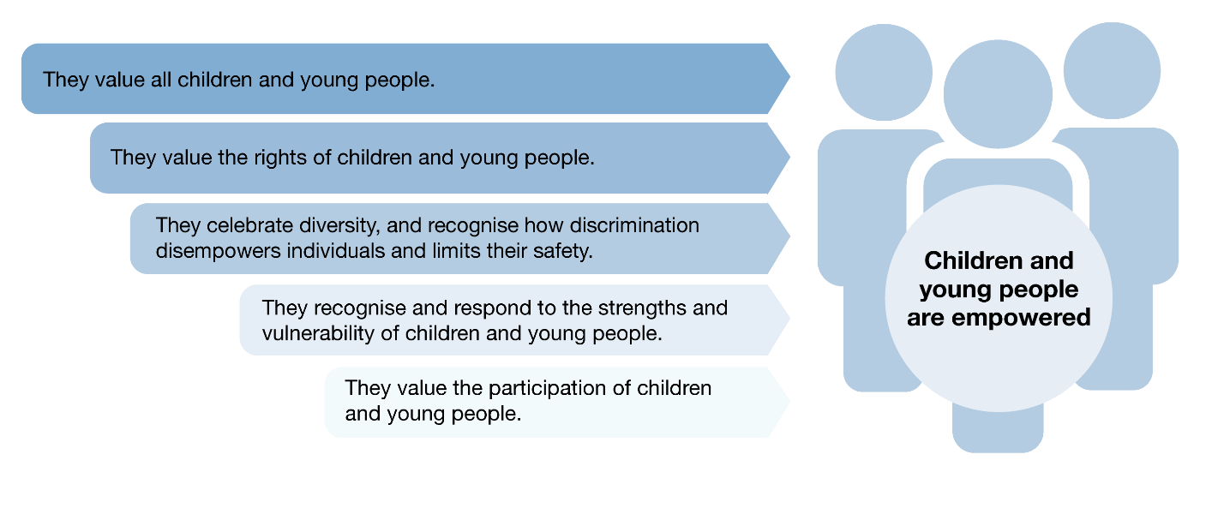
Organisational cultures that aren’t child safe can:
- reinforce children and young people’s powerlessness
- make children and young people feel they are not valued
- discourage adults from empowering children and young people
- provide opportunities for abuse to go unidentified and unspoken.
Children and young people are more confident when they are involved in decision-making, when organisations develop child safe strategies in conjunction with them, and when they know what is being done to keep them safe.

Develop empowering cultures checklist
Does your organisation: | Yes/No
… demonstrate that it values children and young people and their rights and participation?
… have a culture where children and young people are listened to and believed, and have an impact on the way the organisation operates?
… make public statements that demonstrate its commitment to empowering children and young people?
… have processes in place enabling children and young people to influence how the organisation operates, and to talk about what makes them feel safe or unsafe?
... have processes in place to address disempowerment in the organisation?
Make notes here to reflect on how your organisation develops empowering cultures

Empowering relationships
Appropriate relationships between children and young people and adults are built on trust and respect. Relationships of this kind are empowering; they help develop resilience and encourage children and young people to speak up if they feel unsafe. As a safety net, children and young people should be encouraged and assisted to develop a network of adults they trust, and who they can go to if they need help.
In their own words
Young person: She wasn’t in my life for that long but she made a big impact. She was someone who was good at her job, who showed that she cared and that she believed in us. I never saw or heard from her outside of the group and when she contacted me it was always through my parents. That was good – I felt safer because my parents knew her and knew what we were doing… I always knew what to expect from her. She was kind of strict but she was caring at the same time. I always knew where I stood with her.

Empowering relationships checklist
Do children and young people feel that adults in your organisation: | Yes/No
… do things to keep them safe?
… show they care about them?
… show they respect them?
… act in ways that are predictable and like adults ‘should act’?
… have authority but are approachable and listen to them?
… talk appropriately about sensitive issues?
… prioritise their needs and concerns?
… do what they say they will do?
Make notes here to reflect on how your organisation develops empowering relationships

For these relationships to be empowering, adults must show that they care, that they are dependable, and that they take children’s needs and views seriously. They must also maintain appropriate boundaries and adhere to their organisation’s expected standards of behaviour as set out in Codes of Conduct, screening practices or other relevant policies.
To foster empowering relationships, organisations should also ensure children and young people are aware of what is OK and what is not OK so they can be clear and confident about what to expect from adults in the organisation. This may include talking to children and young people about boundaries; sharing age-appropriate versions of key policies (such as Codes of Conduct); or developing a Child Safe Code of Conduct or policy in collaboration with children and young people.
Clear boundaries
Children and young people need adults who:
• follow the organisation’s policies and Codes of Conduct
• treat all young people equally and don’t have favourites
• are friendly but don’t attempt to befriend children and young people
• establish rules that they expect all adults (including themselves) to follow
• respect the boundaries of children and young people in terms of what they are comfortable doing, and who they are comfortable sharing and interacting with
• are transparent with managers about their engagement and interactions with children and young people
• don’t ask children and young people to share things that are personal and private, except in the context of providing support or care
• don’t share private information that is not relevant to their role
• don’t interact with children and young people outside of the organisation (except with the knowledge and permission of the organisation and carers)
• use their power as adults to help rather than control, belittle or isolate children and young people
• have transparent relationships with children and young people, with clear goals and outcomes so that other adults are confident about what they are doing.

Learning from experience
Organisational leader: Your relationship with young people has to be clear. You need to care about them and show that you care but you must have boundaries, you need to have rules, you need to show them the limits. Otherwise they won’t trust you and you can’t teach them if they don’t trust you. They don’t need another friend. They need someone who is an adult who they can trust.
Organisational leader: I think some of our volunteers are anxious about the relationships they have with kids. They don’t want people to think that they’re doing the wrong thing, so they keep them at an arm’s length and don’t really interact. A big part of our training is letting them know what is appropriate and what’s not and how to protect themselves. It’s so important because we need our volunteers to show they care about the kids but they need to have boundaries. They need to know we’ll support them but that there are rules. It’s something that we’ve been focusing on.

Empowering relationships: peers
Young people benefit from having strong friendships and feeling part of a team. They may see their friends as their primary source of support, information and advice, and go to them when they need help. Most often, young people will tell their friends about abuse before they tell adults. Because of this it is often the friend who will raise allegations of abuse rather than the person who has been harmed. This is why it is very important to empower all children and young people to act on concerns relating to themselves or to others. Organisations should encourage young people to develop positive peer relationships and build skills to support each other, while also seeking out adults if required.

Strategies for supporting positive peer relationships
Create a sense of team by:
- adopting a group name
- identifying and celebrating the strengths within the group and in individuals
- identifying shared goals and expectations
- spending time building trust and rapport.
Instigate buddy programs to enable:
- young people to pair up to give each other support and feel connected to others
- new participants in the group and those who feel isolated to have access to special support.
Promote partner or small group work to:
- create opportunities for children and young people to find support from their peers
- assist those who are more isolated or withdrawn
to grow their confidence.
Monitor group dynamics, and be sure to:
- call out bullying or exclusion
- discourage unacceptable behaviour
- encourage positive team dynamics.
Celebrate successes to strengthen a sense of team and individual value. Ask team members to:
- share something about their peers that they admire
- thank their peers for something that they have done together.
Learning from experience
Sports coach: There were a few young lads in our club who were new and were just not fitting in – they had no confidence and they wouldn’t try anything. So we put in a buddying program where some of the older ones we knew were good with kids watched out for the younger ones and made sure they were doing OK. We chose a few boys who hadn’t been leaders before – it was amazing to see them step up to the challenge. I think the new members and their buddies got something out of it. The buddies got so excited when their peers were doing well – it was like they felt proud of them and themselves for their success.

Building awareness, skills and knowledge
Children and young people are empowered when they have the knowledge, skills and confidence to recognise unsafe situations, speak up, raise concerns and influence the organisation. Organisations can empower children and young people by helping them to understand safety, what the organisation is doing to keep them safe, how they can raise ideas and concerns, and what will happen if they do. It is important that the organisation follows through with what it says it will do. Being reliable and meeting expectations builds the confidence of children and young people to speak up and participate.
Children and young people need to be supported to build confidence in themselves, in adults and in organisations.

Building children and young people's confidence
Confidence in themselves | Confidence in adults and organisations
There are opportunities for adults and peers to celebrate their unique skills, talents and contributions. | They have information – appropriate for their age and ability – about what adults and the organisation are doing to keep them safe and feeling safe. This might include information about:  - the organisation’s commitment to children and their safety  - its expectations about appropriate relationships that have boundaries  - what is in place to protect children from harm  - what children and young people can do if they are unhappy, unsafe or need help.
There are opportunities to build positive relationships with adults and peers that are caring, supportive and appropriate, and strengthen a sense of team.
They have opportunities to develop their ability to identify when things are unsafe and to find someone who can help. | They are encouraged to build connections with leaders they know and can turn to if they are unhappy or need something to change in the organisation.
There are choices about what they do and don’t do, how they are supported and how they get what they need within the organisation. | Their experiences demonstrate that the organisation values children and young people, is serious about their safety, and has effective ways of preventing and responding to harm.
They have opportunities to work with adults to find solutions to problems.

Participation
Giving children and young people a voice and allowing them to play a part in decision-making is a great way to empower them. It can strengthen relationships and build their confidence in adults and organisations. It also helps organisations identify and establish ways to overcome factors that may disempower children and young people and make them less safe. In Part two: Participation this guide provides further information about participation. Part three: Tools includes a range of practical group participation activities for children and young people.

Empowering children: a shared responsibility
People at all levels of an organisation have a role to play in empowerment. Adults in organisations also need the awareness, skills and knowledge to empower children and young people. Leaders have a responsibility to ensure staff understand what empowerment means, how important it is to child safety, and what is expected of them in empowering children and young people. Leaders should ensure from the top down that empowerment is practised at all levels of the organisation, including their own.

What can leaders do to foster empowerment?
- Make accessible public statements that demonstrate their organisation’s commitment to young people, their rights and their safety.
- Create opportunities for staff and children and young people to develop shared safety and empowerment goals.
- Establish policies and procedures that support children and young people having input into decision-making processes.
- Ensure that plans are achievable and that sufficient resources – including time, staff, training, mentoring, budget, tools, equipment and ongoing support – are allocated to them.
- Provide ongoing support for child safe practices and mentorship so staff can learn from best practice examples.
- Provide opportunities for appropriate adults, children and young people to become Empowerment Champions.
- Invite children and young people and their parents to provide feedback on their engagement.
- Ensure there are clear policies about appropriate conduct and clear reporting pathways for concerns.
- Model a commitment to empowerment and follow through on what they say they will do.

What can staff and volunteers do to empower children and young people?
- Demonstrate how they value and empower children and young people in their day-to-day practice.
- Participate in creating shared goals that empower children and young people.
- Take opportunities to learn about formal and informal empowering interactions with children and young people.
- Utilise resources such as time, training, tools and equipment to enable empowering interactions with children and young people.
- Reflect on their progress.
- Know how to respond if a child or young person makes a disclosure of harm or abuse.
Learning from experience
Leader: I think if they are going to empower kids, staff in organisations have to be empowered. If they feel threatened or devalued, or that their work isn’t appreciated, then they’re not going to be able to do good work with kids. You have to be strong and confident and supported to help kids feel strong and confident and supported.
Worker: Leadership is so important. If you’ve got a can-do leader who you know is going to back you, and parents and peers who support you, things are so much easier. I don’t know how many times I’ve seen workers who are fired up to do this stuff just get knocked down. And what message does that send to the kids? If this adult who they think is awesome is struggling, how are the kids themselves ever going to get what they need?
Worker: I probably wouldn’t have used ‘empowering’ as a way of describing it but I think about where I’ve done my best work and it’s been places where I feel good about being there, where we’ve all got a shared goal, where people feel like their contributions are valued. Yeah, they’re pretty empowering places to be. And you want the best, to live up to expectations and to get the very best out of your time there.

The process of empowerment
Achieving empowerment takes time and attention. It requires a continuous cycle of planning, action and reflection. Children and young people should be invited to contribute at all stages of the process.
Part three: Tools provides practical tools to assist organisations with each of these steps.

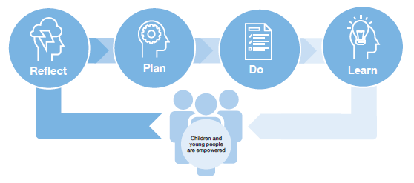

STEP 1: Reflect
Take time to reflect on how your organisation empowers children and young people. Consult widely to understand the current state of your organisation. Consider engaging with leaders, staff, volunteers, children and young people, and parents. Consider what your organisation already does well to embed the four elements of empowerment (culture, relationships, knowledge and skills, and participation) and identify opportunities to improve.

STEP 2: Plan
Set out the practical steps you will take to strengthen the empowerment of children in your organisation. Think about the formal planned activities you will undertake, as well as the informal, everyday changes you can make. Ask yourself:
- What are your organisation’s goals?
- How can you reach these goals and strategies?
- How will you tell if the organisation has achieved these goals?
People are more likely to support changes if they believe they have played a part in shaping them or belong to the team that is supporting the roll out. For empowerment to be a success, ensure everyone in your organisation who has an interest has input in the planning phase.

STEP 3: Do
Your organisation should implement planned activities with careful consideration of the communication and engagement needs of the children and young people and adults involved. Working through people’s concerns or questions is critical to the successful implementation of any strategy. If staff are unclear about why your organisation must empower children and young people, they may need more guidance to understand how it benefits everyone.

STEP 4: Learn
After implementing your action plan, collect information to assess whether it worked and how it made a difference to children and young people. This could include holding formal or informal feedback sessions with staff, parents or children and young people, or conducting surveys to identify whether things have changed and improved. To continue to improve, use this information to inform your next round of reflection (Step 1) and planning (Step 2).

Part two: Participation

How participation empowers young people
Participation is one way children and young people can be both empowered and safer within organisations. Participation provides children and young people with opportunities and support to voice their views and concerns, and to talk about what makes them feel safe or unsafe. Participation is a way of working. It should be part of your organisational culture and everyday practices as well as planned activities.
The United Nations Convention on the Rights of the Child provides a framework to guide organisations in upholding the rights of children and young people. The importance of these rights is evident in the findings of the Royal Commission into Institutional Responses to Child Sexual Abuse, and is included in the National Principles for Child Safe Organisations and the Child Safe Standards.
United Nations Convention on the Rights of the Child
Article 12 1. States Parties shall assure to the child who is capable of forming his or her own views the right to express those views freely in all matters affecting the child, the views of the child being given due weight in accordance with the age and maturity of the child.
Article 13 1. The child shall have the right to freedom of expression; this right shall include freedom to seek, receive and impart information and ideas of all kinds, regardless of frontiers, either orally, in writing or in print, in the form of art, or through any other media of the child’s choice.

What makes positive participation?
In their own words | Positive participation
We’re the ones most affected by this stuff so of course we want to, need to, be involved. | It recognises and values children’s unique views, experiences and needs.
It has to have a point. I hate it when adults talk to you and you know it’s just so they can tick a box and say they’ve done their job. They don’t really give a damn about you or what you’ve got to say. | It needs to be well planned and have a purpose.
It’s about young people and adults working together to suss out what the problems are, what needs to be done and then working together to make real changes. | It’s about working together.
You have to trust em, man, or why would you talk to them?…  You gotta trust that they’ll treat you right, that they will stand up for you and that have the power to do something about it. | It fosters appropriate relationships between adults and young people.
It has to be safe. Gee whiz, you could be [stuffed] if it’s done badly. And it can be really uncomfortable. But… don’t say “we just won’t do it”. | It’s safe, ethical and appropriate.
The ones who are most affected are the ones who’ll have the most to say and the most to get out of it… I don’t think that everyone who should have a say gets to. You should make sure the quieter youth, the ones who are dealing with the toughest stuff, the ones who’ll get a lot out of it – make sure they are involved. | It’s inclusive and targets those with the most to gain (and contribute).
It should help us to help ourselves. I don’t like it when they go: yeah right, we’ll look into that but… most of the time we have to deal with it ourselves, so we need to know what to do. | It builds knowledge, skills, confidence and help-seeking behaviours.
It’s more than listening. It’s about doing… I’m sick of adults asking the questions that they want answered and then putting it in a nice report that goes nowhere. | It’s action-focused and leads to demonstrable change.
I think adults should have to show what they’ve done and how they’ve changed things. They should be accountable. | It empowers young people and holds workers, services and systems accountable.

How can my organisation support positive participation?
Different kinds of organisations have different levels of responsibility for children and young people. This means there is no ‘one size fits all’ approach. Organisations need to consider the kind of participation that is appropriate and relevant to their responsibilities. For example, casual play centres or hobby classes may only see a child or young person occasionally, and only for a specific purpose. For these organisations, there is limited scope to undertake lengthy engagement processes, and it may not be appropriate to ask a child or young person for detailed information about how they feel or their broader life needs. Organisations like this should support participation through activities such as talking to young people about safety, and developing child safe policies and strategies in conjunction with young people.
Organisations that have a high level of responsibility for young people, such as educators and out-of-home care providers, have greater responsibility to meet a broader range of needs of the child or young person. These organisations, which will also have staff with a higher level of expertise in engaging with young people, are better placed and will be expected to undertake more extensive participation activities.

Before you start
When planning a participation activity with children and young people, it is important to consider what needs to be put in place from the outset to make sure it is a safe and positive experience. Any participation activity, planned or unplanned, must be run in line with your organisation’s policies and procedures, such as Codes of Conduct, and management and reporting policies. Prior to any participation activity, ensure all your staff and volunteers understand your organisation’s reporting policy so they know what to do if a young person discloses abuse.
Questions to ask while planning include:
- Have the risks of child abuse in the activity been identified and have practical measures been put in place to mitigate those risks?
- Do you have suitably skilled and experienced staff or volunteers to run the activity? If not, how might your team develop these skills? Is there another organisation you could partner with to develop them?
- Do your staff or volunteers feel comfortable to manage behavioural dynamics in the group, such as bullying?
- How will you decide the most suitable approach or tool for your type of organisation and level of responsibility for children and young people, and who will approve the activity?
- How will children and young people be informed they have a choice to participate?
- How will clear rules and boundaries be set? What will and won’t be discussed, and how do you intend to establish clear expectations of a respectful and bullying-free environment?
- How will transparency and accountability be built in (such as by communicating your approach and reporting outcomes)?
- How will you ensure your staff or volunteers know what to do if a child or young person tells them concerning information?
Some organisations might find the answers to these questions challenging. They are encouraged to ask what they can change or put in place to help children and young people participate, rather than giving up if doing this seems too difficult.
The participation tools in Part three: Tools of this guide include step-by-step information on things to consider when undertaking participation activities.

Building trust and rapport
Children and young people need to know that staff and their peers can be trusted so they can feel safe to have their say. Organisations must ensure their staff have the skills and capacity to make participation a safe and positive experience, or develop them to be able to do so.
It is also important to build trust in any group activities with children and young people. Children and young people are often influenced by their peers. They may be less likely to share if they feel their opinions won’t be taken seriously, if they feel bullied or harassed, or if they’re worried that what they say will be repeated to others outside the group. Adults leading participation activities need to be mindful of this, and set boundaries and expectations for the group to help children and young people feel it is safe to participate.
Children and young people will be more likely to participate if they understand the purpose of participation: why they are being asked for their views and what they can expect will be done with what they share.
Participation can involve groups or individuals. It might be via planned activities, or through informal day-to-day interactions. Some kinds of participation include the following:

Everyday informal activities | Planned activities
Discussing personal safety with children and young people, and how to raise any concerns | Conducting workshops to hear from children and young people about what makes them feel safe or unsafe in your organisation, and how things can be improved
Encouraging feedback after every activity in relation to feeling safe | Having a child safety policy developed in consultation with children and young people
Ensuring children and young people have time and opportunities to express their views | Developing age-appropriate versions of Codes of Conduct and safety policies, which are available as posters, videos and social media
Giving children and young people authority in tasks and activities | Having a children and young person’s representative committee
Checking in regularly with children and young people regarding their experiences in the organisation | Including children and young people at leadership meetings
Having a suggestion box | Conducting periodic feedback surveys, discussions or online polls
 | Giving children and young people opportunities to design and lead activities
 | Appointing children and young people as peer supporters
For planned participation to be effective, organisations need to create the right conditions and deliver the activities in the right way.

For children and young people | For staff
Help young people understand why they are being asked to participate, and offer this information in  age-appropriate ways | Foster an environment that treats children and young people’s participation as valuable
Give them information and time to be able to decide how they think and feel about the topics to be discussed | Show staff that their organisation values the opinions of young people
Give them choices regarding how they can talk about issues | Show staff that their organisation will respond to the views of young people
Give them choices in what issues they discuss | Give staff support to talk to children and young people in ways that are safe, appropriate and meaningful
Prepare them to hear from other children and young people, and allow them to find a shared view | Give staff access to resources that help children and young people express themselves
Let them know that they can choose to stop participating at any time | Allocate time and funding to support staff talking to young people
Give genuine consideration and responses to their views, to build trust and show the organisation takes them seriously | Consider whether parental consent is required or necessary for participation activities, or whether it could impede full and frank participation
Learning from experience
Child Safe Champion: It’s about helping kids feel more in control of their lives, about adults understanding what they want and need and responding to that and, really, changing the ways that adults and kids relate to each other – more as partners than as people with different amounts of power or worth or the value of what they contribute. It’s about having a say but participation is more than that, I think.

Elements of participation
There are different ways that participation has been described. One useful model, developed by Laura Lundy, includes four key elements: space, voice, audience and influence.
“Influe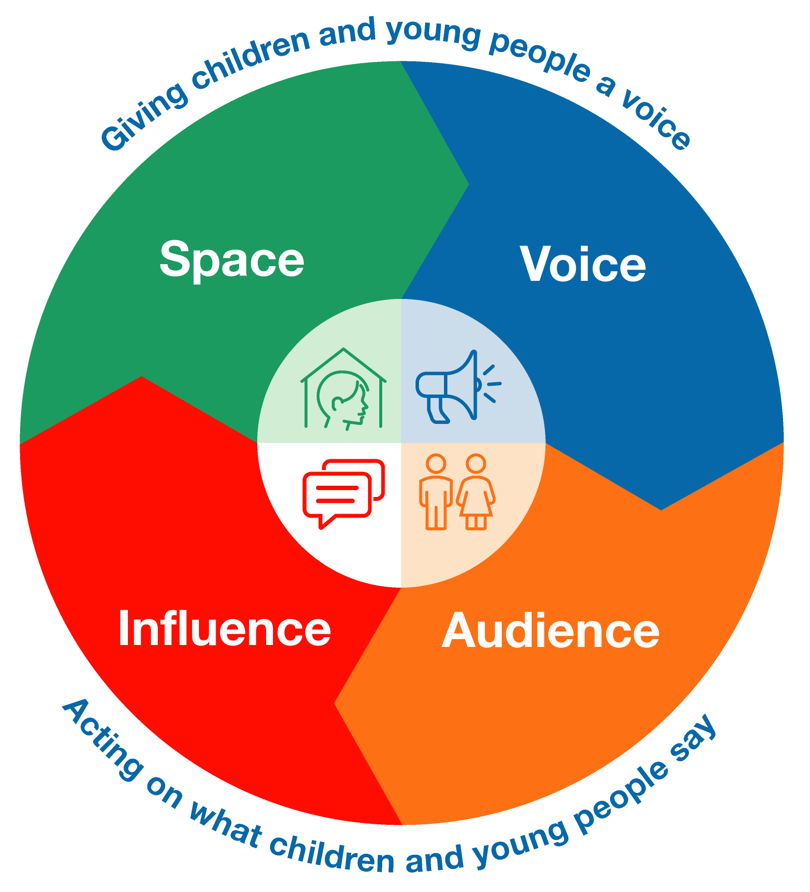

1. Space
Children and young people feel safe when they are in an environment where it is safe for them to speak up. Safety is not just about physical safety and managing hazards; it is also about emotional safety and wellbeing.
- The physical environment should be relaxed, free of distractions, and a place where children and young people feel welcomed.
- The atmosphere created for participation should be emotionally safe. Children and young people should feel they’re taken seriously.
- Participation activities should be inclusive and accessible, tailored as required to the individual needs and abilities of the children and young people involved.
It is important to consider the age of the children and young people who are participating, and how this will impact your plans. Organisations will need to do different things to create safe spaces for different age groups. See the tools and tailoring guide at the end of the document for information on how to make sure spaces are inclusive for young people of different ages, backgrounds, genders, sexualities, abilities and cultures.
In their own words
To be able to have your say you need to feel comfortable, you need to know that you’re going to be taken seriously and that you’re not gonna be judged. Having people you trust helps you. It should be relaxed and help people feel comfy. If it’s too formal you might be intimidated but if it’s not formal enough you might think that they’re not taking it seriously.

Space checklist
Does your organisation: | Yes/No
… ensure the physical environment is a place where children and young people feel comfortable and welcomed?
… create an environment for participation that is emotionally safe?
… enable children and young people to feel they’re taken seriously?
… ensure participation activities are inclusive and accessible?
Make notes here to reflect on how your organisation considers ‘space’

2. Voice
Children and young people are not always used to being asked about their experiences or about what they want. Organisations need to support them to feel comfortable speaking up and provide opportunities to do so. To help children and young people participate, organisations should:
- build trust and rapport with them
- provide information to ensure they understand and are able to participate and feel safe to do so, and can choose whether they want to be involved
- help them identify their views
- help them express themselves
- capture what they have said
- support them to make decision
- explain how you will be using or sharing their views.
Children and young people should feel their individual needs and abilities have been taken into account, and that any accessibility issues have been addressed prior to the session. They should feel their differences have been recognised and celebrated. In general, they should feel stronger and more confident after a session than when they arrived.
In their own words
Sometimes it’s hard to have your say. You are put on the spot and don’t have time to really come up with a good view. So helping us work out what we want and then helping us to put our ideas into words is really important.
I think that the biggest problem isn’t that young people don’t have an opinion; it’s that adults don’t know how to ask, and they freak out if they hear something uncomfortable. But they have to get over it because we need to have our say and they need to listen.

Voice checklist
Before participation activities, do children and young people feel that: | Yes/No
… they have been given enough information about the process so they will be safe?
… they are confident they can speak up safely?
… they know what to do if they feel hurt or harmed?
… they will be safe expressing themselves regardless of having different abilities and backgrounds?
… they can make anonymous comments if they want?
… there is support or activities tailored to those who have difficulty communicating verbally?
… there will be opportunities for appropriate one-on-one feedback if necessary?
… they will find out at some point how their input has been acted on?
Make notes here to reflect on how your organisation considers ‘voice’

3. Audience
Participation is a dialogue. When adults in an organisation are an effective audience, take young people’s views seriously and allow them to inform the way the organisation works, they are effectively collaborating. The adults in the organisation must demonstrate that the views of children and young people are important by the way they listen and the way they respond.
The organisation should be clear about how willing, able and responsible they are to listen and respond to what children and young people have to say. This requires leadership to be clear about what children and young people can expect, and to make a commitment about what the organisation will do.
Good participation is also about ensuring that those who need to know what children and young people think, feel and want receive these messages, and that those responsible for children’s safety are encouraged to respond.
In their own words
We think that the bosses should be the ones listening to us. Our stuff is important and it’s nice for people who have real power to be the ones listening.
I think if people aren’t used to listening or if adults don’t show that they really respect what you’re saying, then we won’t want to talk. So my advice is: really show us that our ideas are taken seriously, that they’ll make a difference and that you’re going to act and, well, you won’t be able to stop us talking!

Audience checklist
Does your organisation: | Yes/No
… ensure that everyone understands why participation is important?
… have a stated commitment to listening and responding to what children and young people say?
… build listening and responding to children and young people into role descriptions, where appropriate?
… support staff to build their skills in listening to children and young people?
… respond to what children and young people say?
Children and young people will quickly see through token attempts to engage them, so their participation must be meaningful and purposeful. This doesn’t mean that organisations have to do everything that young people say, but they should respond to all views including by saying what will or won’t change and why.
Make notes here to reflect on how your organisation considers ‘audience’

4. Influence

Key element 4: Influence
Participation is more than listening – it’s also the actions that follow. For participation to be meaningful, participants should know the intention is to make changes that keep children and young people safe in your organisation.
‘Influence’ involves:
- decision-making that takes into account what you’ve heard from children and young people
- policies and procedures that reinforce your organisation’s responsibilities to listen to and empower young people – and to keep them safe
- letting young people know how you’ve responded to their input.
In their own words
The worst thing they can do is say they’re going to do something and then not do it. Because we watch them and if they let us down, we’re not going to go and ask them again.

Decision-making checklist
Does your organisation: | Yes/No
… recognise that your decisions affect the safety of children and young people?
… provide opportunities for children and young people to inform decisions?
… record what children and young people have told you?
… create opportunities to report back?
… state what obligations it has to take into account young people’s views and wishes?
Make notes here to reflect on how your organisation considers ‘influence’

How you respond to the input of children and young people needs to be included in your existing policies and procedures. These should describe different ways that children and young people can have a voice in your organisation, including informal chats and group discussions. They should also make allowances for cultural differences, ability levels and age requirements, with the aim of hearing from all children and young people, including those who may be less likely to initially speak up. The tailoring guide includes tips on how to promote the participation of children and young people of different ages.

Reporting back checklist
Children and young people can be disempowered when organisations fail to let them know their views are valued and taken into consideration when decisions are made.
They can feel disempowered if their suggestions and opinions aren’t seriously considered, or if they’re not given reasons why their views won’t be adopted.

When reporting back to children and young people, does your organisation: | Yes/No
… let children and young people know what you’ve heard?
… explain why decisions were made?
… explain why you were unable to meet specific requests?
… describe how you might respond in the future?
… explain how their view led to change?
… respond in various ways, such as by video and social media?
… include its responses in formal reporting avenues such as newsletters and annual reports?
In their own words
It would be good if they could tell us what they think of what we’ve said… it would also be good
to hear what they are going to do and if it changed anything.

Benefits of participation
When participation is done well, everyone benefits. Leaders, staff and volunteers can learn from children and young people, who feel valued and taken seriously. Children and young people are safe and feel safer within their organisations.
In general, participation activities should result in the following outcomes:

Leaders | Staff and volunteers | Children and young people
Have a greater appreciation of the views of children and young people | Strengthen relationships with children and young people | Feel empowered by adults because they are helping to improve things
Are more inclusive and responsive, and continue to strengthen the ways children and young people can participate | Experience more job satisfaction | Build skills, confidence and abilities
Feel more confident that children and young people are safe and that their needs are being met | Gain confidence and skills | Understand what to do if they feel unsafe
Show they are meeting their child safe obligations | Are offered feedback on how they can improve | Know how organisations should meet their needs
Ensure that their organisations are safe for children and young people, and responsive to their needs | Can respond to make their work with children and young people more empowering and safe | Are safer and feel safer within your organisation

Part three: Tools

Empowerment tools for organisations
An empowerment strategy and action plan documents your organisation’s commitment to the empowerment and participation of children and young people. It will also help leaders clarify their vision, commitment and goals by putting them into a framework. Children and young people must be provided with opportunities and encouraged to have input into the strategy and plan. Any good strategy has four steps: reflect, plan, do and learn.
The following tools will help organisations:
- promote discussions about empowerment
- identify and celebrate things that organisations are doing well to empower children and young people
- come up with clear steps and priorities for achieving the organisation’s empowerment vision
- reflect on how child safe work might be improved, and set priorities for future work.
The tools provide a starting point for conversations within the organisation – you may think of other things that you need to consider. The tools are designed to be used regularly. Plan to come back to them every six or 12 months and beyond to monitor progress and continue to strengthen the empowerment of children and young people in your organisation.

Step |  | When | Why | Who and where | Time
Reflect | Empowerment tool 1: How empowering is my organisation? | Before developing an empowerment strategy | To reflect on whether your organisation, its leaders and its staff empower children and young people, and how you might build an empowering organisation | At staff gatherings, leadership meetings or board workshops | 1 hour
Plan | Empowerment tool 2: Planning for empowerment | While developing an empowerment strategy | To plan how you are going to empower children and young people | At staff gatherings, leadership meetings or board workshops | 1–4 hours
Do | Implement your strategy
Learn | Empowerment tool 3: Assessing outcomes | After implementing an empowerment strategy | To help your organisation assess how an empowerment strategy worked and where it can be improved in the future | At staff gatherings, leadership meetings or board workshops | 1–4 hours

Empowerment tool 1: How empowering is my organisation?
How empowering is my organisation?
When: Before developing an empowerment strategy | Why: To reflect on whether your organisation, its leaders and its staff empower children and young people, and how you might build an empowering organisation | Who and where: At staff gatherings and during leadership meetings or board workshops  Your organisation might consider including children and young people in these discussions | Time: 1 hour
As a group, determine whether individual statements are true “none of the time”, “some of the time” or “all of the time”. There may be some differences of opinion in the group. It is important that everyone has an opportunity to reflect and share their views. Consider taking notes to capture different opinions. Ask team members what evidence there is to support their assessment. What have they seen or heard? Does your organisation have a method for gathering feedback on these elements? Even if things are going well, ask yourselves what you could improve and what is stopping you from improving. Brainstorm what you can do to improve or sustain your rating. Ask yourselves what you could do to get to where you want to be.
Date of exercise:

Participants:

My organisation | 1  None of the time | 2 | 3  Some of the time | 4 | 5  All of  the time | How do we know? | What can we improve?
Leaders demonstrate that they value children and young people and their views
Leaders demonstrate that they value children’s rights
Your organisation celebrates diversity – different cultures, genders, ages, sexualities and religions
Your organisation actively discourages discrimination against people (including children and young people) on the basis of culture, gender, age, sexuality or religion
Your organisation is aware of children
and young people’s vulnerabilities
Your organisation has strategies in place to empower children in their interactions with adults and within the organisation
Your organisation has invested in opportunities to enable children and young people to have their say
Your organisation has policies in place that clearly articulate how children and young people influence the organisation
Your organisation supports staff to have appropriate and empowering relationships with children and young people

Children and young people | 1  None of the time | 2 | 3  Some of the time | 4 | 5  All of  the time | How do we know? | What can we improve?
Children and young people have opportunities to feel valued
Every child is supported to feel they belong
Children and young people are given opportunities to find solutions to their problems in relation to their time in your organisation
Children and young people are given opportunities to learn what to do if they feel unsafe or unhappy or need help
Children and young people are given choices during their time in your organisation
Children and young people are given information so that they know what your organisation is doing to keep them safe
Children and young people are given information about how your organisation expects staff and volunteers to treat them
Your organisation’s leaders interact with children and young people and know
how they are feeling
Your organisation’s leaders provide children and young people with feedback about what they have heard and how they are responding to children and young people’s views
Children and young people feel safe
while interacting with your organisation
Action notes:

Review date:

Empowerment tool 2: Planning for empowerment
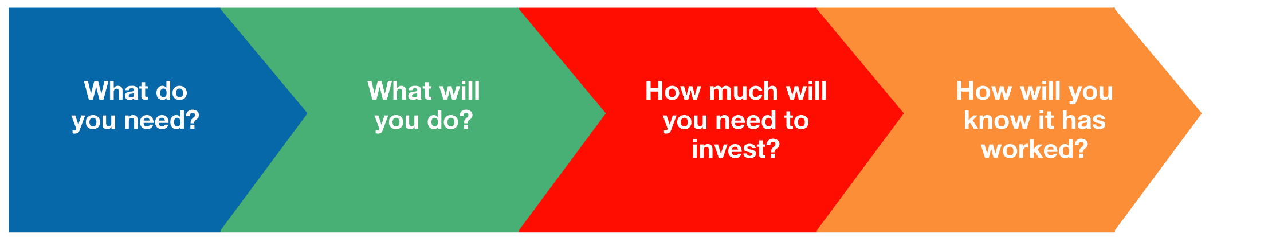

Planning for empowerment
When: While developing an  empowerment strategy | Why: To plan how you are going to empower children and young people | Who and where: At staff gatherings and during leadership meetings or board workshops  Your organisation might consider including children and young people in these discussions | Time: 1/2 day
This tool will help your organisation to decide what steps and strategies to take to empower children and young people and determine whether you have succeeded.
Date of exercise:

Participants:

Step 1: What empowerment needs does your organisation have?
To inform this conversation use your findings from Empowerment tool 1: How empowering is my organisation?
Are specific groups of children and young people more vulnerable or less empowered than others? If yes, which groups are more vulnerable and how are they less empowered?
Are particular children or groups of children and young people more socially isolated than others? If yes, which groups are more socially isolated and how?
Are there particular children and young people who do not feel safe or comfortable in your spaces or activities? If yes, which groups feel unsafe and why?
Are there particular groups of children and young people who might not be able to use your space or participate in activities (for example, because they are not accessible to those with disability)? If yes, which groups and why can’t they participate?
Is your program informed by what children want and need and how can you tell?
What areas for development has your organisation identified?
What do you hope to improve?
Action notes:

Step 2: What will you do?
This step is probably the most important, so don’t confine your conversation to a single discussion if no ideas immediately come to mind.
What have we already done, here or elsewhere, that had the outcomes we were hoping for?
What can we learn from other organisations? What have they done to achieve the same objectives?
Who can we ask? Do children and young people, parents or other stakeholders have insights that can help?
What strategies or actions will you take? How will you work on creating and fostering:
- an empowering culture?
- empowering relationships and strengthening children and young people’s connections?
- children and young people’s awareness, skills and confidence?
- staff’s responsiveness to the needs of children and young people?
- children and young people’s participation?
Action notes:

Step 3: What will you need to invest?
Who should be involved in the activity or strategy?
Which people in your organisation will need to contribute?
What do you need to implement your plan? Do you need to document strategies or plans, develop session outlines, provide staff training or give people time to prepare?
How much time will it take to plan, organise, conduct and review your activity or strategy?
How much will it cost and how will this be budgeted?
What will be asked of children and young people? Will they need to be at a special event, or involved in an activity or process?
How will parents be involved? Will they be asked to do anything they don’t usually do (for example, drop off kids at a different time or be present to help young people decide whether they want to be involved)
What investment needs have you identified to deliver
on your plan?
Action notes:

Step 4: How will you know if you’ve succeeded?
How will you measure the success of your actions?
How will you know whether your plan worked and you have met your objectives?
How will you assess whether children and young people feel more confident and are empowered?
How will you assess whether staff are responding to the needs of children and young people?
What will you put in place to ensure you can measure your effectiveness?
Action notes:

Empowerment tool 3: Assessing outcomes
Assessing outcomes
When: After implementing an empowerment strategy | Why: To help your organisation assess whether your empowerment strategy worked and where it can be improved in the future | Who and where: At staff gatherings and during leadership meetings or board workshops  Your organisation might consider including children and young people in these discussions | Time: 1/2 day
When implementing anything new, it is helpful to keep asking yourself questions such as “why are we doing this?”, “what are we achieving?”, “what can we learn?” or “how can we evolve?” This is also relevant for your organisation’s efforts to empower children and young people, and implement other child safe practices.
You used Empowerment tool 1: How empowering is my organisation? to assess your situation and Empowerment tool 2: Planning for empowerment to help you decide what to do and judge whether you have succeeded. Tool 3 helps you to evaluate your progress so you can celebrate successes, and adapt and strengthen your approach for the future.
Date of exercise:

Participants:

Compare tools 1 and 2 and describe the strategies you implemented and how these met the needs you were hoping to address.
What was successful about your strategy or actions?
What negative consequences did you encounter?
How did you strengthen the safety of children and young people?
What changed about your organisational culture?
What connections were strengthened?
What needs or concerns were addressed?
How were the skills and knowledge of children and young people enhanced?
How did your organisation become more responsive to the needs of children and young people?
How were children and young people encouraged to participate?
What unexpected challenges did you experience, and how did you overcome them?
What evidence have you gathered to demonstrate that your organisation achieved positive results? Consider using Empowerment tool 1: How empowering is my organisation? again to determine what has changed since you began this work.
What have you learned from this experience? What would you do differently next time? Return to Empowerment tool 2: Planning for empowerment to plan your next round of child safe work.
Action notes:

Participation tools
The following tools, games and activities can be used to ask children and young people about their needs and views, to encourage them to share their safety concerns and identify the ways they would like adults and organisations to keep them safe. All the activities have been used with children and young people. Some were developed in partnership with children and young people themselves.
The tools are examples of what you can do to engage and empower children and young people to offer their views. They are not prescriptive: feel free to change them to meet your group’s needs.
The toolkit is by no means complete or exhaustive. It is a set of tools that you can add to as you build your approach to listening and responding to children and young people.
At the end of this guide, there is information about warm-up games and creating a group agreement for constructive and safe group participation.

Setting up a safe space to get children and young people’s views
When conducting participation activities, staff members should follow a number of steps to prepare your organisation and the children and young people involved, to ensure that all children and young people have an opportunity to participate and that your staff are ready to respond to what they tell you.

Think diversity | The way that you work with groups of children and young people needs to be age-appropriate and driven by their needs. The tailoring guide provides guidance on how to tailor your work to children and young people of different ages and needs.
Have clear goals | Your organisation should have clear goals and should shape participation activities to align with these goals. Take time to consider why you are asking children and young people particular questions and whether it is the right time to do so. Decide what you want to learn and choose a tool that helps you get there. You might want to use a tool as is or modify it to meet the needs of your organisation.
Prepare children and young people | Sessions should begin with a brief discussion that explains to children and young people:  - what you are hoping to achieve  - what they are being asked to do  - why they are being asked for their views and opinions  - what you are going to do as a result of their involvement.
Energise children and young people | Begin sessions with a warm-up game or energiser to help focus and build trust within the group. Invite children and young people to share a favourite game. Older young people might be happy with group introductions where they share something that others in the group might not know. Examples of warm-up games are included at the end of this guide.
Have a group agreement | It is helpful to let children and young people share their ideas about how the group will be run and what they expect. Consider how you might build trust, how children and young people can work respectfully, what choices they will have (about what they do and don’t share and if they want to leave), what you will keep confidential in the group and what you will need to share. Guidance on creating a group agreement can be found later in this guide.
Conduct group discussions  or activities | Be clear about what you want to know from children and young people, and choose a game, discussion or activity that will meet your goals. In this guide, we provide a number of participation tools that you could use or modify. The tailoring guide can help you modify your approach for different age groups.
Conduct a closing activity | At the end of a session, it is important to:  - thank participants for their thoughts and ideas  - tell participants what you think you heard and have them confirm your summary.  The session might end with a round robin where participants are each asked “what’s the most important thing you think came out of our group today?” or “what’s the message that leaders in our organisation most need to hear?”  You should then give the children and young people an idea of next steps and what you will do with what you have heard or learned from them, and how they will be updated on any changes made as a result of their views.  As part of this activity, children and young people might decide what things they are happy for their peers to share outside the group. Leaders should also be clear about what information will be provided to others in the organisation. If a child or young person discloses that they or others are being harmed, it is the responsibility of adults to act. It is vital to inform the child or young person that you are concerned about them and what you will need to do.
Record what has been shared | For participation to be meaningful, it is important that children and young people’s needs and views are accurately recorded. It is most effective if children and young people can play a part in crafting the messages and, where possible, give them an opportunity to share their ideas directly with those making decisions.
Next steps | Participation is a three-step process: it is about listening, responding, and then letting children and young people know what your organisation has done to respond to their views. Organisations should think about how best to communicate children and young people’s views to decision-makers.
Sometimes participants will raise concerns or give examples of when they aren’t safe or don’t feel safe. It is important to validate these concerns. Children and young people should feel like their views are appreciated, that you have taken on board their concerns and that you will do something about them.
If a child discloses that they or someone they know has been hurt or harmed in the course of an activity, you must follow your organisation’s policies and report these concerns to the appropriate authorities.

Tools | Aim | Target | Resources | Time
Participation tool 1: Identifying safe spaces | To help obtain feedback on how physically and emotionally safe children and young people feel in your environment and how this might be improved | 3–18 years (with modifications and preferably in partnership with staff and leaders) | Coloured dots (children), sticky notes (young people) or maps of the space | 20–45 minutes
Participation tool 2: Safety Shields | To help younger children understand and inform your organisation’s Child Safety Commitment and show them how it is keeping them safe | 5–12 years | Copies of the Safety Shields template for each participant  Coloured pencils or markers | 45 minutes (including 15–20 minutes to complete activity)
Participation tool 3: Developing a child safe policy or statement of commitment | To help children and young people inform and understand your organisation’s commitment to safety, and show them how it is keeping them safe  To get feedback from children and young people about whether your organisation is empowering and safe, and what things might need to be strengthened | 12–18 years (with modifications) | A summary of the things that might be included in your organisation’s child safe policy or statement of commitment .  A sheet of A3 paper for each point to be made in your policy or commitment  Coloured markers and art supplies (like stickers, glitter and coloured paper) | 45–60 minutes (including 40–45 minutes for exercise)
Participation tool 4: V is for Victory | To involve children and young people in finding solutions, overcoming problems or planning to improve practices or approaches | 5–18 years (with modifications) | Butchers paper  Markers, pens or pencils | 20–40 minutes
The tailoring guide for participation of children and young people of different ages can help you to modify your approach.

Resources for supporting children and young people’s participation
Warm-up games | To help children and young people feel comfortable, energised and ready to participate
Group agreement | To help children and young people set expectations about how they will work together to create a safe space for participation activities and conversations

Participation tool 1: Identifying safe spaces
Children and young people feel safe when they are in an environment where it is safe for them to speak up. This tool provides opportunities for children and young people to discuss ‘safe spaces’. Keep in mind that safety here is not just about physical safety and managing hazards, but is also about emotional safety and wellbeing. Further ideas for creating safe spaces for children and young people of different ages can be found in the tailoring guide.

Aim | Target | Resources | Time
To help obtain feedback on how physically and emotionally safe children and young people feel in your environment and how this might be improved | 3–18 years (with modifications) | Coloured dots (children), sticky notes (young people) or maps of the space | 20–45 minutes
Conduct warm-up activity
Reach a group agreement

Introduction | Briefly explain that the exercise aims to find out how physically and emotionally safe children and young people feel in your organisation.  Explain that children and young people may feel safe in some places and unsafe in others.  Ask children and young people, “what do we mean when we say ‘safe’?”, “how can you tell if you are safe ?”, “what happens in your body?” and “how do people act when they are safe or unsafe?”  Let them know that your organisation is interested to learn which places feel safe and those that don’t, so you can make changes to improve things.  Tell children and young people that they will be asked to explore the space and decide whether they feel safe there. Ask them to identify places that might be out of bounds and, together, decide the boundaries for the activity (for example, don’t go outside the centre, stay in front of gate, don’t cross the road and keep out of staff rooms).  Supervise participants to move around your organisation’s space/spaces and identify areas that feel safest, less safe or unsafe.  Children may like to place coloured dots (green for safe, orange for less safe and red for unsafe) around the space. Young people may place sticky notes around the space and record their views and observations about why it feels safe or unsafe. Alternatively, young people may mark safe, less safe and unsafe places on a map of the organisation’s spaces.  After the participants have marked up the spaces, you may walk around, stopping at spots where participants have placed markers or coming together as a group to talk about the places participants feel safe or unsafe.
Discussion | In a group, ask about:  - the safe spaces:  - where are they?  - what makes a space feel safe?  - would these spaces feel safe for all children and young people (that is, children of different ages, abilities, genders, sexualities and cultural backgrounds)?  - are they accessible to everyone?  - the unsafe spaces:  - where are they?  - what makes a space unsafe or why do they feel unsafe in it?  - are they unsafe for everyone?  - how could they be made safer?  - the best place to talk to children and young people:  - where do they feel the safest, most comfortable and happiest to talk?  - how could a space be changed to make it a good place to talk?
Debrief and key messages | Thank participants for their views and ideas.  Check in with children and young people by asking:  - how are you feeling?  - how did the session go?  - what might we do differently next time?  Ensure that participants:  - are given an opportunity to confirm that what the facilitator has heard represents their views  - understand how your organisation will respond to what has been shared  - understand how you will update them on what has changed as a result of them expressing of their views.  Check in with each child or young person who raised a concern, letting them know what you will do with the information they shared. If necessary, use your organisation’s complaints or other relevant reporting policies.

Modifying for different groups
- Older young people could work in pairs, walking around taking photos on their phones or devices and coming back to the group to share their images and work through questions.
- Older children and young people could record themselves and their peers in different spaces and interview each other about why the space is safe or unsafe for them.
- This activity can be completed with children aged 6+ as a visualisation exercise in which they are asked to close their eyes and imagine they are walking through the space before offering their feedback.
- Children and young people could be asked to imagine that they are a small child, a child with disability or a child from a different culture and complete the steps again.
- Children and young people with mobility issues might be given a map and asked to indicate safe and unsafe spaces rather than walking around the area.
- Children and young people could be asked whether they believe that their parents or other adults would identify the same safe and unsafe spots for them.
- As a follow-up exercise, organisations could use Participation tool 4: V is for Victory to open a discussion about how your organisation might respond to the views expressed. In the first column, ask participants to summarise what arose from the safe spaces exercise and in the second column have them describe what the space would be like if all children and young people felt safe there.

Participation tool 2: Safety shields
Younger children can be given opportunities to learn about and inform the ways your organisation is keeping them safe. This activity helps communicate what your organisation is doing and hear from children about what could be done better. (Participation Tool 3: Developing a child safe policy or statement of commitment to child safety can be used with older children and young people.) Information about how to create a child safe policy or statement of commitment to child safety can be found at https://ccyp.vic.gov.au/child-safety/.

Aim | Target | Resources | Time
To help younger children understand and inform your organisation’s child safe policy or statement of commitment and show them how it is keeping them safe | 5–12 years | - Copies of the Safety Shields template for each participant  - Coloured pencils or markers | 45 minutes (including 15–20 minutes to complete activity)

Preparation | Prepare prompt cards with the following statements written on them (prepare enough sets for small group work):  - Everyone here works to keep children safe.  - Children have rights that need to be taken seriously.  - All children and young people should be respected.  - Every child and young person should be able to give their opinion on things they care about.  - Children and young people from different backgrounds should be celebrated.  - It is good to be different.  - Children and young people have choices about how their views are responded to.  - No one should feel powerless or disrespected.  - Every child should have their say.  - Children and young people need to know what is unsafe and how to protect themselves.
Conduct warm-up activity
Reach a group agreement
Introduction | Explain that children have a right to feel safe and organisations have rules for how adults should act around children and young people to keep them safe.  Explain that this exercise will share what your organisation is doing to keep children and young people safe and ask for their views about what you should do to make sure they continue to be safe.
Activity | Start by sharing some of the things your organisation does to keep children safe or aspects of your policy or statement of commitment, if you have one.  Open conversation about what else could be done by the organisation to keep children and young people safe  Some groups may not need to use the prompt cards and can go straight into brainstorming. For younger children, prompt cards may help start the conversation. If using the prompts, explain the types of things that might be included in a policy or statement of commitment, and lay out the cards with the words or ideas that might be considered.  Pick up each card and check that children understand the meaning of different words (for example, confidentiality) and the ideas being explored. Individual children could choose a card and explain its meaning or the leader could invite suggestions from the group.  Working in small groups, give each group a set of the prompt cards and explain they can draw on these for ideas as needed.  Divide the shield into the following four quadrants:  - What do children and young people expect from your organisation?  - What would they like adults in your organisation to do to keep them safe?  - How would children feel if your organisation did these things?  - What can children do if your organisation doesn’t do these things? (for example, make a complaint or tell a parent)?  Lead children in discussing each of the questions and record their views and observations in the relevant quadrants. Older children can record the group’s views themselves.  Gather as a group to discuss the shields and add any other ideas that are suggested.  Shields can be made into a book or a set of posters that children can access.
Debrief and key messages | Thank participants for their views and ideas.  Check in with children and young people by asking “how are you feeling?”, “how did the session go?” or “what might we do differently next time?”  Ensure that participants:  - are given an opportunity to confirm that what the facilitator has heard represents their views  - understand how your organisation will respond to what has been shared  - understand how you will update them on what has changed as a result of them expressing views.  Check in with each child or young person who raised a concern, letting them know what you will do with the information they shared. If necessary, use your organisation’s complaints or other relevant reporting policies.

Modifying for different groups
- Aboriginal and culturally diverse children and young people might choose to use another culturally appropriate metaphor.
- Younger children can be encouraged to draw their responses to the questions in a copy of the shield and then talk about what they have drawn.

Shield template
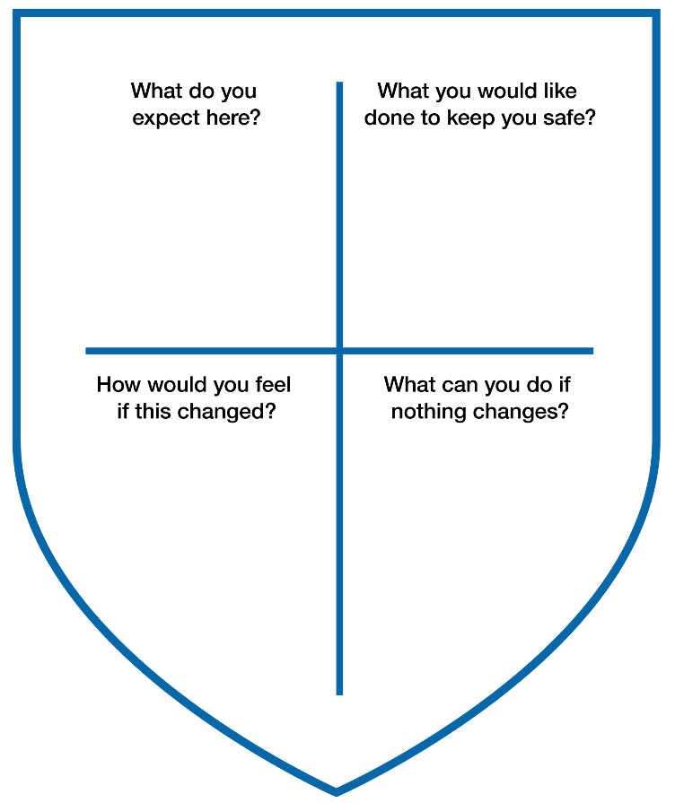

Participation tool 3: Developing a child safe policy or statement of commitment to child safety
Child safe organisations help their community understand how they keep children and young people safe and protect them from harm. Children and young people should have opportunities to inform the development of child safety policies and may need child-friendly versions to appreciate what their organisation is doing. Child-friendly versions can be developed with children and young people to build their knowledge while helping to share messages with their peers. Information about how to create a child safe policy or statement of commitment to child safety can be found at https://ccyp.vic.gov.au/child-safety/.

Aim | Target | Resources | Time
To help children and young people inform and understand your organisation’s commitment to safety and show them how it is keeping them safe  To get feedback from children and young people about whether your organisation is empowering and safe, and what things might need to be strengthened | 12–18 years (with modifications) | - A summary of the things that might be included in your organisation’s policy or statement of commitment  - A sheet of A3 paper for each point to be made in your policy or statement of commitment  - Coloured markers and art supplies (like stickers, glitter and coloured paper) | 45–60 minutes (including 40–45 minutes for the exercise)

Preparation | Prepare a summary of the key commitments included in a policy or statement of commitment. These might include:  - fostering a shared responsibility for protecting children and young people from harm  - upholding children’s rights  - treating children and young people with respect  - valuing children and young people and listening and responding to their views  - promoting cultural safety for Aboriginal, Torres Strait Islander and culturally and liinguistically diverse children and young people  - celebrating diversity  - maintaining privacy and confidentiality  - undertaking continuous improvement.  Your commitment could make specific reference to empowerment, including providing details about culture, relationships, knowledge and participation.
Conduct warm-up activity
Reach a group agreement
Introduction | Provide children and young people with a summary of the key commitments included in a policy or statement of commitment. This could be a printed sheet or flash cards with the words or ideas.  Explain that when discussing safety, you are aware that children and young people might express dissatisfaction with the way your organisation is keeping them safe. Ensure they know that you will listen to their concerns, you are prepared for these conversations and you value their insight.  Explain that you are seeking feedback and suggestions on your organisation’s policy or statement of commitment.
Activity | Go around the group, asking children and young people to choose a commitment and consider (individually or as a group):  - what this commitment means  - why it is important for children and young people that this commitment is included in a policy or statement of commitment.  What are some things an organisation might do to show they are meeting this commitment?  What would it look like if your organisation demonstrated this commitment?  Invite children and young people to share other things they would like to see in your policy or statement of commitment.  In small groups, ask young people to design a poster that uses child-friendly language and images to communicate to other children what they should expect from your organisation.
Debrief and key messages | Thank participants for their views and ideas.  Check in with children and young people by asking “how are you feeling?”, “how did the session go?” or “what might we do differently next time?”  Ensure that participants:  - are given an opportunity to confirm that what the facilitator has heard represents their views  - understand how your organisation will respond to what has been shared  - understand how you will update them on what has changed as a result of their views.  Check in with each child or young person who raised a concern, letting them know what you will do with the information they shared. If necessary, refer to your organisation’s reporting policy.

Modifying for different groups
- Older children or young people might choose to create computer-based presentations or animations to consider the questions.
- Using their phones, young people could record brief responses to the questions and upload them to an appropriate online platform.

Participation tool 4: V is for Victory
Children and young people can play a part in coming up with solutions. In child safe organisations, leaders foster opportunities for children and young people to consider how things are and how things might be, to develop strategies to achieve the organisation’s goals. This tool can be used as an assessment and planning tool and it can focus on any topic children, young people or organisations want to explore. It can be used to find solutions to any challenges identified in participation tools 1, 2 or 3.

Aim | Target | Resources | Time
To involve children and young people in finding solutions, overcoming problems or planning to improve practices or approaches | 5–18 years (with modifications) | - Markers, pens or pencils  - Butchers paper | 20–40 minutes
Conduct warm-up activity
Reach a group agreement

Introduction | Explain that the purpose of this activity is to look at particular situations in your organisation to see whether they can be improved.  Identify an issue you would like to explore, drawing on the other tools (for example, a space that is not inclusive, children and young people not knowing what to do if they feel uncomfortable, children not feeling valued or your organisational culture) or ask children and young people to choose a topic they would like to discuss.  Explain that the purpose of this exercise is to come up with ways to deal with a concern or improve a practice.
Activity | Draw a large V on a piece of butchers paper.  Write “How things are” on the left side of the V and ask children and young people:  - What is the challenge?  - How do they feel?  - How do adults currently act or respond?  - What are some of the good things that are happening?  - What things are currently not great?  Get the children and young people to imagine what things would be like if they were better and record these under a heading “How we’d like it to be”. Explain that you are not looking for a perfect world, but one that is possible. Ask them:  - How would children and young people feel?  - How would adults act or respond?  - What would be going well?  Work with the children and young people to come up with ideas about how your organisation can move from the left side to the right, and the actions your organisation should take. List these in the centre of the V.
Debriefing | Thank participants for their views and ideas. Tell them what you will do with the things they have shared and your limits. For example, tell them, “We can’t do everything you’ve asked but we can definitely think about ways that we can improve”.  Ensure that participants:  - are given an opportunity to confirm that what the facilitator has heard represents their views  - understand how your organisation will respond to what has been shared  - understand how you will update them on what has changed as a result of their views  - are given the opportunity to decide what things they are happy for leaders and peers to share.  Check in with each child or young person who raised a concern, letting them know what you will do with the information they shared. If necessary, use your organisation’s complaints or other relevant reporting policies.

Modifying for different groups
- This activity can be completed by setting up two spaces in your room, for “How things are” and “How we’d like it to be”. Ask children and young people to move into one of the spaces and answer the same questions as above. This can generate more small group discussions and allow children and young people to move from one area to another. Butchers paper could be placed in the two areas or facilitators could move from one group to the other, capturing participants’ views.
- For younger children aged 3–4, draw a line on a piece of paper and ask them to draw what it is like in your organisation now and what they would like it to be. Adults can ask children to tell them about their drawing and write a description of the children’s explanations.

V is for Victory template
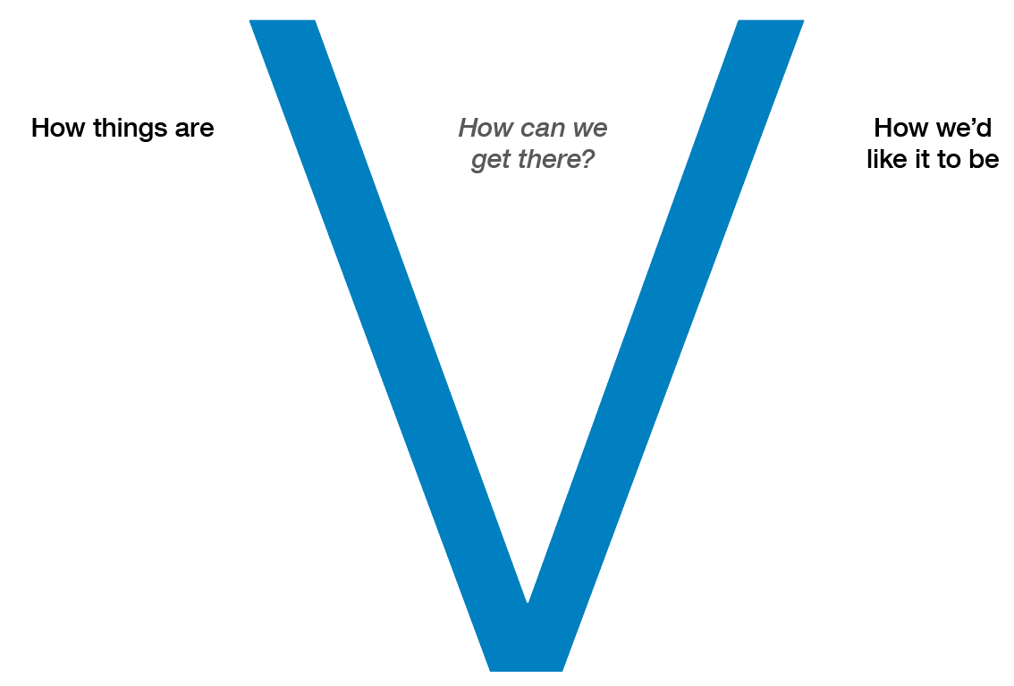

Warm-up games
Before children and young people feel comfortable to share their thoughts they may want and need an opportunity to get to know a little bit about each other and to release some nervous energy. They often tell us that talking about things like safety or being asked their views is unusual, so it is a good idea to begin a session with a quick activity that is familiar. Below are some suggestions for games you can play with children that take minimal time. Children and young people will also have favourite games – so don’t hesitate to ask them for a replacement if you want to try something different. Choose a game that is appropriate to the cohort of children and young people you are engaging with, and be sensitive to games that might exclude or be uncomfortable for some children and young people.

For younger children
1. Kittens and puppy dogs will get children laughing. Split the group into two groups that stand facing each other on either side of a line. One side are kittens and the other are puppy dogs. Kittens are not allowed to laugh or smile. Puppy dogs have to try to make the kittens smile or laugh by using funny voices or making funny faces, or doing other hilarious things. If a kitten laughs or smiles, they sit down or join the puppy dogs to help them make the kittens side laugh or smile. The game finishes when only one (or a few) kittens are left.
2. I Spy is a classic game that most children know, but it can be tweaked to build rapport. In small groups, children are asked to decide on something they like about one of their number. They are encouraged to make sure it is a positive characteristic. One by one, they say, “I spy with my little eye something about [child’s name] that starts with letter” and their peers have to guess the quality they have chosen.

For older children
1. Fruit salad builds energy and a sense of connection. Children sit on chairs in a circle and each is allocated one of five fruits (for example, banana, apple, peach, lychee or strawberry). One child is asked to volunteer to stand in the middle of the circle and their chair is removed, so there is one chair fewer than the total number of children. The volunteer calls out the name of one of the five fruits. Everyone who has been allocated that fruit must stand up and quickly change places (all others remain seated). At the same time, the volunteer must also try to find an empty seat. One child will not find a seat, and they become the new volunteer in the centre and can nominate a fruit. The volunteer can also call out ‘fruit salad’, in which all the ‘fruits’ must stand up and swap places at the same time.
This activity can be modified so that the person in the centre calls out a statement (for example, everyone who had cereal for breakfast) and their peers move.
2. Act it out is a game to help children learn names and find out more about each other. Children stand in a circle and are asked to think about something they like to do that they can mime. The leader begins by introducing themselves; for example, by saying “hi, I’m Sam and I like to read” (acting out reading a book). Sam then invites the child to his left to introduce him and then themselves. “This is Sam and he likes to read [acting out reading] and I’m Jess and I like to sing” [acts out singing]. Each participant then introduces themselves and everyone else to their right, with help from the facilitator and their peers.

For older young people
1. Name balls builds energy. Young people stand in a circle and the leader has three tennis balls or soft objects. The leader throws a ball to a participant to catch, calling out their name as they throw. They then have three seconds to call out the name of a peer in the circle and throw the ball to them. They then call out the name of another peer and throw the ball to them – this repeats. The leader can introduce a second, and then a third ball when the group is ready, so all three are in play at the same time. Participants who hold on to a ball for more than three seconds are out and must sit out.
2. Prize possessions helps young people get to know each other. Leaders ask participants to find something on them or in the space around them that represents something special or an aspect of themselves. For example, they might choose a necklace because it was given by a family member, a learner’s licence because it represents their freedom, or their phone because they use it to stay connected to friends. The leader then introduces themselves and shares their prize possession and invites others to do the same.

Group agreements
Before commencing a group activity or discussion, it is important that the group sets some expectations about how members will work together to create a safe space to talk. Deciding to work together respectfully, to support each other, and to stamp out bullying helps set the tone of a group, and ensures that all children and young people can have their say. The way that you set up this activity should be tailored to the group. Young people probably won’t need much prompting, but younger children might need more help to come up with ideas.

Steps
Introduce: let children and young people know that when talking about things like safety it is important that everyone feels comfortable. They need to know that their contributions are valuable, that they won’t be judged for what they say and that all ideas are helpful.
Inform: Tell the group that these expectations are there for everyone: for children and young people, for observers and for those running the group.
Ask: request that the children and young people come up with some ideas on ways the group could be run so that everyone feels safe. You might want to prompt them in relation to being respectful and supportive, listening and keeping what is said within the group confidential (unless there’s a reason why it needs to be shared).
Write: list the answers on a poster, butchers paper or sheets of paper.
Dig: if needed, ask questions to get children and young people to dig more deeply. For example, “I'm wondering what would be an example of something that wouldn’t make someone feel safe? How could we prevent this?”
Agree: once the group has generated a list, ask members to indicate that they are happy to work together in the ways identified. They might want to have a show of hands, sign a document or do a team handshake.
Check in: at the end of the session, ask: “how did we go?”, “what could we do better?” and “are there other things we might include?”

Modifying for different groups
Although this exercise works best if the group helps establish its own expectations, you might provide a list of proposed ‘norms’ that children and young people work with. These might include:
- being respectful
- having the right to have a say – or not
- listening (one at a time, appreciating others’ contributions)
- laying down rules that there is no bullying, harassing or judging
- treating things said in the group as confidential (unless there are concerns about someone’s safety)
- showing self-care by making sure that you don’t share things you might regret later or that could be shared in private with an adult.

Tailoring guide for participation of children and young people of different ages
This resource provides general guidance about how to create physically and emotionally safe and inclusive spaces for children and young people and support them to participate. This section breaks down these actions by age group, offering some tips and suggestions on things you might do to help engage children, build rapport, ask questions and involve them in conversations. Children and young people all have unique interests, talents, abilities, needs and preferences. You can use these pages as a framework but should recognise that they won’t be relevant to all children and young people in each category and should be adapted as necessary.
It is important to ask children and young people to tell you what helps them to participate and have their say. They can give feedback on whether your approaches have worked in the past and suggest what could be done differently. As well as asking children and young people if approaches are working, be curious, observe, reflect and try different things so that all children and young people can have a voice, and you can listen and respond.
In the event that a child discloses that they or someone they know has been hurt or harmed, you must follow your organisation’s policies and report these concerns to the appropriate authorities.
This section includes guides relating to space and voice for the following age groups:
- 0–3 years
- 3–8 years
- 8–12 years
- 12–15 years
- 15–18 years

Creating safe and inclusive spaces (0–3 years)
Creating a physically safe space | Creating an emotionally safe space | Creating an inclusive space | Understanding support needs | Building trust within groups | Building peer connections
Infants (0–18 months)  Explore the space to make sure there are no hazards for infants who are learning to roll, crawl and walk.  Include infant-friendly toys, blankets and mats to help them feel comfortable. | Infants (0–18 months)  Invite parents to be present during activities to increase an infant’s comfort.  Respond to an infant’s gestures, smiles and discomfort.  Speak in warm and gentle ways. Show that you are happy to be with them and delighted by them. | Infants (0–18 months)  Talk to families and learn about their values, beliefs and culture, and how they help children feel safe.  Have spaces dedicated to infants. Make the space inclusive and engaging by reflecting diversity. | Infants (0–18 months)  Infants need adults to protect them, to affirm them and to help them build their skills by modelling and celebrating their successes.  Parents will most often have a good idea about what a child needs and wants, and how they best express themselves. Spend time talking about their children and getting to know their needs.  Infants will have some language but will more often communicate with their bodies and in their behaviours. | Infants (0–18 months)  Although infants will still be developing their language skills and ability to understand what will happen next, talking to infants, letting them know what is going to happen next and establishing routines can foster feelings of trust. | Infants (0–18 months)  Infants will be aware that other children are around and start to appreciate what others are doing and may want to be near them.  Infants will sometimes focus solely on themselves and may need to be encouraged to interact, show care for or respond to their peers.
Toddlers  (18 months–3 years)  Organise furniture and play materials to spark curiosity and make things comfortable.  Have separate spaces for noisy and quiet play.  Decorate with toddler-friendly toys, furniture and materials.  Display toddlers’ artwork to show they are welcome there. | Toddlers  (18 months–3 years)  Warmly greet each toddler and their family on arrival.  Calmly set limits and provide gentle guidance on how to interact in the space and with others.  Name emotions when children are communicating to show that you have listened.  Observe toddlers to see whether they are engaged in activities and give them choices when they are not. | Toddlers  (18 months–3 years)  Recognise that toddlers of different ages and stages will be able to do different things and interact in different ways.  Toddlers with disability might find it more difficult to navigate space: observe how they are going and make changes when needed.  Have a variety of gender - inclusive toys, games and activities that are engaging.  Use posters, toys and artwork from different cultures to show that difference is valued.  Acknowledge the Traditional Owners of the lands the organisation is on and include an Acknowledgement of Country in activities. | Toddlers  (18 months–3 years)  Speak to and observe toddlers to identify their needs, provide activities and adapt practices that support them. | Toddlers  (18 months–3 years)  Group-based activities can help children to develop their sense of team spirit and cooperation. This will also foster a sense of trust when children are working with each other.  Sometimes children will not be attuned to the needs of others and will believe that their needs must be responded to immediately. Explaining to children what you are doing and helping them to appreciate their peers’ needs can strengthen their cooperation. | Toddlers  (18 months–3 years)  Toddlers become more aware of their peers and will sometimes empathise with their feelings. They can become competitive and push others to the side to meet their own needs or to capture adults’ attention. Help children recognise their peers’ needs by explaining to them that they need to share your attention.

Promoting voice (0–3 years)
Building trust and rapport with adults | Exploring what is known | Helping children to decide what they want and need to know | Assisting children to  express themselves | Telling children how to get help
Infants  Have positive interactions with parents in front of infants.  Celebrate children’s unique interests, talents and likes.  Respond in a timely manner when children show signs of discomfort or distress so that they know they can rely on you.  Be predictable so that infants know what to expect.  Use a gentle tone and welcoming body language. | Infants  Ask parents and carers about what safety means to their child and what worries or concerns their child.  Observe them to see when, where and with whom they feel safest.  When they show discomfort, name the feeling for them. For example, say “you look unhappy, what shall we do?” | Infants  Tune in and be aware of their physical, social and emotional needs. | Infants  Pay attention to their communication attempts such as gestures, smiles and vocalisations. Acknowledge these efforts and describe what is happening (descriptive praise). | Infants  Talk to children about how to seek help if they need to.  Collaborate with parents about what helps their child to feel secure and safe, so others can do the same.  Record observations of their interactions and have these displayed. For example, “John feels safe when ...”  Engage parents on ways they can get help.
Toddlers  Warmly welcome children into the space and greet them by their name.  Spend time following their lead in play experiences.  Use descriptive praise. For example, “I liked the way you helped Sonia when she was upset”. | Toddlers  Ask children or get them to draw. For example, say “what does safe mean? When do you feel safe? Who makes you feel safe?” (Write down their explanations.)  Show an interest in children’s  ideas and insights.  Record children’s feedback to show that you have listened and are taking their thoughts seriously. | Toddlers  When a child seems uncomfortable or confused name it. For example, say “you’re not sure what to do?” or ask “what can we do to help?” Support the child to lead this discussion.  Suggest new ideas, sometimes offering new information or alternative viewpoints.  Talk about and encourage parents/carers to join in with their children’s problem-solving activities and explorations. | Toddlers  Have a ‘back and forth’ conversation and extend the conversation by asking questions or giving prompts.  Make comments, then pause and wait for a response.  Praise effort and persistence.  Encourage children to choose and lead interactions. | Toddlers  Develop a visual record of the children’s ideas, theories, wants and needs to feel safe to participate.  Develop a map of their social connections with people and the places they identified as safe.

Creating safe and inclusive spaces (3–8 years)
Creating a physically  safe space | Creating an emotionally safe space | Creating an  inclusive space | Understanding  support needs | Building peer connections | Engaging children
Consider the space from the eye level of a child.  Provide a comfortable space free of hazards. This could include child-size furniture, beanbags, cushions or a chill-out corner.  Provide opportunities for children to direct their play and activities.  Set up spaces in an organised way. Children thrive in an environment that has structure and familiarity.  Consider ways to create an informal, welcoming environment that is not intimidating, such as by managing the ratio of children to adults, using a relaxed conversational style or not wearing formal uniforms. | Create a sense of belonging by helping children to co-create a ‘group contract’ about how everyone is going to treat and support each other.  Build friendships by playing games that encourage social interaction.  Provide group and individual activities.  Provide opportunities for children to share their concerns with a trusted adult. | Consider the needs of each child (for example, comfort and accessibility). Will some children need more or less help to participate?  Role model inclusive conversations and offer activities and toys to all children, regardless of their gender.  Decorate the space with artwork or posters depicting diversity and provide culturally inclusive toys, jigsaws, games, activities and other materials.  Acknowledge the Traditional Owners of the lands your organisation is on and include an Acknowledgement of Country in activities.  Don’t assume a child or young person’s gender identify or preferred name. Ask them how they would like to be referred to and respect their choice. | Children will have different abilities, cultures, behaviours and experiences. Learn about these and ask children how they want to be supported.  Adapt practices to support children’s needs.  Help children develop relationships with peers and caring adults to develop a support network. Use play, teamwork and collaborative activities to help with this. | Help children engage in structured games and play involving rules negotiated with others.  Help children understand their rights and responsibilities.  Encourage children to see other children’s strengths.  Help children connect with other children who have similar interests.  Help establish buddy systems. | Help children set and reach practical goals or learn new skills to build confidence.  Use stimulating spaces and engaging activities to provide opportunities for conversations.  Give children age-appropriate roles and responsibilities.  Children can find adult or bureaucratic language alienating and disempowering. Aim to create a shared, mutually understood vocabulary. Use inclusive plain English and provide positive reassurance such as by saying “thank you for sharing” and “that’s a great perspective”, to encourage communication.

Promoting voice (3–8 years)
Building trust and  rapport with adults | Exploring what is known | Asking what they need | Helping children to decide what they want and need | Assisting children  to express themselves | Telling children  how to get help
Be responsive and attentive to children’s physical, emotional, mobility and social needs.  Validate children’s feelings by listening, empathising, replying and supporting them.  Be someone they know they can depend on and come to.  Be predictable and trustworthy, and let  them know what is expected of them.  Respect their boundaries.  Make time to get to know each child and their story. | Encourage children to speak with you about what is important to them.  Provide opportunities for children to lead play and activities, and observe.  Ask questions about what they are doing, what they know and what they want to know.  Help children understand that others can have different ideas to them. | Check in with children to see how they are feeling, whether they feel comfortable, safe and happy or unhappy.  Help children to reflect on what they think could be better.  Ask children if they have any concerns.  Use games, songs and activities to seek feedback; for example, by using a mood metre such as “you’re happy and you know it”.  If you notice a change in a child’s behaviour, ask them if they are ok and if they need anything. | Build children’s independence and confidence by letting them make age-appropriate choices.  Help children understand the difference between wants and needs.  Guide children to solve problems.  Ask children what they like, what they would like to see more of and what they would like to see changed. | Encourage open communication. Provide opportunities for children to talk about what they would like to see happen.  If appropriate, ask children to draw what they are thinking or feeling and ask them to tell you about the picture. Adults can write this down.  Invite children to share their opinions on age-appropriate versions of child safe policies and procedures, or invite them to co-develop these resources (children aged 5–8 years). | Talk to children about how to seek help if they need to.  Put up age-appropriate posters or guides on how to raise concerns.  Develop age-appropriate versions of child safe policies and procedures and share with children.

Creating safe and inclusive spaces (8–12 years)
Creating a physically  safe space | Creating an emotionally safe space | Creating an inclusive space | Understanding  support needs | Building peer connections | Engaging children
Provide a comfortable space free of hazards. This could include access to materials and resources, beanbags or cushions, a chill-out corner and privacy where appropriate.  Provide opportunities for children to have a say in how their environment is set up.  Make sure supervisors can see indoor and outdoor spaces and that they are well lit.  Provide physical spaces that reflect equality and encourage communication; for example, seating where everyone can see each other.  Consider ways to create an informal, welcoming environment that is not intimidating, such as by managing the ratio of children to adults, using a relaxed conversational style, or not wearing formal uniforms. | Work with children to develop ground rules about how everyone is going to treat and support each other.  Role model and encourage acceptance, open communication, care, respectful relationships, honesty and supportive responses to all opinions.  Be supportive in helping children explore their identity, values and beliefs.  Provide opportunities for children to share problems. | Make sure your space supports children of all abilities, cultures, genders and sexualities.  Role model inclusive conversations and offer activities to all children, regardless of their gender.  Create a sense of community by discussing differences and similarities.  Decorate the space with artwork or posters depicting diversity and provide culturally inclusive, activities, books and other materials.  Acknowledge the Traditional Owners of the lands your organisation is on and include an Acknowledgement of Country in activities.  Don’t assume a child or young person’s gender identify or preferred name. Ask them how they would like to be referred to and respect their choice. | Children will have different abilities, cultures, behaviours and experiences. Learn about these and ask children how they want to be supported.  Adapt practices to support children’s needs.  Help children develop strong relationships with peers and caring adults to foster a strong support network; for example, by using teamwork and collaborative activities. | Provide opportunities for children to engage in structured games involving rules negotiated with others.  Help children understand their rights and responsibilities.  Encourage children to see other children’s strengths, reflect on their own strengths and identify what they can do to support one another.  Help children connect with other children who have similar interests. | Help children set and reach practical goals, acquire knowledge or learn new skills to build confidence. Celebrate their successes.  Aim to create a shared, mutually understood vocabulary. Use inclusive plain English and provide positive reassurance such as “thank you for sharing” and “that’s a great perspective” to encourage communication.  Use stimulating spaces and engaging activities to provide opportunities for conversations.  Provide opportunities for children to cooperate and coordinate activities.  Provide opportunities for children to take on leadership roles; for example, as a spokesperson for peers/group.  Share common goals and seek children’s feedback.

Promoting voice (8–12 years)
Building trust and rapport with adults | Exploring what is known | Asking what they need | Helping children to decide what they want and need | Assisting children to express themselves | Telling children  how to get help
Be responsive to children’s needs.  Validate children’s feelings, concerns and grievances by listening, sympathising and supporting them.  Be someone they know they can depend on and come to.  Be predictable and trustworthy by letting them know what is expected of them.  Respect their boundaries.  Make time to get to know each child and their story. | Ignite conversations with children to find out what is important to them.  Provide opportunities for children to lead activities and ask them to share what they know about them.  Openly discuss current social topics and ask children what they know about them and what they want to know.  Check-ins at the beginning of sessions can be a great way of understanding how children are travelling and things that are going on around them. | Check in with children to see how they are feeling, whether they feel comfortable, safe and are happy or unhappy.  Ask them what makes them feel safe and unsafe.  Check in with them: by asking “do you feel safe here?”  Help children to reflect on what they think could be better.  Ask children if they have any concerns.  Provide a suggestion box.  If you notice a change in a child’s behaviour, ask them if they are ok and if they need anything. | Build children’s independence and confidence by involving them in decision making.  Ask children what they like, what they would like to see more of and what they would like to see changed. This can be done individually or as a group.  Involve children in planning how their needs can be met. | Encourage open communication.  Provide opportunities for children to talk about what they would like to see happen.  Use child-friendly games, activities and art, to help children express their needs. Repeat to them how you have interpreted their ideas to make sure you have understood.  Help children to explore and test their ideas. Thank children for sharing their ideas.  Invite children to share their opinions on age-appropriate versions of child safe policies and procedures, or invite them to co-develop these resources. | Respond positively when children ask for help.  Share information about plans, activities, policies and procedures that will impact on them in age-appropriate language and ask them their opinions.  Put up age-appropriate posters or guides on how to raise concerns.  Develop age-appropriate versions of child safe policies and procedures and share with children.

Creating safe and inclusive spaces (12–15 years)
Creating a physically  safe space | Creating an emotionally  safe space | Creating an inclusive space | Understanding  support needs | Building trust within groups | Engaging young people
Dedicate a space for your group activities – that is away from distraction and where you can provide privacy.  Ask young people where they feel most comfortable to meet. Provide options to use informal or formal spaces (such as a boardroom).  Have age-appropriate furniture such as beanbags or chairs and tables for group work.  At the beginning of an activity, check in with young people and ask how the space might be modified to make it more comfortable and safe.  Consider ways to create an informal, welcoming environment that is not intimidating, such as by managing the ratio of young people to adults, using a relaxed conversational style, or not wearing formal uniforms. | Begin activities by working with groups to come up with their own group norms. Ask them how you might help all young people feel comfortable and able to speak up.  Reinforce that young people have choices: about whether or not to participate, share things or to leave if they want.  Talk about self-care. Say that in addition to looking out for others, it’s important to look after yourself.  Acknowledge that sometimes it’s safer to not share things with a group if it’s not comfortable, and suggest alternative ways of contributing for those that don’t feel comfortable sharing in front of the group.  Model the behaviours you want to see in the group. Show that you care, that you value opinions, that you will treat young people with respect and stick up for them when others bully or put them down.  Consider a dedicated ‘chill-out’ space away from the group where young people can go if they would like some time away from the group or discussion. | Consider whether the space is appropriate, accessible and comfortable for all young people. Can children with mobility and communication needs participate? Will all young people feel as though they belong there?  Consider whether you can modify games or activities to respond to young people’s varying abilities and interests. Use a mix of creative, discussion-based and interactive methods as well as individual exercises.  Display artwork and use stories or examples that are culturally diverse.  Don’t assume the genders or preferences of participants and ask how young people would like to refer to each other.  Acknowledge the Traditional Owners of the lands your organisation is on and include an Acknowledgement of Country in activities.  Don’t assume a child or young person’s gender identify or preferred name. Ask them how they would like to be referred to and respect their choice. | Young people are developing their independence and will often want a greater say over what they do and how they do it. Ask them: “how do we best talk about these things?” and “how should we tackle these problems today?”  Young people will often want to learn from, share with and find solutions with their peers. Build this into your activities.  Young people will still seek out acknowledgement and encouragement from adults, so spend time validating and affirming their thoughts and feelings. | Bullying can reduce young people’s sense of safety and their confidence in groups. Watch out for this, model supportive behaviours and ‘call out’ situations when young people are being disrespectful or harmful to each other.  Affirm a sense of team spirit, encourage young people to support and learn from each other and appreciate each other’s feelings, views and needs.  Start sessions with a group agreement, asking young people how they would like to work with each other and how to make it a safe space for all.  Give young people  support roles as peer leaders, co-facilitators  or mentors. | Young people often feel comfortable using techniques from everyday and school life (like small group discussions, debates and role play) and the media they use day to day (such as social media, computer software and music). Consider using creative ways to help young people express themselves.  Young people can find adult or bureaucratic language alienating and disempowering. Aim to create a shared, mutually understood vocabulary. Use inclusive plain English and provide positive reassurance such as by saying “thanks, I hadn’t thought of that.” “that’s an important point” to encourage communication.  Be genuine – young people will often dismiss adults who are ‘trying too hard’, who do not have authority or who aren’t upfront about what they know, what they can do and how they can act.

Promoting voice (12–15 years)
Building trust and rapport with adults | Exploring what is known | Asking what they need | Helping young people  to decide what they  want and need | Assisting young people  to express themselves | Telling young people  how to get help
Young people in this age group will often still value connections with adults while wanting to be more self-reliant. Their confidence in adults’ ability to understand young people and their views may also be limited. Take your lead from the young people as to how they want you to lead, guide and support them.  Young people want adults who are genuine, have authority and set boundaries, but who also give young people a greater say about how things happen.  Build connections with each young person by acknowledging them, finding out something unique or praiseworthy about them, and affirming this when possible. | Be upfront about your child safe work and its purposes.  Ask them what they understand is in place to keep them safe and respond when they have been harmed. | Ask them what makes them feel safe and unsafe.  Check in with them by asking “do you feel safe here?”  Help young people to reflect on what they think could be better.  Ask children and young people if they have any concerns.  Provide a suggestion box.  If appropriate, ask them about any difficulties they face. Think about what a young person would need. What help could your organisation provide? What would they need to support themselves? | Give young people time to consider questions or to form a view.  Build young people’s independence and confidence by involving them in decision-making.  Involve young people in planning how their needs can be met.  Try sharing a list of topics ahead of time or start a session by giving them a task to complete on their own, then share with a peer and then with the large group. This will help them formulate an opinion, learn from others, and then, if they feel comfortable, share with the whole group. | Use youth-friendly mechanisms for young people to share their thoughts. Try using online polls, presentations or journalling.  Young people may not share their thoughts if they think they will not be endorsed by their peers. Make it clear that every opinion is valuable, and that differences open up opportunities for innovation.  Ask young people how they would like to be supported to share their views – whether they would like to work individually, in groups, through discussions or by other means. | Provide organisational policies, procedures or plans and help young people to understand their purpose and how they might use them.  Young people often learn by teaching others. Provide information and encourage them to come up with ways that the key messages can be shared.  Share information about plans, activities, policies and procedures that will affect them, in age-appropriate language, and ask them their opinions.

Creating safe and inclusive spaces (15–18 years)
Creating a physically  safe space | Creating an emotionally  safe space | Creating an inclusive space | Understanding  support needs | Building trust  within groups | Engaging young people
Dedicate a space for your group activities that is away from distraction and where you can provide privacy.  Ask young people where they feel most comfortable to meet. Provide options to use informal or formal spaces (such as a boardroom).  Have age-appropriate furniture such as beanbags or chairs and tables for group work.  At the beginning of an activity, check in with young people and ask how the space might be modified to make it more comfortable and safe.  Consider ways to create an informal, welcoming environment that is not intimidating, such as by managing the ratio of young people to adults, using a relaxed conversational style, or not wearing formal uniforms.  Where young people are engaged as employees or volunteers, ask how they could be made comfortable in existing (adult) work spaces and whether they would prefer a dedicated youth space. | Begin activities by working with groups to come up with their own group norms. Ask them how you might help all young people feel comfortable and able to speak up.  Reinforce that young people have choices: about whether or not to participate, share things or to leave if they want.  Talk about self-care. Say that in addition to looking out for others, it’s important to look after yourself. Acknowledge that sometimes it’s safer to not share things with the group if it’s not comfortable.  Model the behaviours you want to see in the group. Show that you care, that you value opinions, that you will treat young people with respect and stick up for them when others bully or put them down.  Have a dedicated ‘chill-out’ space away from the group where young people can go if they would like some time away from the group or discussion. | Consider whether the space is appropriate, accessible and comfortable for all young people. Can those with mobility needs participate? Will all young people feel as though they belong there?  Consider whether you can modify games or activities to respond to young people’s varying abilities and interests. Use a mix of creative, discussion-based and interactive methods as well as individual exercises.  Display artwork, use stories or examples that are culturally diverse.  Don’t assume child or young person’s gender identify or preferred name. Ask them how they would like to be referred to and respect their choice.  Acknowledge the Traditional Owners of the lands the organisation is on and include an Acknowledgement of Country in activities.  Aboriginal or Torres Strait Islander young people may want to lead or participate in the acknowledgement. | Young people are developing their independence and will often want a greater say over what they do and how they do it. Ask them: “how do we best talk about these things? “how should we tackle these problems today?”  Young people will often want to learn from, share with and find solutions alongside their peers. Build this into your activities.  Young people will still seek out acknowledgement and encouragement from adults, so spend time acknowledging and affirming their thoughts and feelings. | Bullying can reduce young people’s sense of safety and their confidence in groups. Watch out for this, model supportive behaviours and ‘call out’ situations when young people are being disrespectful or harmful to each other.  Affirm a sense of team spirit, encourage young people to support and learn from each other and appreciate each other’s feelings, views and needs.  Start sessions with a group agreement by asking young people how they would like to work with each other and how to make it a safe space for all.  Give young people support roles as peer leaders, co-facilitators or mentors. | Young people often feel comfortable using techniques from everyday and school life (like small group discussions, debates and role play) and the media they use day to day (such as social media, computer software, and music). Consider using creative ways to help young people express themselves. Sometimes they are also often happy to just sit and talk. Take the lead from the group.  Be genuine: young people will often dismiss adults who are ‘trying too hard’, who do not have authority or who aren’t upfront about what they know, what they can do and how they can act.

Promoting voice (15–18 years)
Building trust and rapport with adults | Exploring what is known | Asking what they need | Helping children to decide what they want and need | Assisting young people to express themselves | Telling children  how to get help
Older young people will often appreciate being treated in the same way as adults. Be respectful in your language, approach and interactions.  Be clear about the nature of your relationship, why you are asking for their views and what they can expect you to do in response to their thoughts and wishes. | Be upfront about your child safe work and its purposes.  Ask them what they understand is in place to keep them safe and respond if they have been harmed. | Ask young people what they would do if they were in your position or in charge of your organisation.  Ask them what they think adults get right and wrong and what else they might do to help children and young people in your organisation. | Give young people time to consider questions or to form a view.  Build young people’s independence and confidence by involving them in decision-making.  Involve young people in planning how their needs can be met.  Young people can be asked what should be done for younger adolescents and children. They may want to take charge in implementing strategies to keep children safe through mentoring, support buddies or assuming youth leadership roles.  Allow individuals to spend time contemplating their answers, offer them the opportunity to share their ideas with peers and then have a shared group discussion. | Older young people will generally be more confident about sharing their thoughts and opinions than their younger peers, but some may need additional support to express their views. Think about the children and young people who don’t tend to participate and how you might support them to do so.  Ask young people what they need to express themselves.  Observe individuals and note who isn’t contributing. Check in with them during breaks to see if there is anything they would like to add and whether you could change the way the group interacts so they are able to participate. | Provide organisational policies, procedures or plans and help young people to understand their purpose and how they might use them.  Ask young people to generate a list of places where they can get support.  Share information about plans, activities, policies and procedures that will affect them, in age-appropriate language, and ask them their opinions.  As young people will often turn to their peers for advice or help before they talk to adults, ask them how they might respond if they are worried about a peer, and give them skills to support this kind of situation.

Further resources
Participation and empowerment in child safe organisations
- SA Government and South Australian Youth Affairs Council, Better Together: A practical guide to effective engagement with young people
Supporting children and young people’s participation in organisational decision-making
- NSW Office of the Advocate for Children and Young People, Taking PARTicipation seriously
- WA Commissioner for Children and Young People, Involving Children and Young People: Participation Guidelines
- Save the Children and Dynamix (2002), Participation: Spice it up! Practical tools for engaging children and young people in planning and consultations, United Kingdom
- WA Department of Local Governments and Communities, Youth Participation Kit
Engaging younger children
- Ballarat, Brimbank, Maribyrnong, Melton & Wyndham City Councils; the Western Metro Department of Education and Early Childhood Development: and Kurunjang Primary School, Engaging Children in Decision Making: A guide for consulting children
Cultural safety
- Victorian Commission for Children and Young People, Tip Sheet: Child Safe Organisations – Cultural safety for Aboriginal children
Engaging with Aboriginal children and young people
- The Victorian Aboriginal Child Care Agency (VACCA), Child’s Voice – our children have the right to be heard, https://www.vacca.org/content/Document/Childs_Voice_Booklet.pdf
Engaging children and young people from culturally and linguistically diverse backgrounds
- Centre for Multicultural Youth Issues (2005), Inclusive organisations: A guide to good practice strategies for engaging young people from migrant and refugee backgrounds in services and programs
Engaging children and young people with disability
- Youth Affairs Network Queensland (2011), Involving young people with a Disability: Effective Practices for Engagement, Participation & Consultation
Engaging children and young people who are LGBTIQ
- QLife, Young People: Tips for Engaging LGBT Youth

See: Moore, T., McArthur, M., Noble-Carr, D., & Harcourt, D. (2015). Taking us seriously: young people talk about safety and institutional responses to their safety concerns. A report for the Royal Commission into Institutional Responses to Child Sexual Abuse.
‘In their own words’ quotes are from children and young people involved in research for the Royal Commission into Institutional Responses to Child Sexual Abuse. See Moore, et al, 2015 for more.
Royal Commission into Institutional Responses to Child Sexual Abuse, Volume 2: Nature and cause, 2017: p3.
See: Moore, T., McArthur, M., Noble-Carr, D., & Harcourt, D. (2015). Taking us seriously: young people talk about safety and institutional responses to their safety concerns. A report for the Royal Commission into Institutional Responses to Child Sexual Abuse.
Lundy, L. (2007). ‘Voice’ is not enough: conceptualising Article 12 of the United Nations Convention on the Rights of the Child. British Educational Research Journal, 33(6), pp 927–942.
A map of Indigenous Australia can be found at: https://aiatsis.gov.au/explore/map-indigenous-australia. Guidance on how to acknowledge Traditional Owners can be found at: https://www.indigenous.gov.au/contact-us/welcome_acknowledgement-country.
A map of Indigenous Australia can be found at: https://aiatsis.gov.au/explore/map-indigenous-australia. Guidance on how to acknowledge Traditional Owners can be found at: https://www.indigenous.gov.au/contact-us/welcome_acknowledgement-country.
A map of Indigenous Australia can be found at: https://aiatsis.gov.au/explore/map-indigenous-australia. Guidance on how to acknowledge Traditional Owners can be found at: https://www.indigenous.gov.au/contact-us/welcome_acknowledgement-country.
A map of Indigenous Australia can be found at: https://aiatsis.gov.au/explore/map-indigenous-australia. Guidance on how to acknowledge Traditional Owners can be found at: https://www.indigenous.gov.au/contact-us/welcome_acknowledgement-country.
A map of Indigenous Australia can be found at: https://aiatsis.gov.au/explore/map-indigenous-australia. Guidance on how to acknowledge Traditional Owners can be found at: https://www.indigenous.gov.au/contact-us/welcome_acknowledgement-country.

