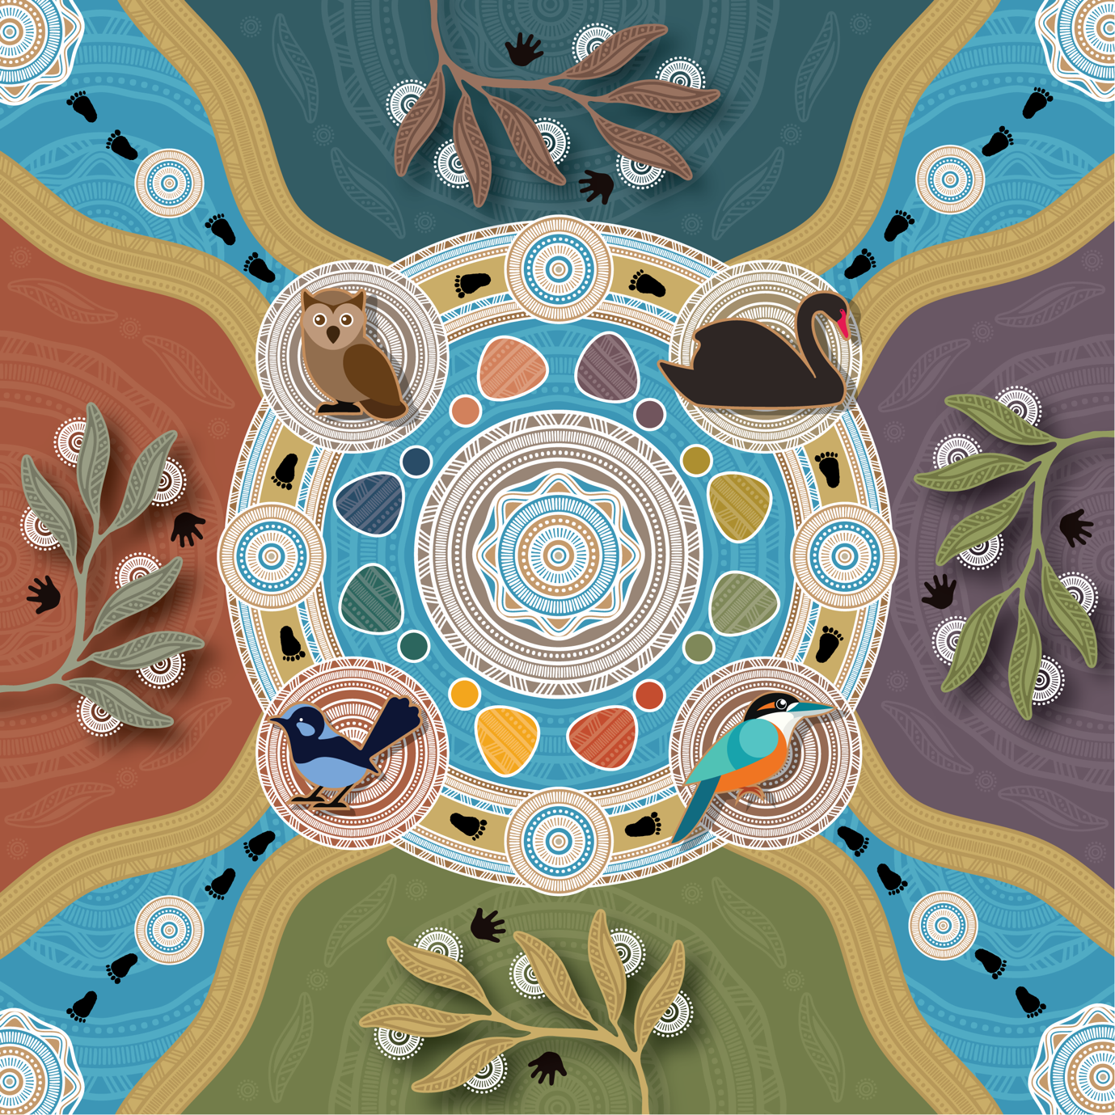
Understanding cultural safety
for Aboriginal children
and young people
A resource for implementing Child Safe Standard 1
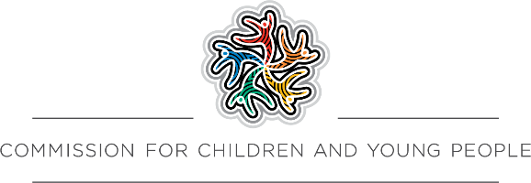
This work is copyright. Apart from any use as permitted under the Copyright Act 1968, no part may be reproduced by any process without prior written permission from the Commission for Children and Young People, Level 18, 570 Bourke Street, Melbourne Victoria 3000.
Also available at www.ccyp.vic.gov.au
ISBN 978-1-7635304-0-9

Commission for Children and Young People
Level 18, 570 Bourke Street
Melbourne VIC 3000
Phone (free call): 1300 78 29 78
Email: contact@ccyp.vic.gov.au
www.ccyp.vic.gov.au

Artwork by Dixon Patten
Layout and Design by Little Rocket
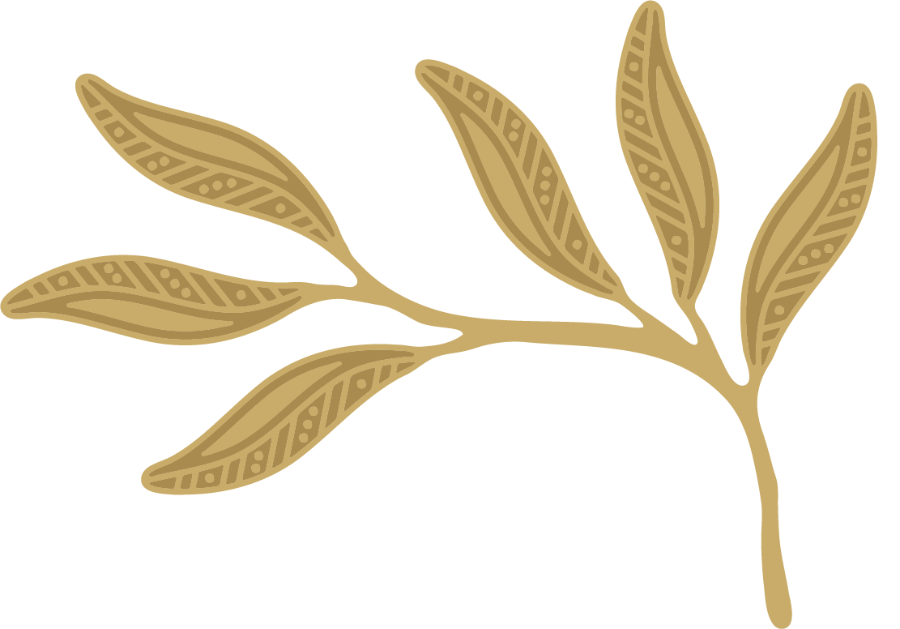
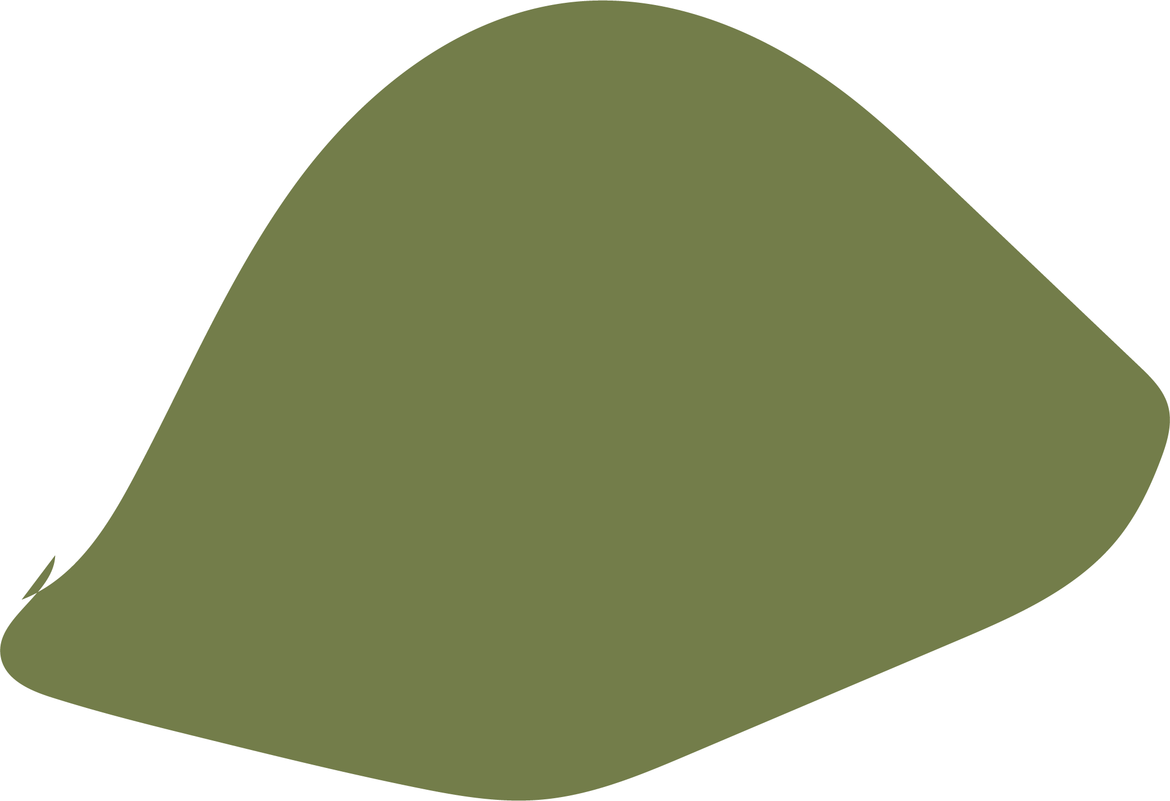

The Commission for Children and Young People (the Commission) acknowledges the Traditional Owners of Country throughout Victoria and recognises their continuing connection to lands, waters, sky and cultures.
We pay our respects to Elders, children and young people of past, current and future generations as the holders of the memories, the traditions, the culture and the spiritual wellbeing of the Aboriginal and Torres Strait Islander peoples across Victoria, and the nation. The Commission acknowledges the important role of Aboriginal people and culture within the Victorian community, and the Strength, Resilience and Endurance of the Stolen Generations Survivors.
We also acknowledge the people of all ages who shared their experiences with us and supported the Commission to develop this guidance. This could not have been achieved without the wisdom and generosity of the Commission’s Aboriginal Advisory Committee and many other Aboriginal people with whom we have consulted. The Commission extends its gratitude and thanks to all those
who were involved.
The Commission notes that some of the content of this guidance may be difficult for people with lived experience of racism, or who have experienced barriers to expressing their cultural rights or exclusion from an organisation due to their cultural identity. Some of the quotes included throughout this report may be distressing.
Aboriginal and Torres Strait Islander people should be aware that this document may contain quotes and names of deceased persons.
If you or someone you know needs support, help is available.
For support, contact 13YARN on 13 92 76 (at any time, 24/7) or go to 13yarn.org.au; visit Strong Brother Strong Sister at sbssfoundation.org/;
or call Lifeline on 13 11 14 (at any time, 24/7) or visit lifeline.org.au

About the artwork in this guide

bernak nindi thana bunga – Grow our camp (village)
Gunai/Kurnai Language

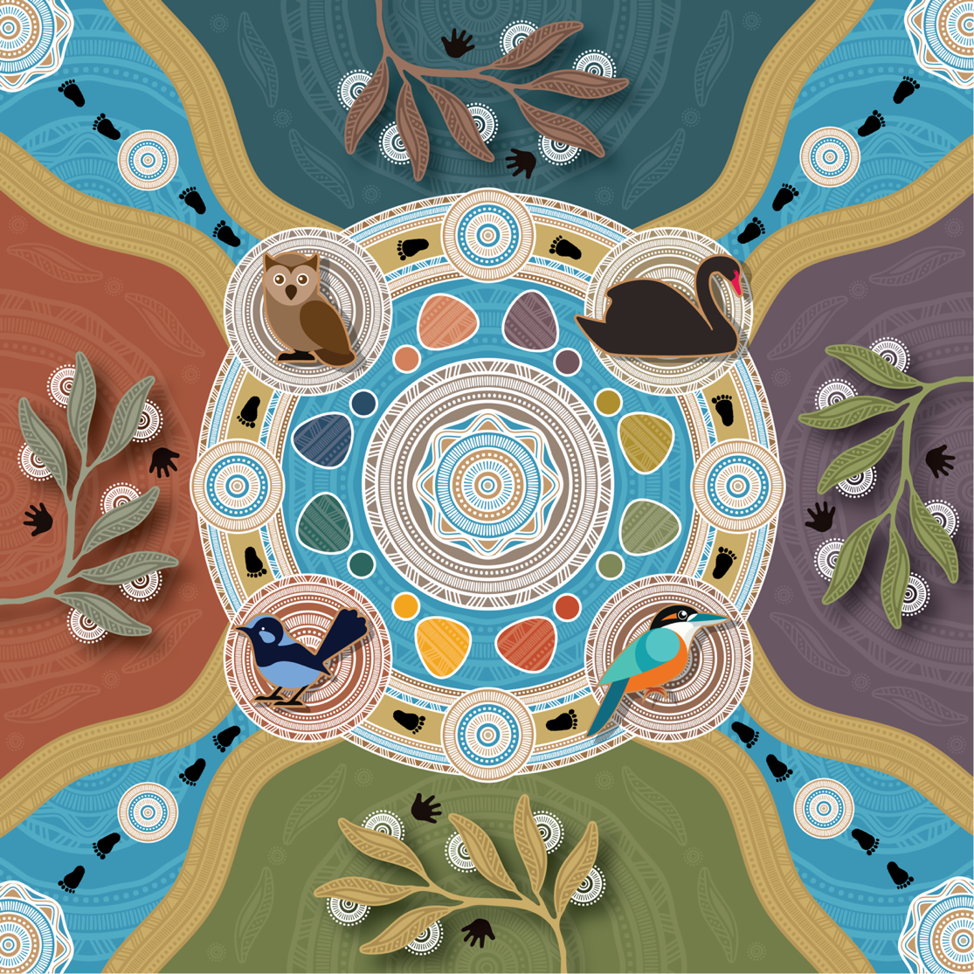
The central circle represents the Commission working collaboratively with our diverse community to support children, young people and their carers and families. The Commission also strives to support the system and its workers in helping them to understand the cultural needs and rights of people it aims to support and to ensure organisations are following the mandated Child Safe Standards.

The coloured healing stones represent children and young people, their assorted colours represent their diverse personalities, experiences and journeys.
The gum leaves represent being ‘Welcome’, and acknowledges the transformation that growth can initiate.
The feet and hands acknowledge the four pillars guiding the ongoing journey of the Child Safe Standards; influencing the Child Protection and adjacent systems.
The four birds were chosen that had characteristics that symbolise the four Child Safe Standard pillars:

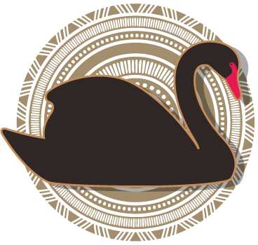
SELF REFLECTION: Black Swan
The swan spends much of its time in clear, still, calm water. It acknowledges the importance of being still, deep-listening and having a clear mind to receive information and being accountable to our processes, regulations, environments, our children and our community.

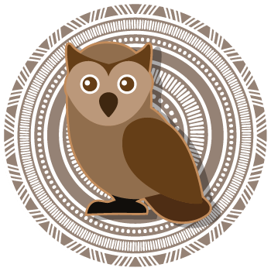
BUILDING KNOWLEDGE: Owl
The owl is often a symbol of wisdom, it honours knowledge being passed down for millennia from elders to younger generations, our cultural values centre around kinship and family systems, community and environment, they are all intertwined and inform and influence each other.

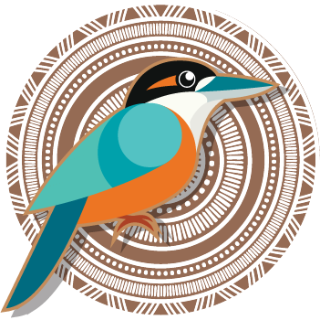
TAKING ACTION: Sacred Kingfisher
The kingfisher moves with the seasons, it will migrate north to Queensland even PNG and Indonesia to have their offspring then will head back south when the babies have grown; this represents movement and understanding the importance of planning, awareness and taking action.

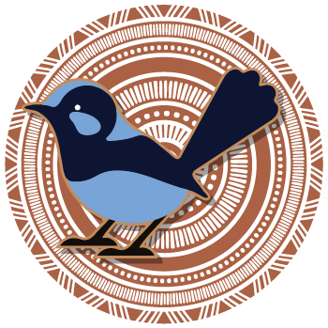
CONTINUOUS IMPROVEMENT AND MONITORING: Blue Wrens
Blue Wrens are the only birds to sit on their eggs until they hatch - they are one of nature’s most paternal animals and are very attentive to their young.

It truly does take a village to raise children / young people; their well-being, safety and rights should be priority. It is our shared responsibility to guide, nurture, comfort, educate and empower all people; this is the true definition of Community.
Bitja (Dixon Patten)

Commissioner’s foreword
Welcome to the Commission for Children and Young People’s (the Commission’s) guidance: Understanding cultural safety for Aboriginal children and young people: a resource for implementing Child Safe Standard 1.
Child Safe Standard 1 requires organisations to establish a culturally safe environment for Aboriginal children and young people so they can feel safe and supported to participate fully in the organisations they’re engaging with.
This includes welcoming their families and community and making sure everyone understands that racism is not tolerated.
Aboriginal people in Australia are the proud custodians of the oldest continuous living cultures in the world. Our stories, technology and wisdom have been passed down for thousands of generations, and deserve to be respected, celebrated, and protected.
Establishing a culturally safe organisation for Aboriginal children requires an ongoing commitment by everyone in the organisation to:
- reflect on their attitudes and practices
- challenge their biases and assumptions
- actively contribute to building an anti-racist and inclusive place for Aboriginal children.
This resource is to help you get started on your journey. To help you understand Aboriginal cultural safety and what actions may be needed, we have included links to resources, tools, and case studies to support building knowledge and taking action.
There are some 60,000 organisations in Victoria that need to comply with Child Safe Standard 1, and the other ten Child Safe Standards. This means your organisation’s journey could look very different to other organisations. I encourage you to make connections with other organisations in your sector and share your successes and challenges to support each other in this important work.
At its heart, cultural safety is about respect, understanding and inclusion. This means everyone can benefit from creating culturally safe environments. The best way to approach this work is with an open mind, and most importantly, an open heart.
I thank you for your ongoing work and commitment to keep Aboriginal children and young people, and all children and young people in Victoria, safe, supported, and free from harm and abuse.
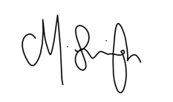
Meena Singh
Commissioner for Aboriginal Children and Young People

Contents
About the artwork in this guide 4
bernak nindi thana bunga – Grow our camp (village) Gunai/Kurnai Language 4
Commissioner’s foreword 6
About this resource 9
Who this guide is for 10
What is in this guide 10
What this guide is not 11
Terminology 11
Understanding Child Safe Standard 1 12
Cultural safety for Aboriginal children and young people 12
Asking about Aboriginal identity 14
Keeping Aboriginal children and young people safe 16
Respecting Aboriginal children and young people’s diverse and unique identities 17
Connection to culture 18
Connection to Country 19
Connection to family and kinship, connection to community 20
Aboriginal community in Victoria today 21
Respecting someone’s identity 22
The impact of colonisation on Aboriginal people 23
Understanding the impact of racism on Aboriginal children and young people 25
What next? 26
Tools to support the implementation of Child Safe Standard 1 27
Creating a culturally safe environment 27
Working to establish a culturally safe environment 29
Commitment to change 30
Informed and engaged leadership 30
Case study 1: Getting started 31
Step 1: Reflection 33
Reflection tool 1: Thinking about your own views, beliefs and understanding 35
Reflection tool 2: Organisational culture, practice and learning assessment 41
Step 2: Building knowledge 50
Case study 2: Building knowledge 52
Step 3: Taking action 55
Case study 3: Taking action 56
Taking action tool: Develop a learning and action plan 58
Step 4: Review and improvement 65
Review and improvement tool: Checking in on progress and planning next steps 66

About this resource

This is a guide to understanding the importance of cultural safety for Aboriginal children and young people and how to establish a culturally safe environment. This means welcoming Aboriginal children, young people and their families, supporting them to express their culture and to enjoy their rights, and not allowing racism.
Child Safe Standard 1 came into effect on 1 July 2022. It requires that:
Organisations establish a culturally safe environment in which the diverse and unique identities and experiences of Aboriginal children and young people are respected and valued.
Child Safe Standard 1 includes 5 minimum requirements:
  - A child’s ability to express their culture and enjoy their cultural rights is encouraged and actively supported.
  - Strategies are embedded within the organisation which equip all members to acknowledge and appreciate the strengths of Aboriginal culture and understand its importance to the wellbeing and safety of Aboriginal children and young people.
  - Measures are adopted by the organisation to ensure racism within the organisation is identified, confronted, and not tolerated. Any instances of racism are addressed with appropriate consequences.
  - The organisation actively supports and facilitates participation and inclusion within it by Aboriginal children, young people and their families.
  - All of the organisation’s policies, procedures, systems and processes together create a culturally safe and inclusive environment and meet the needs of Aboriginal children, young people and their families.
Implementing the Child Safe Standards will help your organisation create a culturally safe environment, which will contribute to children and young people feeling safer in general.
Standard 1 may feel quite different from the other Child Safe Standards for people who are not Aboriginal. When it comes to understanding Aboriginal culture and cultural safety, many non-Aboriginal people do not know where to start and worry about asking the wrong questions and causing offence. The best way to approach implementing this Standard is to think of it as a learning journey, where individual members and your organisation as a whole work to create a place that values cultural safety and understands its importance.

Who this guide is for
This guide has been written to help you implement cultural safety in your organisation. The guide will help people in organisations understand why cultural safety is important, not just for Aboriginal children and young people, but for all people.
While everyone in your organisation plays a role in creating a culturally safe environment, it is a good idea for people with key roles to read this document to support implementation and understand what is involved. These key people might include:
- the head of your organisation - whatever their title – who is ultimately responsible for ensuring compliance with the Child Safe Standards. They might be a CEO, club president, secretary, or your board members.
- anyone directly interacting with children and young people who is responsible for their safety and wellbeing.
- staff and volunteers directly involved in child safety and wellbeing. For example, your organisation might have a dedicated child safety officer.
- learning and development staff.
There may be other members of your organisation who only need to engage with some parts of the guide and the information in it.

What is in this guide
This guide has been developed to support organisations to comply with Child Safe Standard 1 and reflects an evidence-based approach to establishing a culturally safe environment for Aboriginal children and young people. It focuses on understanding what cultural safety means and why it is important to the safety and wellbeing of Aboriginal children and young people. This will help organisations, staff and volunteers to begin and continue their learning journey.
The guide then builds on these learnings and focuses on how organisations can create culturally safe environments for Aboriginal children and young people. This section contains practical tools, tips and resources that can support your organisation. There may also be other ways for your organisation to achieve this.
We recommend reading this guide alongside the Commission’s A guide for creating a Child Safe Organisation. There is a dedicated chapter on Child Safe Standard 1, including how the Standard was developed.

What this guide is not
This guide, while prepared with the oversight and guidance of Aboriginal community organisations and people, nonetheless comes from a non-Aboriginal organisation. There is no way a single resource can capture everything there is to know about Aboriginal history and culture. It is not the place of a non-Aboriginal organisation, such as the Commission, to try to produce such a resource.
Rather, this guide provides advice about how your organisation can work to gain knowledge that will support your organisation’s practice in creating culturally safe environments. This includes learning resources that will help staff and volunteers in your organisation to learn about the experiences, ongoing struggles and triumphs of Aboriginal people. You’ll find these resources throughout this guide.
We usually think of learning as gathering new knowledge. Sometimes we might need to also challenge and let go of things we learnt in the past that may not actually be true or be the full story. This is a process called unlearning. In working through the steps suggested in this guide, those in your organisation’s community may find themselves unlearning previous knowledge and assumptions about Aboriginal people, as well as learning new things.
The Commission does not expect your organisation to learn everything there is to know about Aboriginal culture. That would be impossible. But in implementing the minimum requirements of the Child Safe Standards, your organisation will learn a lot about Aboriginal culture in Victoria and where your organisation is based. This will encourage people in your organisation to continue learning, not only for their work with Aboriginal children and young people, but for their own benefit too.
Remember: This guide is not the ‘be all and end all’ for your organisation’s work. It is a starting point. This guide encourages you to seek out knowledge from Aboriginal people and community through a range of sources.

Terminology
In Child Safe Standard 1 and throughout this guide, the Commission uses the word ‘Aboriginal’. This is to be consistent with the use of ‘Aboriginal’ in Child Safe Standard 1 and the minimum requirements. However, the information in this, and other resources for Child Safe Standard 1, will apply to creating culturally safe spaces for anyone who identifies as Aboriginal, Torres Strait Islander, Indigenous, First Nations, First Peoples or any other Indigenous language group or Country in Victoria. We encourage you to also look at the Frequently asked questions with Meena Singh, Commissioner for Aboriginal Children and Young People, for more information on words used to talk about Aboriginal people.
We use the term children and young people to include anyone under the age of 18 years.
This resource should be read alongside A guide for creating a Child Safe Organisation which has specific guidance about the 11 Child Safe Standards. This and other resources from the Commission are available on our website.

Understanding Child Safe Standard 1

Cultural safety for Aboriginal children and young people
Child Safe Standard 1 legally requires that:
Organisations establish a culturally safe environment in which the diverse and unique identities and experiences of Aboriginal children and young people are respected and valued.
Great! But what is a ‘culturally safe environment’?
In fact, what is ‘cultural safety’?
The Child Safe Standards are all about keeping children and young people safe. Let’s start with ‘safety’.
The feeling of safety is something that everyone can relate to.
Physical safety, emotional safety and psychological safety are important to everyone, regardless of age. We have all been in situations or environments where we have felt unsafe or uncertain of ourselves. We might not have known how to behave or what to say. We might have looked, dressed or sounded different from everyone else around us.
Next, ‘culture’.
Everyone has culture.
We talk about culture specific to cities, regions and countries. We talk about groups of people with shared identity having their own culture. We talk about culture within communities and organisations, and we can also experience culture in our groups of friends or with our family members.
Culture is all around us and expressed in many ways. If you are raised and living in a place where your identity fits in with the dominant culture, you might not necessarily recognise your culture because it is all around you. Similarly, you often won’t ‘see’ culture until it is different from your own practices, and what you are used to.

Cultural safety is feeling safe in a particular way that relates to someone’s individual culture. It involves a person’s culture being understood and respected.
The Commission for Children and Young People developed a definition of cultural safety specific to the context of abuse prevention in organisations. In consultation with Aboriginal children and young people, and with the Commission’s Aboriginal Advisory Committee, we developed the following descriptor of cultural safety.
Cultural safety for an Aboriginal child means they experience a safe, nurturing, and positive environment, where their unique identity is respected without attack, challenge or denial. In this environment, their voice is heard and valued, and they are free to explore and express themselves, their culture, views and needs.
Based on this definition, organisations are legally obliged to create an environment that is safe, nurturing and positive, where Aboriginal children and young people can bring their whole self, and their unique identity is respected. Remember that ‘environments’ can be physical environments (where children and young people play, learn, pursue hobbies, sports and other recreational activities) and virtual and online environments (through social media, chat rooms and visiting websites).

Asking about Aboriginal identity
Many organisations, such as health services, hospitals and schools, must ask about the Indigenous identity of people accessing their services. If this is your type of organisation, find out what guidance your organisation has about going about this respectfully.
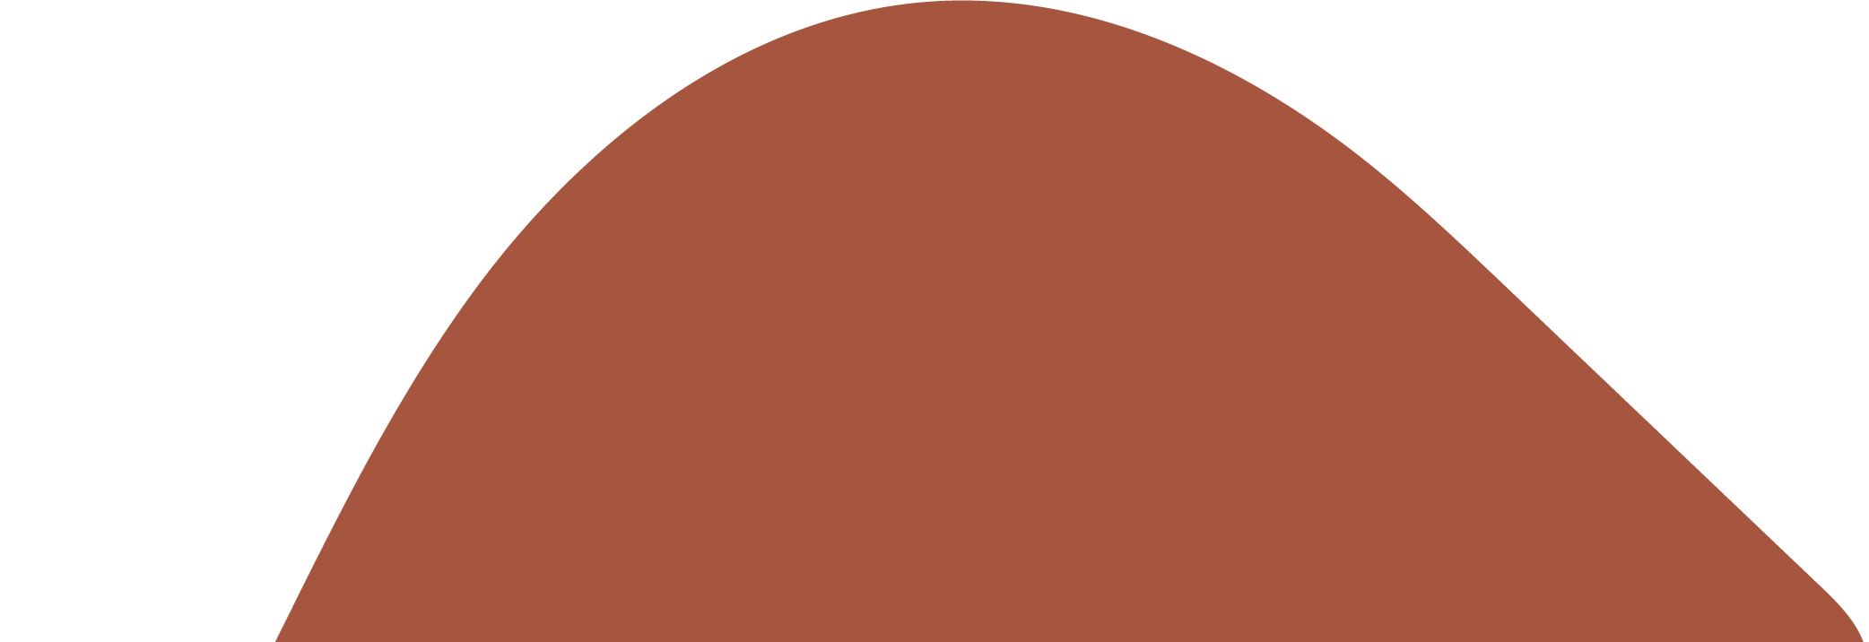
If you are new to asking about Aboriginal identity, and want to ask so you can better connect with, support and encourage engagement with Aboriginal children and young people and their families, here are some tips:
Identity is personal. There are many parts of a person’s identity that they might not be comfortable sharing with others. It is their choice to tell others or not to.
Some Aboriginal people will proudly tell you their identity or display it in ways that make it clear that they are Aboriginal. Others will not, and there are many reasons for this, including:
- They don’t know how other people will treat them.
- They don’t want to experience discrimination, stereotypes or prejudices such as ‘you don’t look Aboriginal’.
- They don’t want to be asked lots of questions.
- They want to know that a place is safe for them before sharing that part of themselves.
- Leave all assumptions about Aboriginal identity that are based on skin colour or personal traits and attributes behind. They are not useful to the work of cultural safety.
- Let someone know why you want to know, and how that information will be used. This goes for any personal information you are gathering about someone. Think about it from your own perspective – if someone asked you a personal question, you would want to know why, who has access to that information, and how it will be used. Never share any personal information about someone else without their clear permission and consent.
- Use questions such as ‘Do you identify as Aboriginal or Torres Strait Islander?’ or ‘Are you Aboriginal or Torres Strait Islander?’. Asking a question such as, ‘You’re not Aboriginal, are you?’ not only reveals an assumption, but depending on how you say this, you could be seen as positioning Aboriginal identity as a negative.
- Seek information about Aboriginal identity using standardised club or organisation forms that are completed by everyone.
- Start a conversation by asking, ‘Is there anything you’d like me to know about you and your family that would help you feel more welcome, or make sure you get what you need from us?’ Create an environment where people know they can always raise their concerns or needs with you.
- Display signs that let people know all identities are welcome in your organisation and encourage people to share any needs they have based on identity (this could include, for example, gender identities and disabilities).
- Don’t assume a child or young person’s identity based on a parent’s or another family member’s identity. Some Aboriginal children and young people will have a non-Aboriginal parent and family members.
Also remember that identifying as Aboriginal is completely voluntary. If someone says, ‘I’d prefer not to say’ or ‘I don’t want to answer that’, for whatever reason, you should not push for an answer.


Keeping Aboriginal children and young people safe
Promoting the cultural safety of Aboriginal children and young people has been an important part of the Child Safe Standards since they were introduced in 2016.
In 2019, the Royal Commission into Institutional Reponses to Child Sexual Abuse delivered its final report. The Royal Commission found that Aboriginal children and young people are at more risk of abuse in organisations and are significantly over-represented in high-risk environments such as out-of-home care and youth detention.
The Royal Commission also identified a range of unique challenges that Aboriginal children and young people face, which places them at a higher risk of harm and abuse in organisations. These include:
- trauma that has been passed down over generations
- being removed from families
- feelings of shame
- feeling afraid to raise a safety concern because it could affect their family and community
- ongoing systemic racism.
Research from the Royal Commission concluded that strong cultural identity and positive community connections act as protective factors for Aboriginal children and young people, helping them to be more confident and know what to do if they experience abuse or have safety concerns.
Establishing culturally safe spaces for Aboriginal children and young people means they feel safe in your organisation’s environment. By showing Aboriginal children and young people that their identity is respected - that they can share their experiences with dignity, and will be heard - they are more likely speak up and to trust members of your organisation with their story if they experience problems.
Culture is not a ‘perk’ for an Aboriginal child – it is a lifeline.

Respecting Aboriginal children and young people’s diverse and unique identities
Identity means different things to different people – there may be common aspects, but identity is personal. Everyone is unique, so our identity is unique to each of us.
Child Safe Standard 1 asks organisations to establish culturally safe environments in which the diverse and unique identities and experiences of Aboriginal children and young people are respected and valued.
To do this, we need to understand the importance of factors such as culture, Country, community and family ties to Aboriginal children and young people, and how they connect with one another to create and support each Aboriginal child and young person’s individual identity.
Figure 1 shows a model of social and emotional wellbeing for Aboriginal people. It helps us understand the connectedness of many different aspects of creating wellbeing for an individual Aboriginal person.

Figure 1: Model of social and emotional wellbeing for Aboriginal people
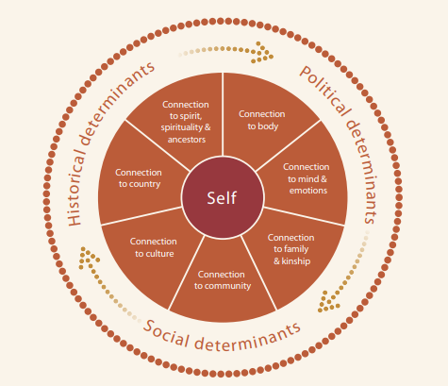
Source: Gee G, Dudgeon P, Schultz C, Hart A, Kelley K. (2014). Understanding Social and Emotional Wellbeing and Mental Health from an Aboriginal and Torres Strait Islander perspective. Chapter 3 in Dudgeon P, Milroy H, Walker R. (Eds). Working Together: Aboriginal and Torres Strait Islander Health and Wellbeing Principles and Practice (2nd Edition). Australian Council for Education Research and Telethon Institute for Child Health Research, Office for Aboriginal and Torres Strait Islander Health, Department of Health and Ageing: Canberra.
The Aboriginal person, ‘self’, is in the middle. Around them are the different but interconnected factors and influences that create someone’s understanding of their self – their own identity. On the outside, there are broader influences of historical, political and social determinants that can shape lives for whole communities.
Included are connections to Country, culture, community, kinship and family, as well as physical, mental and spiritual connections to someone’s own mind, body and ancestors. These are ‘protective factors’ that can help keep them safe, healthy, strong and resilient.
The following is a brief introduction to some of these protective factors. You’re encouraged to do more research to get a deeper understanding.

Connection to culture
Culture frames the identity of our people. Our Culture ties us to each other, to Country and to our Ancestors – it explains the world to us and helps us to understand our role in life. Knowing Culture helps us to know ourselves.
Culture has kept Aboriginal people strong for tens of thousands of years. There is no single Aboriginal culture, but there are many features that all Aboriginal people recognise, such as respect for Elders, strong bonds with relatives who might be called ‘extended family’ (aunties, uncles, cousins) and the importance of caring for land and Country.
Below is a quote from Uncle Andrew Jackomos, Yorta Yorta and Gunditjmara Elder and inaugural Commissioner for Aboriginal Children and Young People.
Culture is about family networks, Elders and ancestors. It’s about relationships, languages, dance, ceremony and heritage. Culture is about spiritual connection to our lands and waters. It is about the way we pass on stories and knowledge to our babies and children; it is how we greet each other and look for connection. It is about all the parts that bind us together.
Aboriginal people have their own understanding of their identity that will usually include the importance of Country, family and culture.
To hear about the importance of connection to culture for Aboriginal people and what happens when that culture is taken away, watch the video of Meena Singh, Commissioner for Aboriginal Children and Young people speaking at the Yoorrook Justice Commission.
Watch the video on the Yoorrook Justice Commission website.

Connection to Country
You may have noticed the use of a capital ‘C’ for Country. Professor Mick Dodson’s description of Country explains his perspective of Country for Aboriginal people:
‘When we talk about traditional ‘Country’ … we mean something beyond the dictionary definition of the word. … we might mean homeland, or tribal or clan area and we might mean more than just a place on the map. For us, Country is a word for all the values, places, resources, stories and cultural obligations associated with that area and its features. It describes the entirety of our ancestral domains. While they may all no longer necessarily be the title-holders to land, Aboriginal and Torres Strait Islander Australians are still connected to the Country of their ancestors and most consider themselves the custodians or caretakers of their land.’
As you can see, Country is a key source of culture, and connection to Country will mean different things for different people. Sadly, colonisation has meant some Aboriginal people have not grown up knowing, or being connected to, their Country.
Have you ever seen a map of Aboriginal Australia? AIATSIS provides a map that shows just how many Countries and languages there are across Australia. Also have a look at the Victorian Aboriginal Languages Map from the Victorian Aboriginal Corporation for Languages. Both of these maps will give you an understanding of the diversity of this continent.
- See the AIATSIS map of Indigenous Australia
- See the languages map from the Victorian Aboriginal Corporation for Languages.
Country is also important for how an Aboriginal person might identify themselves. Have a look at the Frequently asked questions with Meena Singh, Commissioner for Aboriginal Children and Young People for more on this.

Connection to family and kinship, connection to community
In Aboriginal and Torres Strait Islander cultures, children and family are everything. When it comes to keeping Aboriginal children and young people safe, everyone has a role – as individuals and families but also in organisations.
Connection to family and kinship, and to community, are foundational for all people, and Aboriginal people are no different. Reconciliation Australia’s video clip is helpful as a starting point to understand family and kinship from an Aboriginal perspective.
Understanding differences between Aboriginal families and kinship arrangements, and non-Aboriginal familial ties, is important to supporting Aboriginal children and young people to feel safe. Not making assumptions about who is or isn’t ‘family’ is one way to support all children and young people (not only Aboriginal children and young people), to feel welcome and included in your organisation’s physical and online environments.
Time spent with community is also vitally important for Aboriginal children and young people. The opportunity to spend time with peers, see Elders who are role models, connect with culture (often on Country), means positive reinforcement of identity. For Aboriginal children and young people who might be the only Aboriginal person at their school, sporting or recreational club, these connections allow Aboriginal children and young people to be ‘one of many’, rather than being the only ‘one’ in other spaces.
Events such as cultural days through Aboriginal co-operatives and community organisations, sporting carnivals and other events bring community members together. Similarly, events around NAIDOC Week also represent opportunities to come together and celebrate resilience and pride.

Aboriginal community in Victoria today
In Victoria, Aboriginal people make up 1% of the population, some 65,646 people as at 2022. The Aboriginal community in Victoria includes people whose Country is in Victoria, and others who have moved here. Some people from other Countries around Australia are here because of historical forced removal of people off their Country and into Victoria, and the forced removal of children from their families placing them with Aboriginal and non-Aboriginal families in Victoria.
Today, the Aboriginal community in Victoria is a young community. The median age is 24 years old, compared with 38 for the overall Victorian population. This means that work done to create culturally safe spaces for Aboriginal children and young people is vitally important for them to feel safe now, and to thrive in the future.
‘Aboriginal children and young people are holding onto culture and its gifts, but also have a responsibility to keep culture alive. Culture is constantly evolving because of the young ones. They’re shaping culture today. If we shut them down, we are shutting down and are at risk of losing one of the oldest cultures in the world.’ – Djirra

We don't have any Aboriginal children or young people in our organisation, do we still have to do this work?
Yes.
Under Victorian law, all organisations that are subject to the Child Safe Standards must meet the requirements of each of the 11 Standards.
But let’s dig a little deeper. How do you know you do not have any Aboriginal children or young people in your organisation? There may be Aboriginal children and young people and their families who have chosen not to tell you about their Aboriginal identity. Remember, a person does not have to disclose if they are Aboriginal. Part of cultural safety is creating an environment where people feel safe to not only disclose their Aboriginal identity but also to express their culture. What is your organisation doing to support and enable people to identify as Aboriginal?
Also remember that at the heart of this work is respect and inclusion. These help ensure every child or young person in your organisation feels safe and valued.
Showing respect for and valuing an Aboriginal child or young person’s individual identity, just like showing respect for anyone’s identity, can be done in many ways. Having read this section, how might you go about doing this in your organisation?

Respecting someone’s identity
It is important to remember that questioning a person’s identity is offensive, for anyone.
Be aware that your understanding of someone being Aboriginal may be influenced by stereotypes of what Aboriginal people look and act like. Many Aboriginal people have mixed ancestry, but this does not make them less Aboriginal.
This is especially important for Aboriginal children and young people, who, like any child or young person, are finding out who they are as they grow and interact with others. To have an adult ask questions that challenge their understanding of who they are can be upsetting and can make a child feel they are not welcome for who they are, and not safe. This can lead to children and young people not wanting to take part in activities or get services they need.
There are respectful ways to go about asking about someone’s Aboriginal identity. Have a look at the Frequently asked questions with Meena Singh, Commissioner for Aboriginal Children and Young People to find out more.

The impact of colonisation on Aboriginal people
There has been significant research about the impact of colonisation on Aboriginal people, and how colonisation has created the issues of disadvantage that many Aboriginal people face today.
Since invasion, and through colonisation, there have been many racist narratives about Aboriginal people and culture. These have been used to justify laws and policies to discriminate against Aboriginal people. Racist ideas still permeate Australian culture, and many Aboriginal people experience racism, in its many different forms, every day. Working towards cultural safety must involve identifying and dismantling any attitudes that will have a negative impact on Aboriginal children and young people and their families.
‘The idea that ‘Australia’ was settled suggests that colonisation was a smooth, peaceful process – the complete opposite of what actually occurred. ‘Australia’ had a permanent civilization living on its land. When the British came and decided to stay they tried to eliminate our people and steal our land – it is for this reason we were invaded and not settled.’ – Deadly Story
It is important to listen to Aboriginal voices retelling the history of Australia that has largely left them out or has only portrayed them in a negative way (refer to Figure 2 on the next page). To ensure a safe and inclusive environment for Aboriginal children, young people and their families, it is essential to identify, challenge and eliminate any negative attitudes that may harm them.

Figure 2: A brief history of Aboriginal culture and the impact of invasion
Aboriginal culture has kept Aboriginal people strong for over 60,000 years. Culture is drawn from the Country, it is shown in language, kinship ties, dance and ceremony. | British Empire invasion interrupts Aboriginal cultural practices through a range of colonising tools, including disease, massacre, removal of people from Country, removal of children and young people from their families, denial of cultural practices, all justified by racist narratives. | Despite this interruption, and attempts at destruction, Aboriginal culture remains intact, although changed. Some knowledge has been lost forever. The protective factors of culture, of Country, have been eroded. | Aboriginal people experience disproportionately negative outcomes in a range of areas because of negative discrimination and a lack of understanding of their culture and history by broader Australian society. | Cultural safety puts respect for Aboriginal culture and Aboriginal cultural practice back into non-Aboriginal spaces, to ensure Aboriginal children and young people are safe. It is about respect, inclusion and understanding that will benefit all children and young people.

To understand Australian history from the experiences and narratives of Aboriginal people, we encourage you to start with the following resources:
- First Australians - The SBS television series and resource books detail the experience of invasion and colonisation from First Australian perspectives. This series was produced by Rachel Perkins, daughter of Aboriginal activist Charles Perkins.
- The Australian Wars - This SBS television series details the ‘Frontier Wars’ fought between Aboriginal people and the British Empire to take control of Aboriginal land. Each episode focuses on a different area of the continent of Australia. This series was also produced by Rachel Perkins.
- Welcome to Country - This beautiful book by Marcia Langton is part travel, part history, part culture, and there is also an edition for younger audiences.
- Aboriginal Victorians - A history since 1880. This book was written by Richard Broome, a non-Aboriginal historian, focusing on the life of Victorian Aboriginal people in the colony and then state of Victoria.
Find more resources on the Commission’s website.

Understanding the impact of racism on Aboriginal children and young people
Aboriginal people face racism in many aspects of their lives. It can be easy to spot, like refusing to hire a person based on their appearance, but it is much more likely to be subtle.
Aboriginal people can experience this kind of ‘casual’ racism almost every day. Something as seemingly harmless as being followed around in a supermarket, or overhearing jokes about Aboriginal people, can have an impact that lasts far longer than the act of racism itself.
An organisation's response to racism must be swift. The response should be supportive of the people impacted by racism and it should be clear that racism will not be tolerated. Talking to staff, volunteers and young people about racism can be difficult. It is challenging to acknowledge the biases and harmful behaviour of those closest to us in our work and our personal lives.
But the challenging nature of this discussion does not outweigh the harmful effect on Aboriginal children if these conversations do not take place.
Aboriginal children are often faced with racism in places they visit, such as schools and sporting clubs. Even seeing or hearing stories about racism can have a profound impact on their emotional and physical health and wellbeing.
Experiencing racism can lead to poor mental health, self-harm and even suicide. It can also affect a person’s physical health. Racism can prevent access to much-needed services and reduce someone’s participation in the community.
Meena Singh, the Commissioner for Aboriginal Children and Young People, regularly meets with Aboriginal children and young people to listen to the things that are important to them, about their hopes and about their challenges. Sadly, they tell her about the racism they experience in a range of environments including from peers and teachers in schools. Sometimes, what is most frustrating is the lack of appropriate responses to Aboriginal children and young people when they experience such things.
In November 2023, the Commission for Children and Young People tabled Let us learn: Systemic inquiry into the educational experiences of children and young people in out-of-home care in the Victorian Parliament. The following is a quote from one of the Aboriginal young people we spoke to. It shows the pain of experiencing racism in places where you should feel safe.
‘There’s a race war here. It’s pretty bad. Basically, the people at the school don’t like Aboriginal people. My teacher is racist, she says the n word, says racial slurs like Abo. This school is one of those places where you encounter racism, but you don’t get any response.’
A good place to start is by acknowledging that racism exists, both in an organisation and more broadly in Australian society. It is important not to place the responsibility of responding to racism on the person who has experienced it or expecting Aboriginal staff in your organisation to address the behaviour.
Racism within an organisation should be challenged by all staff, but particularly those in senior roles. This is the only way to ensure real change can happen within an organisation.

What next?
The aim of this guide is to give individuals and organisations an introduction to cultural safety for Aboriginal children and young people. This includes an understanding of key concepts and terms to help build knowledge, confidence and hopefully excitement about implementing Child Safe Standard 1.
The next step is to look at the tools and case studies provided in the rest of this guide alongside other resources from the Commission and other organisations. These will help you continue your individual and organisational journey to establish a culturally safe environment for Aboriginal children and young people. In doing so, you’ll contribute to keeping all children and young people safe and free from abuse.
Remember, the best way to approach this work is to see the benefits not only for Aboriginal children and young people but for all children and young people, and your organisation as well. The lessons you take from it will make a difference in your work, and to your understanding of the Aboriginal and broader Australian community.
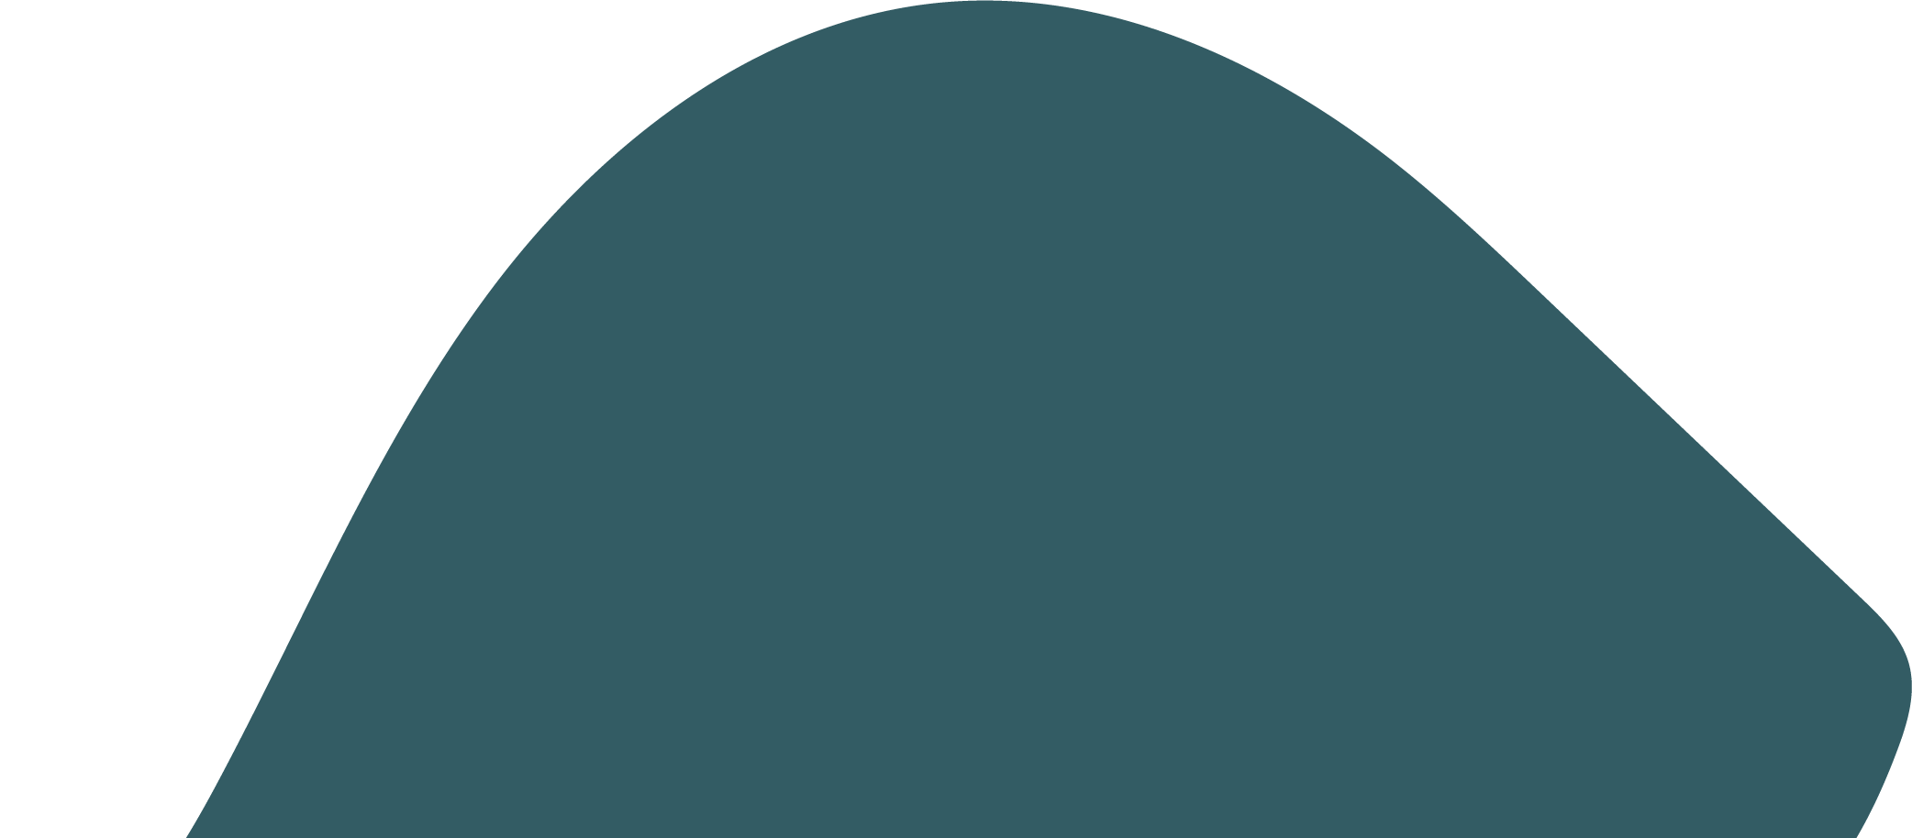

Tools to support the implementation of Child Safe Standard 1

Creating a culturally safe environment
Creating a culturally safe environment requires your organisation’s leaders, staff and volunteers to show a genuine commitment to making the changes necessary to comply with Child Safe Standard 1. This commitment needs to be the starting point and must be maintained as your organisation continues this journey.
An important part of cultural safety is how you engage with Aboriginal children, young people and their families. But another equally important part is how you talk about Aboriginal people when they are not around.
It is important that everyone engaging in this work uses language that is respectful. The Australian Human Rights Commission has published a valuable guide Let’s talk race: A guide on how to conduct conversations about racism that supports leaders to have challenging conversations about racism.
All members of your organisation, from staff and volunteers to leaders, should be modelling positive behaviours for each other and for children and young people. Communications, attitudes or behaviours that display any sort of racist views should be addressed immediately.
Organisations will be at different starting points with their work, and some may encounter roadblocks along the way. These are expected as part of the ongoing process to comply with Child Safe Standard 1. What is important is that your organisation remains committed to learning and growing.
‘Cultural safety is a journey. It will take time so come into it with an open mind and willingness to learn in a range of ways. Mistakes might be made and that’s ok so long as they were done with good intentions. – Neville Atkinson, Victorian Aboriginal Education Association Inc.’
It’s important to remember that this section does not contain all actions your organisation needs to take to create cultural safety for Aboriginal children and young people.

Different types of organisations have different levels of contact and responsibility for children and young people. Some organisations are large and have extensive resources, while others are small and less resourced. There is no ‘one size fits all’ approach to creating cultural safety. Organisations should consider the kinds of actions that are appropriate and relevant to their responsibilities. Action plans do not have to be extensive. They should be practical and achievable for your organisation.
As part of this work, it may be helpful to identify cultural safety champions in your organisation. Cultural safety champions are people who genuinely want to support cultural safety for Aboriginal children and young people. They are likely to be people who already model inclusive practice and are willing to learn and grow their knowledge and skills and can influence others to do the same. Cultural safety champions are leaders but are not necessarily in leadership roles. Your organisation’s cultural safety champions will be important as you work towards becoming more culturally safe.
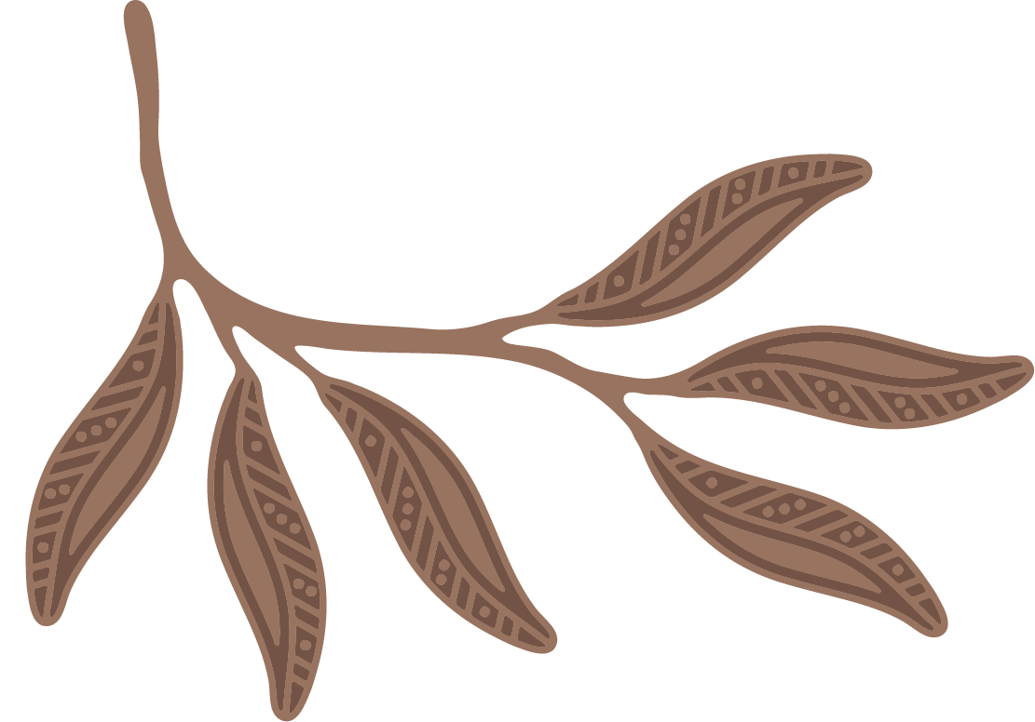

Working to establish a culturally safe environment
This process has four steps, each with different tools, to help your organisation take stock of what you already have in place and what further actions may be needed. Some organisations may start at different points, depending on the work you have already done.
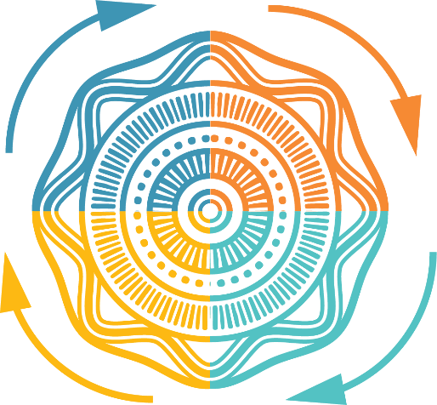
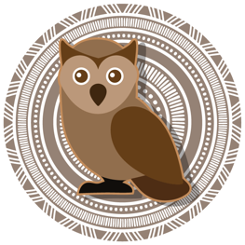
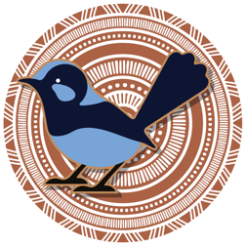
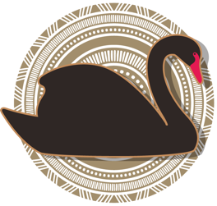
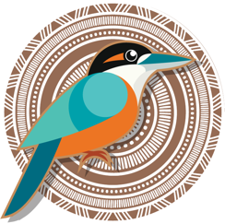
Commitment to change
Informed and engaged leadership
STEP 4: Review and improvement
Continuously reviewing the organisation’s approach to
cultural safety to ensure
ongoing improvements
Review and improvement tool: Checking in on progress and planning next steps
STEP 1: Reflection
Reflecting on individual and organisational beliefs, practices, attitudes, biases and privileges, and willingness to change
Reflection tool 1: Thinking about your own views, beliefs and understanding
Reflection tool 2: Organisational culture and practice assessment
STEP 3: Taking action
Developing a plan of what your organisation will do to support the cultural safety and wellbeing of Aboriginal children and young people
Taking action case study: Responding to racism
Taking action tool: Develop a learning and action plan

STEP 2: Building knowledge
Building knowledge to better support the cultural safety of Aboriginal children and young people
Building knowledge case study: Get the conversation started
Develop a learning and action plan

Commitment to change
Organisations must have a genuine commitment to change when working towards a culturally safe environment and complying with Child Safe Standard 1. Real change in an organisation comes from a culture of learning and improvement. Leaders, staff and volunteers must all show a genuine commitment to building a culture of child safety.

Informed and engaged leadership
Creating a culturally safe environment in an organisation needs the support and engagement of leadership. Leaders must model awareness about the importance of cultural safety and show they are genuinely committed to change how the organisation operates to create this essential element of child safety.
When leaders model best practice, organisations are better positioned to make meaningful change to create a culturally safe environment for Aboriginal children and young people.

Case study 1: Getting started

How an organisation started working with Child Safe Standard 1
Bend and Stretch Calisthenics Club has around 40 children, young people and adults attending classes. Many of the performers also compete at the state and national levels. There are two adult coaches at Bend and Stretch, Sam and Mei, and several junior coaches aged 14 to 18 years. Mei is also the club’s director. The club is managed by a committee of parent-carer volunteers.
At a recent committee meeting, the president, Samir, spoke about the need to update the club’s policies and processes, particularly around diversity. Samir has asked Reggie, one of the committee members, to look at what the club needs to do to comply with Child Safe Standard 1.
Reggie’s first step is to read through this guide. She makes sure she is clear about the minimum requirements for Child Safe Standard 1, which is what they are working towards, and the compliance indicators the Commission will look for – both of these are in A guide for creating a Child Safe Organisation.
She realises she will need help from other people at the club because she also works full time. Reggie sends an email to the performers’ parents and carers asking for volunteers to form a small working group.
Reggie sets up a small working group with Mei, two parent-carers, and one of the junior coaches. Reggie is keen to ensure the voice of young people is included in the working group.
The working group meet and individually complete the self-reflection tool, and then have a discussion and share their experiences with each other. They realise that, as a group, they don’t know a lot about Aboriginal history and culture or what it means to create cultural safety, and they don’t even know if there are any Aboriginal children or young people in the club. The group decides their next steps. Reggie will email the committee members and Mei will speak with the coaches and ask them to also complete the self-reflection tool before the next committee meeting. Reggie also requests that cultural safety be put on the agenda for the rest of the year.
At the next committee meeting, members and the adult coaches share what they learnt and their gaps in knowledge. They then work through the organisational culture and practice assessment. Reggie takes notes on what the club is doing well and what improvements are needed. The committee also discuss what budget they have available.
Over the next few weeks, Reggie uses the information from the self-assessments and organisational assessment to draft the club’s learning and action plan. At the next working group meeting Reggie shares the plan and the budget. The group makes a few changes and finalises the learning and action plan.
The working group decide that, because their budget is limited, they are going to focus on sharing some of the resources in this guide with the club’s community and purchase Aboriginal and Torres Strait Islander flags to display during classes.
Over the next few months, the club changes its email signature to include an Acknowledgement of Country and a statement that the club does not tolerate racism. They change the enrolment form to include an option for new performers to share whether they are Aboriginal. Mei encourages one of the junior coaches to give an Acknowledgement of Country at the start of all competitions hosted at their club.
At the end of the year, Reggie and the working group meet for the last time. Some of the members are continuing in the group next year, while others are leaving to focus on other things. The group spends time completing the review and improvement tool. They still want to do more, so they list the actions they will recommend the new board focus on. They also know the club has made some significant achievements over the past 12 months and share these with the club community through their newsletter.


Step 1: Reflection
It is important to begin by reflecting on what knowledge you already have, recognising that knowledge sits in the context of our individual identity, biases and experiences. Self-reflection is a vital part of undertaking the work to create a culturally safe environment for Aboriginal children and young people.

Unpacking your own bias
Bias can be a favourable attitude, where we form positive impressions based on someone’s skin colour, surname or ancestry. Or it can be unfavourable, with negative impressions.
Bias can lead to unfair outcomes for some people. Bias does not necessarily amount to racism. However, it can when coupled with the power to discriminate against or limit the rights of others.
Bias is sometimes called implicit or unconscious bias because it can be hard to detect, even in ourselves.
Everyone has biases.
Some biases you may be aware of and display (such as vocalising your dislike of a particular sporting team). Other biases are unconscious, and you may not necessarily be aware of them (such as automatically trusting or distrusting people of certain backgrounds). These biases have developed over time and are influenced by your identity, environment and experiences. Biases might not just be about people and their identity or traits. They could also be about behaviours or attitudes other people show or have that make you think negatively of them.
There are a lot of negative stereotypes about Aboriginal people that are not true. Unfortunately sometimes people still believe these stereotypes. These sorts of attitudes have no place in the work you are doing for Child Safe Standard 1 to create a culturally safe environment.

The first step is asking the leaders, staff and volunteers in your organisation to think about what they already know and their attitudes about:
- Australia’s history and how Aboriginal people have been treated
- Aboriginal people and their diverse and multiple cultures
- the strengths of Aboriginal culture
- cultural rights
- racism
- engaging with Aboriginal children and young people and their families and communities.
This is an essential first step because it helps those in your organisation become aware of their biases so they can then understand and challenge them, and identify gaps in their knowledge.
Each person within your organisation’s community has had their own life experiences. They will have different levels of understanding about Australia’s history and how Aboriginal people have been treated, Aboriginal people and their cultures and how being connected to culture supports the safety and wellbeing of Aboriginal children and young people.
Thinking about your own behaviours, attitudes and beliefs, and those of other people in your organisation, helps you identify what learning and action will help make your organisation safe for Aboriginal children and young people.
Reflecting on and talking about what cultural safety means for you and your organisation may feel confronting and challenging. It requires everyone to consider their own biases and attitudes, and to sometimes have difficult conversations. These conversations can be difficult because they ask us all to look honestly at our own beliefs and question them in a way that we may not have done before. Speaking with a trusted colleague or friend or seeking support can help.
As an organisation, it is important that your leaders create a safe space for staff and volunteers to reflect on and discuss their knowledge of and attitudes towards Aboriginal people, their cultures and history, including the impact of colonisation.
Remember: We all have opportunities to positively influence the people around us, and this includes children and young people. Try to think of yourself as an agent of positive change, regardless of your role, in creating a culturally safe environment for Aboriginal children and young people and inclusion for all children and young people.

The purpose of the following two tools is to help your organisation reflect on whether the people in your organisation are doing all they need to do to provide a safe environment for Aboriginal children and young people.

Reflection tool 1: Thinking about your own views, beliefs and understanding
The aim of this exercise is to help you reflect on your own understanding of Aboriginal culture, community and people, and how your beliefs might affect the way you engage with Aboriginal children and young people.
It is not a comprehensive list of questions but has been designed to highlight key questions you might ask yourself. When you’re finished reflecting, answer the questions at the end.
You may like to do this activity by yourself then share the responses to the self-reflection questions with other staff or volunteers at a meeting or development session.

What I THINK and BELIEVE about Aboriginal children and young people, families and communities | Strongly agree | Agree | Neither agree nor disagree | Disagree | Strongly disagree | Why do I think this? | What can I improve?
I understand that my beliefs about people from different backgrounds may be based on assumptions that may not be true
I have thought about how I came to hold my views and attitudes towards Aboriginal people, communities and cultures
I respect other people’s culture and identity as equal to my own
I believe that learning more about Aboriginal culture and the impact of colonisation will help me provide a culturally safe environment

Reflection tool 1: Thinking about your own views, beliefs and understanding

Reflection tool 1: Thinking about your own views, beliefs and understanding

What I KNOW and UNDERSTAND about creating safety for Aboriginal children and young people | Strongly agree | Agree | Neither agree nor disagree | Disagree | Strongly disagree | How do I know this? | What can I improve?
I know that my beliefs and attitudes affect how I behave
I understand and acknowledge the history and experience of Aboriginal people and the ongoing impact of colonisation
I know that Aboriginal people continue to experience harm due to separation from land, culture and family
I know that Aboriginal children, young people and their families continue to face racism
I understand how connection to culture helps Aboriginal children and young people to feel safe and thrive
I understand that children and young people and their families may not tell us they are Aboriginal if they don’t feel safe and supported
I know ‘not being racist’ is not enough to prevent racism. I know what being ‘anti-racist’ means and why it is important

Reflection tool 1: Thinking about your own views, beliefs and understanding

Reflection tool 1: Thinking about your own views, beliefs and understanding

What I DO to create safety for Aboriginal children and young people | Strongly agree |  | Agree | Neither agree nor disagree | Disagree |  | Strongly disagree | How do I do this? | What can I improve?
I support all children to feel welcomed, respected and valued in my day-to-day practice
I talk about positive aspects of Aboriginal people and don’t rely on stereotypes
I do not tolerate racism in my professional and personal life, and I call it out and report it
I take active steps to build trust with Aboriginal children, young people and their families
I actively apply my organisation’s policies and practices regarding cultural safety
I empower children and young people by providing them with information, including how staff and volunteers should behave, and what to do if they feel unsafe or need help
I take deliberate steps to create an environment in which Aboriginal children can feel comfortable to be themselves

Reflection tool 1: Thinking about your own views, beliefs and understanding

I seek opportunities for training and professional development in creating safety for Aboriginal children and young people and their families
I am open to feedback on my cultural safety practices
I am confident to provide feedback to others about their cultural safety practices
What I learnt about myself
Gaps in my understanding and knowledge

What I am going to do to learn more
A learning and action plan can help you identify and meet the learning and training needs you identified in this reflection.
As you go through this activity, consider the scale of knowledge-building efforts you require. Your needs may be like others in your organisation and may be better done as a group.
You might want to raise these learning needs with your manager, child safety officer or organisational leadership to make sure it feeds into organisation-wide learning and development planning.
Your learning plan may also involve reading, visiting websites, watching movies and having discussions to increase your knowledge and understanding.
My learning needs |  | What I will do |  |  |  | When will I do it
Examples:  I don’t have a good understanding of the impact colonisation has had on Aboriginal people  I don’t feel confident speaking up when I hear someone make a racist comment |  | Examples:  - Visit the Koorie Heritage Trust  - Explore the resource Racism. It stops with me  - Speak with my manager about undertaking external training
Review date:

Reflection tool 1: Thinking about your own views, beliefs and understanding

Reflection tool 2: Organisational culture, practice and
learning assessment
This activity will help you reflect on what your organisation, its leaders and its staff are doing a to provide a safe environment for Aboriginal children and young people, and how your organisation might build its capacity.
You can use this tool at smaller staff gatherings and during leadership meetings or board workshops. Your organisation might consider having a separate conversation with children and young people to ensure you understand their views. The Commission’s resource Empowerment and participation: a guide for organisations working with children and young people can help you plan this.
Before you start, refer to the Building knowledge case study to help you create a safe and respectful space for having discussions.
As a group, determine whether you agree or disagree with the statements in the table. Be prepared to give examples for your views. There may be differences of opinion in the group. It is important that everyone has an opportunity to reflect and share their views. Consider taking notes to capture different opinions. Ask team members what evidence there is to support their assessment. What have they seen or heard? Does your organisation have a method for gathering feedback from the broader staff and volunteer group? Even if things are going well, ask yourselves what you could improve and what is stopping you from improving. Brainstorm what you can do to improve or sustain your achievements. Ask yourselves what you could do to get to where you want to be.

Child Safe Standards minimum requirements
As you work through this tool, connect your thinking and responses to the minimum requirements for Child Safe Standard 1.
In complying with Child Safe Standard 1 an organisation must, at a minimum, ensure:
  - A child’s ability to express their culture and enjoy their cultural rights is encouraged and actively supported.
  - Strategies are embedded within the organisation which equip all members to acknowledge and appreciate the strengths of Aboriginal culture and understand its importance to the wellbeing and safety of Aboriginal children and young people.
  - Measures are adopted by the organisation to ensure racism within the organisation is identified, confronted and not tolerated. Any instances of racism are addressed with appropriate consequences.

  - The organisation actively supports and facilitates participation and inclusion within it by Aboriginal children, young people and their families.
  - All of the organisation’s policies, procedures, systems and processes together create a culturally safe and inclusive environment and meet the needs of Aboriginal children, young people and their families.

Reflection tool 2: Organisational culture, practice and learning assessment

Organisational leadership and culture
 | Strongly agree | Agree | Neither agree nor disagree | Disagree | Strongly disagree | Why do I think this? | What can I improve?
Our organisation’s leaders show they value children and young people and actively seek their views in a way that respects their culture and identity
Our organisation’s leaders understand the importance of building trust with Aboriginal children, young people and their families and take action to do this
Our organisation understands the importance of Aboriginal cultural safety and its connection to the wellbeing and safety of Aboriginal children
Our organisation has policies and processes in place to prevent racism

 | Strongly agree | Agree | Neither agree nor disagree | Disagree | Strongly disagree | Why do I think this?
Our leaders do not tolerate staff members or volunteers being racist and takes action against those who do
Respect for Aboriginal culture is part of our everyday practice
Our organisation makes complaints processes accessible and welcomes concerns and complaints when they are made
Our organisation has a culture of learning and continuous improvement and actively supports staff and volunteers to access training on Aboriginal cultural safety
Staff and volunteers are actively encouraged to support Aboriginal children’s right to express their culture |  |  |  |  | Reflection tool 2: Organisational culture, practice and learning assessment

Reflection tool 2: Organisational culture, practice and learning assessment
Organisational leadership and culture

 | Strongly agree | Agree | Neither agree nor disagree | Disagree | Strongly disagree | Why do I think this?
People across all levels of our organisation model cultural awareness and culturally safe behaviours
Our organisation makes efforts to provide culturally safe physical spaces and online environments

Reflection tool 2: Organisational culture, practice and learning assessment
Organisational leadership and culture

Children and young people

Reflection tool 2: Organisational culture, practice and learning assessment

 | Strongly agree | Agree | Neither agree nor disagree | Disagree | Strongly disagree | Why do I think this? | What can I improve?
Children and young people feel safe to tell us if they are Aboriginal
Our organisation takes steps to encourage Aboriginal people to engage with us
Aboriginal children, young people, families and community members tell us they feel valued and respected by our organisation
Our organisation talks with all children and young people about Aboriginal culture
Children and young people are given opportunities to learn what to do if they feel unsafe or unhappy or need help
Aboriginal children and young people have information about what our organisation is doing to keep them culturally safe, including how staff and volunteers are expected to behave
Aboriginal children and young people tell us they feel safe to be themselves at our organisation

Reflection tool 2: Organisational culture, practice and learning assessment
Children and young people

Organisational processes and practices

Reflection tool 2: Organisational culture, practice and learning assessment

Please refer to the compliance indicators in A guide for creating a Child Safe Organisation for the documents and actions required to comply with Child Safe Standard 1 | Strongly agree | Agree | Neither agree nor disagree | Disagree | Strongly disagree | Why do I think this? | What can I improve?
Our organisation has developed documentation to meet the compliance indicators for Child Safe Standard 1
Our documents do more than state our commitment to cultural safety for Aboriginal children, they provide us with practical help to achieve this
Our documents set out expectations about respect and steps to take to include Aboriginal children and young people, and the consequences for breaching policies and procedures
Our documents are widely communicated and read by all staff and volunteers
Our organisation’s key strategic documents help us to prioritise action to create safety for Aboriginal children
Our complaints process is known and accessible to children and young people and is used by Aboriginal children and young people and their families when needed
Action notes:
Date of exercise:
Review date:

Reflection tool 2: Organisational culture, practice and learning assessment
Organisational processes and practices

Step 2: Building knowledge
For Aboriginal people, culture is the foundation on which everything else is built, and it underpins all aspects of life. Building an appreciation of the strengths and resilience of Aboriginal people, including the Aboriginal children, young people and families that engage with your organisation, will help you create an environment where they feel safe, supported and valued.
Building knowledge is fundamental to respect and appreciation and is essential to ensuring the actions your organisation takes towards cultural safety are meaningful and relevant. Building knowledge is not a passive process, it involves more than just reading or ‘desktop’ study. It requires your organisation to engage with Aboriginal people, to listen, to respectfully take part in events and celebrations, to create connections and to build their trust in your organisation.
Victorian Aboriginal communities and people are culturally diverse, with rich and varied languages, traditions and histories. There is no single ‘Aboriginal culture.’
‘It is important to remember that due to the impacts of colonisation, there have been many breakdowns in cultural links and understanding, and many Aboriginal people are still piecing together their own cultural identity.’ – Meena Singh, Commissioner for Aboriginal Children and Young People
Organisations can consider learning about:
- Aboriginal culture and community pre-invasion
- colonisation and its impacts on Aboriginal people
- the importance of culture to identity and wellbeing
- the impacts of racism on Aboriginal people
- ways to respectfully and appropriately celebrate Aboriginal people and culture
- culturally safe practices and activities to welcome and support Aboriginal children and young people and their families.
It is not up to Aboriginal children, young people and their families to identify and address any gaps in your organisation, or to educate and change the behaviours of others. Your organisation should be committed to learning, respecting and taking action to create an environment where Aboriginal children can be themselves.

Supporting staff and volunteers to learn about Aboriginal cultures deepens their understanding about cultural rights and what they can do to encourage and support the Aboriginal children and young people they engage with. You can learn more about your obligations under Child Safe Standard 8, which requires staff and volunteers to be equipped with the knowledge, skills and awareness to keep children and young people safe through ongoing education and training.
The Commission has a list of resources that you and your organisation can use to build your knowledge. Find the resources on our website.

Case study 2: Building knowledge

Get the conversation started
Van volunteers at his local church and has offered to champion Aboriginal cultural safety. He has always been interested in Aboriginal culture and history and feels the church can do better to provide for Aboriginal children and young people, and their families.
Van invites volunteers and staff from across the church to take part in a forum to share their experiences and ideas about how to embed cultural safety.
Van gives the group Reflection tool 1: Thinking about your own views, beliefs and understanding and asks everyone to complete it before the session.
Van does his own preparation by reading the Australian Human Rights Commission’s Let’s talk race: a guide on how to conduct conversations about racism to build his confidence to facilitate and keep the session on track.

Establishing ground rules
To begin the session, Van asks the participants to be respectful of each other’s views and experiences. He is very clear that harmful or offensive behaviour will not be tolerated. To give the group a sense of ownership and accountability Van asks the group to agree to some ‘rules for discussion’ on how everyone will treat each other and behave in the meeting.
He recognises that some of the discussion may make some participants uncomfortable and offers guidance on coping mechanisms if this should happen – for example, allowing people a short break out of the room or temporarily excusing themselves from the session.
Van makes it clear that questions are welcomed and that it’s okay not to know all the answers.
Lastly, he asks participants to approach conversations in good faith and with a willingness to listen, learn and be challenged.

What is trying to be achieved
Van knows it’s important to get individual buy-in during this process. He does this by clearly outlining the purpose of the session and inviting participants to share what they are hoping to get out of it. Van highlights to the group the great work they have done to create inclusivity for the LGBTIQ+ community and communities of colour and uses these achievements to inspire the group.

Setting the scene
Van takes time to talk about why it is important to create cultural safety for Aboriginal children and young people.
Van presents some of the things the church is already doing to promote cultural safety as well as some gaps he’s identified, such as how they will involve children and young people in their work to be a child safe organisation. This process helps participants to understand the intention of the conversation.
Van asks participants to consider their self-reflections as a starting point for discussion and for them to consider:
- what they learnt about themselves through the self-reflection
- how this has affected their thinking about how the organisation operates more broadly
- what they might have already done to be more culturally safe
- where they want to take their learning on Aboriginal cultural safety.
Van builds in break-out opportunities for smaller groups to discuss their experiences and thoughts, and to complete Reflection tool 2: Organisational culture and practice assessment to identify and document the gaps in their organisation.

Positive and constructive conversations
The group comes back together to share their small group discussions. Van also offers participants the option to have one-on-one conversations after the group session.
He acknowledges that this is an ongoing process and will take time to create and embed culturally safe processes, practices and procedures, and for the impact of those actions to be felt.

Time for reflection
Van allows time at the end of the session for participants to reflect on and share any feelings or concerns the session has raised for them.

Appreciation
Van thanks everyone for their participation and informs the group what the next steps will be, including coming back together to complete Taking action tool 1: Develop a learning and action plan.

Call out to cultural safety champions –
You are the link to the best outcome!
You may have heard the idea of office or organisational ‘champions’ before. These champions may not be in leadership roles, but they demonstrate leadership qualities by modelling positive behaviours and providing support to others in the workplace on particular practices, issues or changes.
A cultural safety champion is someone who shows commitment and passion for creating a culturally safe environment. They might be someone who has demonstrated an interest in Child Safe Standard 1 and connecting with Aboriginal culture and community. They may be the sort of person who naturally creates inclusion for everyone by the way they engage with children and young people and their families. They might demonstrate ‘out of the box’ thinking for collaborating with others.

These members of your organisation could potentially become your ‘cultural safety champions’ by talking about the benefits of cultural safety, and encouraging others to get involved. You could put the call out for a few people in different roles or parts of your organisation. Make sure they have opportunity to engage with each other, but also leadership and people making decisions about resources or actions, and make sure the organisation understands what their role is.

Step 3: Taking action
Cultural safety cannot be assumed, even in organisations with the best intentions. Organisations need to take action to create a culturally safe environment. To feel respected and valued, Aboriginal children and their families need to feel safe in all environments within your organisation. When they are welcomed and a genuine effort has been made to include Aboriginal people in the space of your organisation, they are more likely to spend time there, take part and feel free to be themselves.
‘Cultural safety is individual. It needs to be done with empathy, not a checklist.’ – Leyla, Koorie Youth Council
Creating a culturally safe environment for Aboriginal children and young people requires effort across the whole organisation that is positive, well documented and communicated to all those involved. Like all work on the Child Safe Standards, taking action is an essential part of creating a culture that prioritises the safety, wellbeing and empowerment of all children.
To get started, consider your services, activities and spaces and how they could be more inclusive and encourage Aboriginal children, young people and their families to be themselves and engage with your organisation. Think about what you can do to recognise and celebrate Aboriginal people.
Aim to create an environment where it feels safe for people to identify as Aboriginal. When an Aboriginal child or young person can identify safely, this helps them feel comfortable discussing their culture, feel pride in their identity, and feel that their identity matters.
Consider your organisation’s physical and online environment. Physical environments are the places an organisation uses or owns, such as a building, facility or space. It includes places that are shared spaces, places for regular, occasional or one-off usage, or places managed through a contract or agreement. Online environments are any technological platforms that people in the organisation use or control, such as computers, phones, websites, the intranet, social media and videoconference facilities. Consider all the activities that occur in these physical and online environments.
Aboriginal children and young people need to know that if they experience racism, adults in the organisation will take appropriate action.

Case study 3: Taking action

Responding to racism
Grant is a staff member at an overnight camp for children and young people. He loves his work, interacting with children and young people and watching their confidence grow as the camp progresses.
One day, when the campers are doing an outdoor activity, Grant hears two young people racially abuse Anita, another camper.
Grant immediately steps in, telling the young people that their behaviour is unacceptable and harmful and asks another staff member to take them to a separate area of the camp, making a mental note of the young people involved, what was said, the time and the place.
Grant carefully approaches Anita and tells her that what the other young people did is not OK and asks if she is alright. Grant tells her that he takes this behaviour very seriously and will be reporting it to the camp manager. Grant asks Anita if she would like any friends to come to be with her and which staff member she would most like to be with.
Once Anita is with a staff member and a friend she is comfortable with, Grant writes down what he saw and heard in the camp incident reporting form and updates the camp manager Salina on what occurred. Salina and Grant refer to the camp policy on managing racism to make sure they cover all steps. Salina also refers to the Complaint Handing Guide: Upholding the rights of children and young people, which she thinks is a handy resource.
Salina sits down with Anita and her support person and asks her what happened. She lets Anita know how the organisation manages incidents such as this, what the next steps are and how long it will take. Salina commits to keeping Anita informed throughout the process. Salina asks Anita if she would like to contact her family, or would like any other support. Anita responds that she is happy with the support of her friends at camp for now.
The leadership team review the incident and Salina and Grant talk with the two young people who racially abused Anita. The young people say they were only joking, and that Anita is ‘too sensitive’. Salina and Grant inform the two young people that their actions were racist, not jokes, and are a breach of the camp’s Child safety and wellbeing policy and the Code of Conduct they signed as a requirement to attend the camp. They take the opportunity to talk with the two young people about the harm racism does. Both young people engage in the conversation and agree to apologise to Anita.

The camp’s Child safety and wellbeing policy and Code of Conduct outline actions for breaches and these are put into place.
Salina checks if Anita is willing to talk again. Anita asks to meet with Salina alone this time because she doesn’t want to face too many people. Salina tells Anita of the actions they have taken and asks her again if she would like any further supports. Anita says she would like to speak with her older sister, so Salina organises a quiet space for Anita to make a private phone call. Salina asks Grant to keep an eye on Anita for the rest of the camp, to check she doesn’t appear distressed and seems to be enjoying the camp.
In line with the camp’s Child safety and wellbeing policy, Salina contacts Anita’s parents and lets them know what has occurred. She tells them what they are doing to keep Anita safe and asks if they suggest any other support for Anita. Salina also has a discussion with the parents of the two young people who racially abused Anita to let them know of their concerns and the actions that have been taken.
When Anita’s parents arrive for pick-up, Salina asks to have a conversation with them, offering ongoing support, if this would be helpful. They agree to be contacted by Salina in a week’s time to make sure Anita, and her parents, are OK.
Key features of the response from Grant and Salina were:
- Intervening quickly, according to their organisational practises and demonstrating zero tolerance for racism.
- Providing care for Salina and her family, including advising them of what they could do, and keeping them up to date with progress.

- Helping the young people engaging in racist abuse to understand why
their actions and attitudes were wrong, and including their parents/carers in
the process.

Taking action tool: Develop a learning and action plan
The next step is to develop a learning and action plan that sets out the steps your organisation will take to create a culturally safe environment for Aboriginal children and young people.
Using the gaps identified in Reflection tool 2: Organisational culture and practice assessment:
- determine what steps your organisation will need to take to fill these gaps
- determine what knowledge or experience needs to be gained
- assign each step a priority
- allocate a person or position who will be responsible for ensuring each action is taken
- assign a due date and a date to review each action.
Your planning should consider how your actions support your organisation to meet the minimum requirements of Child Safe Standard 1.

Organisational leadership and culture

Taking action tool: Develop a learning and action plan

Gaps identified | Priority | Steps that need to be taken to address issues and gaps | Person/position/team responsible | Due date | Review date
Example:  Leaders don't always take appropriate action when racism occurs | High  Medium  Low | Example:  Leaders ensure action is taken to respond to all incidents of alleged racism and that proper records are kept

Learning needs identified | Priority | Steps that need to be taken to meet learning needs | Person/position/team responsible | Due date | Review date
Example:  Learn more about how to be a good ally and call out racism | High  Medium  Low | Example:  Whole of organisation staff meeting focusing on the Australian Human Rights Commission’s Racism. It stops with me – Let’s talk race: a guide on how to conduct conversations about racism

Taking action tool: Develop a learning and action plan
Organisational leadership and culture

Children and young people

Taking action tool: Develop a learning and action plan

Gaps identified | Priority | Steps that need to be taken to address issues and gaps | Person/position/team responsible | Due date | Review date
Example:  We don’t know how welcoming our organisation feels to Aboriginal children and young people who engage with our organisation | High  Medium  Low | Example:  Plan and implement a culturally sensitive way to ask Aboriginal children, young people and their families for their views about what we can do to better support them

Taking action tool: Develop a learning and action plan
Children and young people

Learning needs identified | Priority | Steps that need to be taken to meet learning needs | Person/position/team responsible | Due date | Review date
Example:  Learn more about how to better support Aboriginal children and young people | High  Medium  Low | Example:  Watch Keeping Aboriginal children safe in mainstream organisations (VACCA) followed by a whole of staff discussion

Organisational policies, procedures and systems

Taking action tool: Develop a learning and action plan

Gaps identified | Priority | Steps that need to be taken to address issues and gaps | Person/position/team responsible | Due date | Review date
Example:  Our complaints policy doesn’t help us deal with racism | High  Medium  Low | Example:  We need to update our complaints policy and help children know how to raise their concerns about racism

Learning needs identified | Priority | Steps that need to be taken to meet learning needs | Person/position/team responsible | Due date | Review date
Example:  Staff and volunteers know about the organisation’s policies and procedures but don’t understand why they are important | High  Medium  Low | Example:  The person responsible for human resources to attend team meetings and talk about the systems, how they work to keep Aboriginal children and young people safe and why they are important

Taking action tool: Develop a learning and action plan
Organisational policies, procedures and systems

Step 4: Review and improvement
A child safe organisation is one that makes ongoing efforts to create and maintain an environment where Aboriginal children, young people and their families feel safe, welcome and able to be themselves.
‘Cultural safety is not just a once a year thing. It’s about taking a deeper dive into why you take actions. It’s understanding the purpose of an Acknowledgement of Country and displaying the Aboriginal flag. Understanding why they are used and their importance to our community.’ – Kim Powell, Victorian Aboriginal Education Association Inc.
It is important to regularly review progress, identify areas for improvement, plan next steps and celebrate achievements. Child Safe Standard 10 requires your organisation to show your implementation of the Child Safe Standards is regularly reviewed and improved. This includes your work to create a culturally safe environment.
Reviews should look at all aspects of your organisation’s policies, procedures, systems and processes. Consider progress made and assess how effective the organisation’s actions are in creating an environment where Aboriginal children and young people:
- are safe from harm and abuse
- feel safe and free to be themselves
- know that racism will not be tolerated, and that action will be taken if they raise a complaint or concern
- feel that they, and their families, belong and are included in your organisation.
Try to approach review conversations with openness, welcoming feedback as an opportunity to learn, even if it is critical or negative. Encouraging a culture of learning and improvement will better position your organisation to progress on its journey towards cultural safety.
The success of your work to be culturally safe can only be measured by the experience and views of Aboriginal children and young people.

Review and improvement tool: Checking in on progress and planning next steps
Your organisation can use this tool to check your progress with cultural safety for Aboriginal children and young people.
This tool should be used after completing and implementing your Taking action tool 1: Develop a learning and action plan to reflect on and review your current approach. Complete this review annually, even if you haven’t finished all the actions in your plan. You should also review your plan if a relevant safety incident occurs, or a complaint or concern is raised. This tool is designed to be completed by organisational leaders and child safety officers.
Your organisation should consider having discussions with children and young people. The Commission’s Empowerment and participation: a guide for organisations working with children and young people can help you plan this.

Next steps
Use what you find out in your review to develop a new or updated action plan.
Assess the action you have taken and your organisation’s leadership, culture, policies, procedures and practices. It is important that everyone has an opportunity to reflect and share their views. Ask yourselves if you have progressed in creating a culturally safe environment for Aboriginal children and young people in your organisation, what worked and didn’t work and what you can do next to get to where you want to be.
Even if things are going well, ask yourselves what you could improve and what is stopping you from further improving. Standard 10 in A guide for creating a Child Safe Organisation gives guidance on how your organisation can undertake a review including example consultation questions for children and young people, families, staff and volunteers.

Review and improvement tool: Checking in on progress and planning next steps

Organisational leadership and culture
 | Achievements since last review | Opportunities for improvement | Actions to be taken | Priority and timeframe | Person/role/team responsible
What worked well over the past 12 months, and why? What didn’t work well, and why?

What have we learnt about our organisation?
Have we made connections with the Traditional Owners of the land(s) on which we operate and other relevant Aboriginal organisations, such as Aboriginal community-controlled organisations and community members? If not, why not?
Have we seen interest from our staff and volunteers to access training and development on Aboriginal cultural safety? If not, why might this be?

Review and improvement tool: Checking in on progress and planning next steps  Organisational leadership and culture | Achievements since last review | Opportunities for improvement | Actions to be taken | Priority and timeframe | Person/role/team responsible
Have we seen changes in the way staff and volunteers behave around and engage with children? Have we seen changes in the way staff and volunteers talk about Aboriginal culture and act in relation to Aboriginal people and communities? Do these changes improve safety for Aboriginal children?
Have we seen a shift in staff and volunteer confidence about acting in a culturally safe and inclusive way?
Has there been better engagement and improved outcomes for the Aboriginal children and young people in our organisation? If not, why not?
Do we see Aboriginal children and young people fully taking part in our organisation?
Have we asked Aboriginal children and young people and their families how they are experiencing our organisation? What did they say, and have we acted on their views?
Are there fewer or more incidents of racism alleged in our organisation since our last review? Why do we think that is?

Children and young people

Review and improvement tool: Checking in on progress and planning next steps

 | Achievements since last review | Opportunities for improvement | Actions to be taken | Priority and timeframe | Person/role/team responsible
Did any children or young people tell us they are Aboriginal? How did the organisation respond? Do you think this was a positive experience for the children and young people? If not, why not?
Did our organisation take specific steps to encourage Aboriginal people to take part? If not, why not? If we did take steps, what were they and were they successful?
Have we heard from children and young people that they feel good about the organisation, that they belong and that they feel safe? If not, do you know why?
Do you think Aboriginal children, young people, family and community members would tell us they feel respected by our organisation? If not, do you know why?
Did we check the views of Aboriginal children and young people and their families about whether they feel comfortable to raise concerns or complaints with our organisation? Did we act on their views?
Have we talked with all children and young people in our organisation about Aboriginal culture?
Did our organisation provide children and young people with information so they know what we are doing to create a culturally safe environment? Did we seek out and listen to their views about what we should do?

Review and improvement tool: Checking in on progress and planning next steps
Children and young people

Organisational processes and practices

Review and improvement tool: Checking in on progress and planning next steps

Please refer to the compliance indicators in A guide for creating a Child Safe Organisation for the documents required to comply with Child Safe Standard 1. | Achievements since last review | Opportunities for improvement | Actions to be taken | Priority and timeframe | Person/role/team responsible
What progress did we achieve to meet the compliance indicators for Child Safe Standard 1?
Did we review and improve our complaints and reporting process based on what children and young people told us? If not, why not?
Did we review and improve our Code of Conduct following any breaches of policies and procedures? If not, why not?
Was communication to staff and volunteers about expected behaviours effective? If not, why not and what will we do to improve?
Did our organisation develop and implement a learning and action plan about Aboriginal cultural safety?
Did we review and improve our systems, policies or procedures following allegations of racism? If not, why not?
Next steps:

Participants:

Review date:

Review and improvement tool: Checking in on progress and planning next steps
Organisational processes and practices

The term ‘cultural safety’ was first used in relation to the work of Māori nurses in New Zealand who wanted to make sure their community felt safe to access health services from mainstream organisations such as hospitals, without having racist assumptions made about their identity and needs. It also examined the experiences of Māori nurses and nursing students in these mainstream organisations, and how power dynamics such as racism and sexism played out. For more information, refer to: Papps E, Ramsden I, ‘Cultural safety in nursing: the New Zealand experience’, International Journal for Quality in Health Care, vol. 8, no. 5, 1996, pp. 491–497. Also refer to: Williams R, ‘Cultural safety – what does it mean for our work practice?’, Australian and New Zealand Journal of Public Health, vol. 32, no. 2, 1999, p. 213.
In preparing this definition and descriptor, the Commission drew on research and practice in cultural safety in Australia and the experiences of Aboriginal professionals, staff, clients and community members.
Anderson P, et al., Aboriginal and Torres Strait Islander children and child sexual abuse in institutional settings, Report for the Royal Commission into Institutional Responses to Child Sexual Abuse, 2017, pp. 34, 39.
Anderson P, et al., Aboriginal and Torres Strait Islander children and child sexual abuse in institutional settings, Report for the Royal Commission into Institutional Responses to Child Sexual Abuse, 2017, pp. 34, 39.
Jackomos A, ‘Culture is not a “perk” for an Aboriginal child – it is a #JustJustice lifeline’, originally published in Indigenous Law Bulletin, vol. 8, no. 17, 2015, updated and republished on https://www.croakey.org/andrew-jackomos-culture-is-not-a-perk-for-an-aboriginal-child-it-is-a-justjustice-lifeline/
An internet search will provide you with lots of information about protective factors, but a good place to start, specifically for Aboriginal children and young people is on the Healing Foundation’s website.
Deadly Culture, Culture, https://deadlystory.com/page/culture
Jackomos A, Always was, always will be Koori children: systemic inquiry into services provided to Aboriginal children and young people in out-of-home care in Victoria, Commission for Children and Young People, 2016, p 9.
SNAICC, Keeping our Kids Safe: Cultural Safety and the National Principles for Child Safe Organisations, 2021, https://www.snaicc.org.au/wp-content/uploads/2023/09/210501_8_Keeping-Our-Kids-Safe.pdf
Australian Bureau of Statistics, Aboriginal and Torres Strait Islander population summary, 2022, https://www.abs.gov.au/articles/victoria-aboriginal-and-torres-strait-islander-population-summary
Country is the term often used by Aboriginal people to describe the lands, waterways and seas to which they are connected. The term contains complex ideas about law, place, custom, language, spiritual belief, cultural practice, material sustenance, family and identity. For more, refer to the AIATSIS website.
You can learn more about the historical and current removal of Aboriginal children in these reports: Australian Human Rights Commission, Bringing Them Home and Commission for Children and Young People, Our youth, our way.
Australian Bureau of Statistics, Victoria 2021 Census All persons QuickStats, 2022, https://www.abs.gov.au/census/find-census-data/quickstats/2021/2
Victorian Equal Opportunity and Human Rights Commission, Aboriginal Cultural Rights, 2018, https://www.humanrights.vic.gov.au/static/f69995a8aff392c8b1b91ed6fa4712f1/Resource-ACR_Fact_sheet_Public_authorities.pdf.
For an explanation of the use of the term ‘invasion’ in this guide, refer to The Uluru Statement, Invasion.
Deadly Story is the result of a partnership between VACCA, SNAICC, The Koorie Heritage Trust, The Federation of Victorian Traditional Owners Corporation and Brightlabs, in conjunction with the Department of Families, Fairness and Housing.
Australian Human Rights Commission, Racism. It stops with me: Key terms, 2022, https://itstopswithme.humanrights.gov.au/commit-to-learning/key-terms

