This reflection tool is part of our guide: Understanding cultural safety for Aboriginal children and young people. You can find all the tools and other relevant resources on our website:
Understanding cultural safety for Aboriginal children and young people

About Reflection tool 1
The aim of this exercise is to help you reflect on your own understanding of Aboriginal culture, community and people, and how your beliefs might affect the way you engage with Aboriginal children and young people.
It is not a comprehensive list of questions but has been designed to highlight key questions you might ask yourself. When you’re finished reflecting, answer the questions at the end.
You may like to do this activity by yourself then share the responses to the self-reflection questions with other staff or volunteers at a meeting or development session.
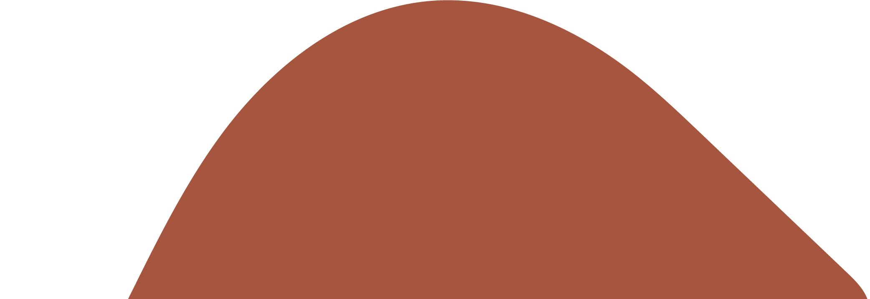
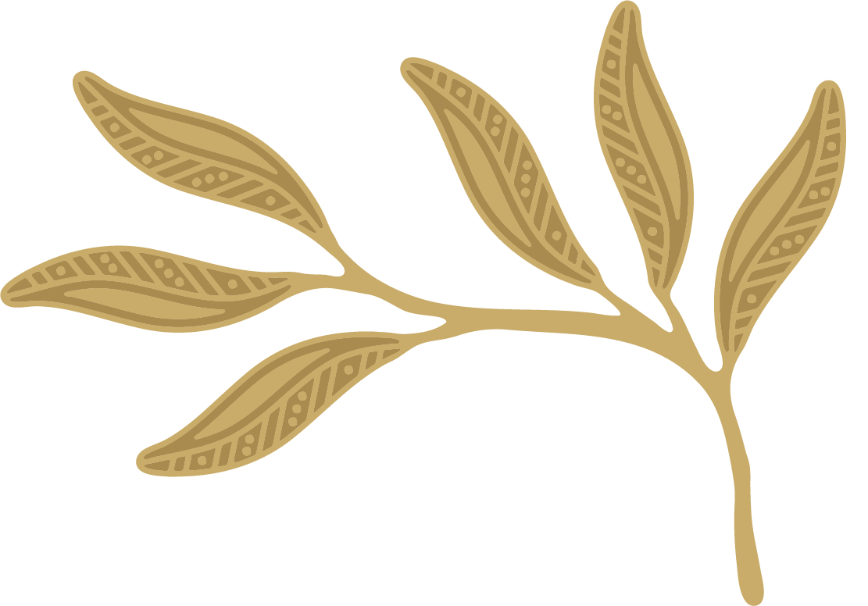
What I THINK and BELIEVE about Aboriginal children and young people, families and communities | Strongly agree | Agree | Neither agree nor disagree | Disagree | Strongly disagree | Why do I think this? | What can I improve?
I understand that my beliefs about people from different backgrounds may be based on assumptions that may not be true

I have thought about how I came to hold my views and attitudes towards Aboriginal people, communities and cultures
I respect other people’s culture and identity as equal to my own
I believe that learning more about Aboriginal culture and the impact of colonisation will help me provide a culturally safe environment

What I KNOW and UNDERSTAND about creating safety for Aboriginal children and young people | Strongly agree | Agree | Neither agree nor disagree | Disagree | Strongly disagree | How do I know this? | What can I improve?
I know that my beliefs and attitudes affect how I behave
I understand and acknowledge the history and experience of Aboriginal people and the ongoing impact of colonisation
I know that Aboriginal people continue to experience harm due to separation from land, culture and family
I know that Aboriginal children, young people and their families continue to face racism
I understand how connection to culture helps Aboriginal children and young people to feel safe and thrive
I understand that children and young people and their families may not tell us they are Aboriginal if they don’t feel safe and supported
I know ‘not being racist’ is not enough to prevent racism. I know what being ‘anti-racist’ means and why it is important

What I DO to create safety for Aboriginal children and young people | Strongly agree |  | Agree | Neither agree nor disagree | Disagree |  | Strongly disagree | How do I do this? | What can I improve?
I support all children to feel welcomed, respected and valued in my day-to-day practice
I talk about positive aspects of Aboriginal people and don’t rely on stereotypes
I do not tolerate racism in my professional and personal life, and I call it out and report it
I take active steps to build trust with Aboriginal children, young people and their families
I actively apply my organisation’s policies and practices regarding cultural safety
I empower children and young people by providing them with information, including how staff and volunteers should behave, and what to do if they feel unsafe or need help
I take deliberate steps to create an environment in which Aboriginal children can feel comfortable to be themselves
I seek opportunities for training and professional development in creating safety for Aboriginal children and young people and their families
I am open to feedback on my cultural safety practices
I am confident to provide feedback to others about their cultural safety practices
What I learnt about myself
Gaps in my understanding and knowledge

What I am going to do to learn more
A learning and action plan can help you identify and meet the learning and training needs you identified in this reflection.
As you go through this activity, consider the scale of knowledge-building efforts you require. Your needs may be like others in your organisation and may be better done as a group.
You might want to raise these learning needs with your manager, child safety officer or organisational leadership to make sure it feeds into organisation-wide learning and development planning.
Your learning plan may also involve reading, visiting websites, watching movies and having discussions to increase your knowledge and understanding.
My learning needs |  | What I will do |  |  |  | When will I do it
Examples:  I don’t have a good understanding of the impact colonisation has had on Aboriginal people  I don’t feel confident speaking up when I hear someone make a racist comment |  | Examples:  - Visit the Koorie Heritage Trust  - Explore the resource Racism. It stops with me  - Speak with my manager about undertaking external training
Review date:
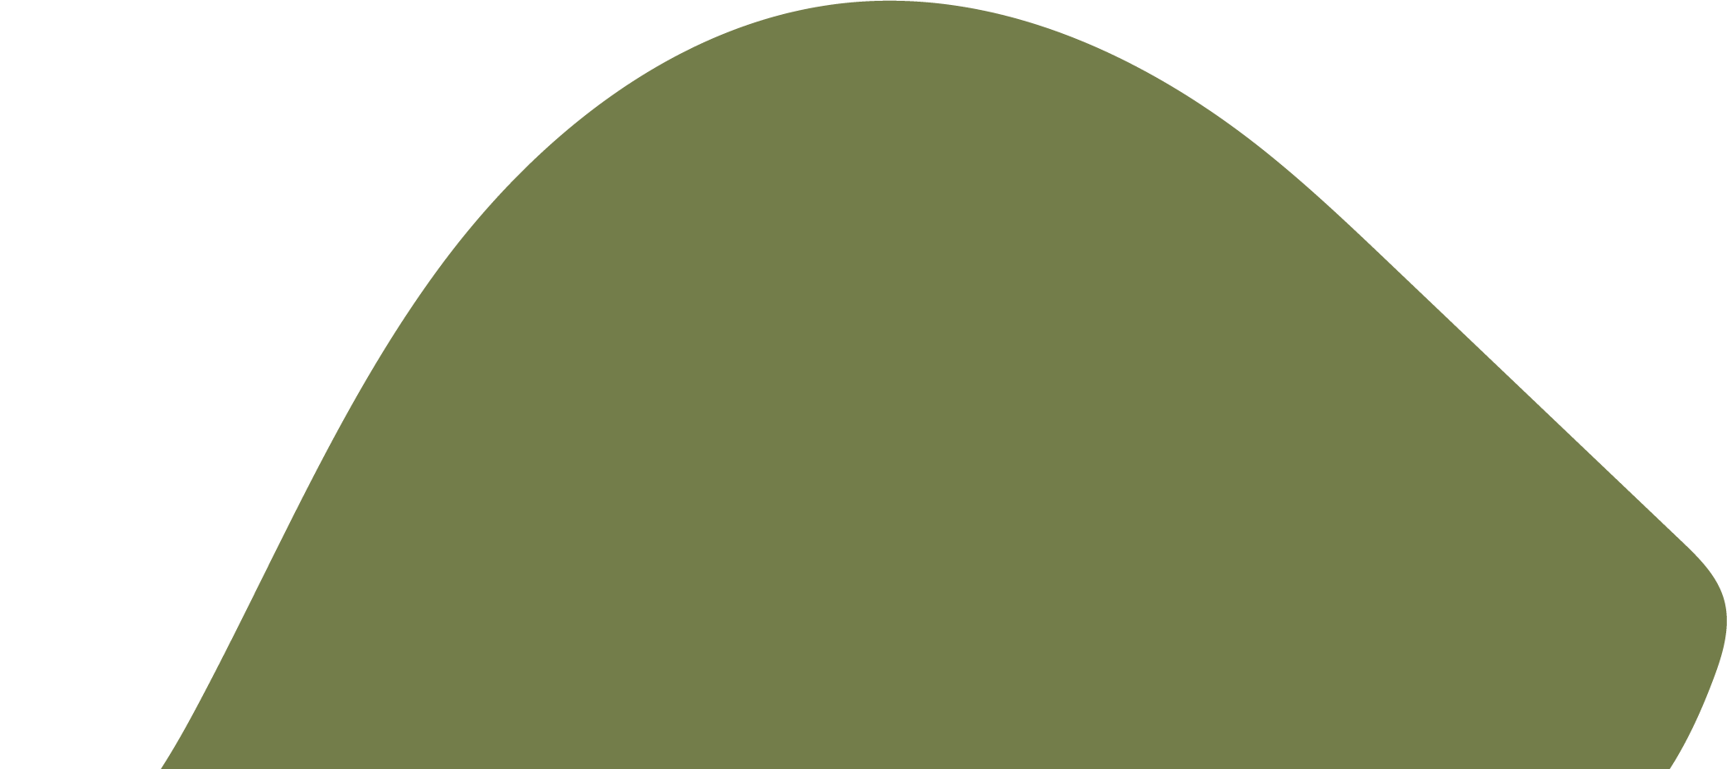
Go to the next tool: Reflection tool 2: Organisational culture, practice and learning assessment

