This taking action tool is part of our guide: Understanding cultural safety for Aboriginal children and young people. You can find all the tools and other relevant resources on our website:
Understanding cultural safety for Aboriginal children and young people

About this tool
The next step is to develop a learning and action plan that sets out the steps your organisation will take to create a culturally safe environment for Aboriginal children and young people.
Using the gaps identified in Reflection tool 2: Organisational culture and practice assessment:
- determine what steps your organisation will need to take to fill these gaps
- determine what knowledge or experience needs to be gained
- assign each step a priority
- allocate a person or position who will be responsible for ensuring each action is taken
- assign a due date and a date to review each action.
Your planning should consider how your actions support your organisation to meet the minimum requirements of Child Safe Standard 1.

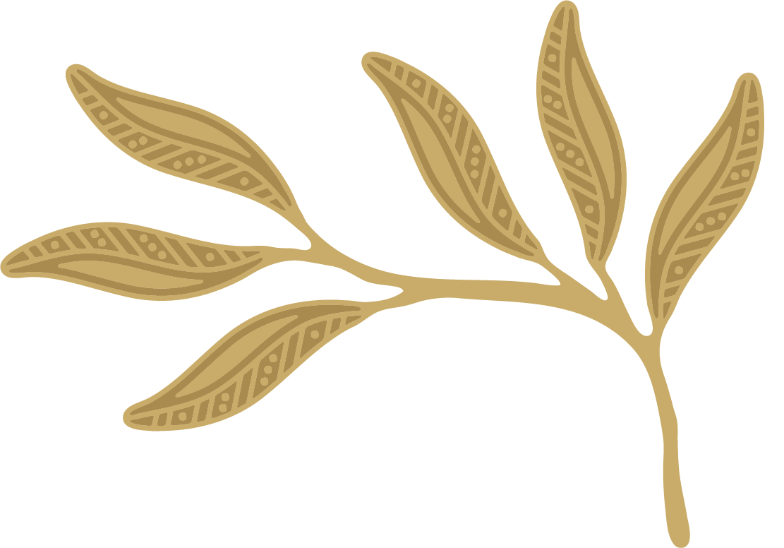

Organisational leadership and culture
Gaps identified | Priority | Steps that need to be taken to address issues and gaps | Person/position/team responsible | Due date | Review date
Example:  Leaders don't always take appropriate action when racism occurs | High  Medium  Low | Example:  Leaders ensure action is taken to respond to all incidents of alleged racism and that proper records are kept

Organisational leadership and culture
Learning needs identified | Priority | Steps that need to be taken to meet learning needs | Person/position/team responsible | Due date | Review date
Example:  Learn more about how to be a good ally and call out racism | High  Medium  Low | Example:  Whole of organisation staff meeting focusing on the Australian Human Rights Commission’s Racism. It stops with me – Let’s talk race: a guide on how to conduct conversations about racism

Children and young people
Gaps identified | Priority | Steps that need to be taken to address issues and gaps | Person/position/team responsible | Due date | Review date
Example:  We don’t know how welcoming our organisation feels to Aboriginal children and young people who engage with our organisation | High  Medium  Low | Example:  Plan and implement a culturally sensitive way to ask Aboriginal children, young people and their families for their views about what we can do to better support them

Children and young people
Learning needs identified | Priority | Steps that need to be taken to meet learning needs | Person/position/team responsible | Due date | Review date
Example:  Learn more about how to better support Aboriginal children and young people | High  Medium  Low | Example:  Watch Keeping Aboriginal children safe in mainstream organisations (VACCA) followed by a whole of staff discussion

Organisational policies, procedures and systems
Gaps identified | Priority | Steps that need to be taken to address issues and gaps | Person/position/team responsible | Due date | Review date
Example:  Our complaints policy doesn’t help us deal with racism | High  Medium  Low | Example:  We need to update our complaints policy and help children know how to raise their concerns about racism

Organisational policies, procedures and systems
Learning needs identified | Priority | Steps that need to be taken to meet learning needs | Person/position/team responsible | Due date | Review date
Example:  Staff and volunteers know about the organisation’s policies and procedures but don’t understand why they are important | High  Medium  Low | Example:  The person responsible for human resources to attend team meetings and talk about the systems, how they work to keep Aboriginal children and young people safe and why they are important

Go to the next tool: Review and improvement tool: Checking in on progress and planning next steps

